

**FLM - FPT EDUCAITON LEARNING MATERIALS**

**Software Requirement Specification**

– Hanoi, August 2022 –

**Record of changeS**

| **Date** | **A* M, D** | **In charge** | **Change Description** |
| --- | --- | --- | --- |
| 25/5 | A | trungnvhs160609 | Thêm mô tả chức năng Login (II.1.c) |
| 25/5 | A | trungnvhs160609 | Thêm mô tả chức năng Forgot Password (II.1.d) |
| 28/5 | A | tienlvhe161878 | Thêm mô tả chức năng Setting List(II.2.c) |
| 28/5 | A | tienlvhe161878 | Thêm mô tả chức năng Setting Detail(II.2.d) |
| 28/5 | A | quantnhe161199 | thêm mô tả chức năng Home Page (II.1.a) |
| 28/5 | A | quantnhe161199 | Thêm mô tả chức năng Register(II.1.b) |
| 28/5 | A | khoanthe161852 | Thêm mô tả chức năng Account List(II.2.a) |
| 28/5 | A | khoanthe161852 | Thêm mô tả chức năng Account Detail(II.2.b) |
| 28/05 | A | quannthe160206 | Thêm mô tả Overview (I) |
| 28/05 | A | quannthe160206 | Thêm mô tả chức năng User Profile(II.1.e) |
| 28/05 | A | quannthe160206 | Thêm mô tả chức năng Change Password(II.1.f) |
| 04/06 | A | trungnvhs160609 | Thêm mô tả chức năng Curriculum List(II.3.a) |
| 04/06 | A | trungnvhs160609 | Thêm mô tả chức năng View Curriculum(II.3.b) |
| 04/06 | A | trungnvhs160609 | Thêm mô tả chức năng Add Curriculum(II.3.c) |
| 11/06 | A | quannthe160206 | Thêm mô tả chức năng Subject List(II.4.a) |
| 11/06 | A | quannthe160206 | Thêm mô tả chức năng New Subject(II.4.b) |
| 11/06 | A | quannthe160206 | Thêm mô tả chức năng Subject Import(II.4.c) |
| 11/06 | A | quannthe160206 | Thêm mô tả chức năng Subject Detail(II.4.d) |
| 11/06 | A | khoanthe161852 | Thêm mô tả chức năng Subject Predecessors(II.4,f) |
| 11/06 | A | khoanthe161852 | Thêm mô tả chức năng Subject Successors(II.4.g) |
| 11/06 | A | tienlvhe161878 | Thêm mô tả chức năng PLo List(II.5.a) |
| 11/06 | A | quantnhe161199 | Thêm mô tả chức năng Edit Curriculum (II.3.d) |
| 11/06 | A | quantnhe161199 | Thêm mô tả chức năng Curriculum Subject Detail (II.6.a) |
| 11/06 | A | quantnhe161199 | Thêm mô tả chức năng Add Curriculum Subject (II.6.b) |
| 21/06 | A | quannthe160206 | Thêm mô tả chức năng Content Group List (II.8.c) |
| 21/06 | A | quannthe160206 | Thêm mô tả chức năng Content Group Detail (II.8.d) |
| 21/06 | M | quannthe160206 | Chỉnh sửa mo tả Overview (I.2, I.3, I.4) |
| 25/6 | A | khoanthe161852 | Thêm mô tả chức năng Po List(II.5.a) |
| 25/6 | A | khoanthe161852 | Thêm mô tả chức năng Po detail |
| 25/6 | A | khoanthe161852 | Thêm mô tả chức năng Po import |
| 25/6 | A | khoanthe161852 | Thêm mô tả chức năng Po mapping |
| 25/6 | A | quannthe160206 | Thêm mô tả chức năng PLO import |
| 25/6 | A | trungnvhs160609 | Thêm mô tả chức năng List Decision |
| 25/6 | A | trungnvhs160609 | Thêm mô tả chức năng Add Decision |
| 25/6 | A | trungnvhs160609 | Thêm mô tả chức năng Detail Decision |
| 25/6 | A | trungnvhs160609 | Thêm mô tả chức năng Overview Decision |
| 12/7 | A | quannthe160206 | Thêm mô tả chức năng Submit List (II.11.a) |
| 12/7 | A | quannthe160206 | Thêm mô tả chức năng Submit Detail (II.11.b) |
| 12/7 | A | quannthe160206 | Thêm mô tả chức năng Syllabus Import (II.9.e) |
| 20/7 | A | quantnhe161199 | Thêm mô tả chức năng Session List(II.12.aa) |
| 20/7 | A | quantnhe161199 | Thêm mô tả chức năng Session Details(II.12.b) |
| 20/7 | A | quantnhe161199 | Thêm mô tả chức năng Session Import(II.12.c) |
| 20/7 | A | trungnvhs160609 | Thêm mô tả chức năng Question List |
| 20/7 | A | trungnvhs160609 | Thêm mô tả chức năng Question List |
| 20/7 | A | trungnvhs160609 | Thêm mô tả chức năng Question List |
| 20/7 | A | khoanthe161852 | Thêm mô tả chức năng CLO List |
| 20/7 | A | khoanthe161852 | Thêm mô tả chức năng CLO Detail |
| 20/7 | A | khoanthe161852 | Thêm mô tả chức năng CLO Import |
| 20/7 | A | khoanthe161852 | Thêm mô tả chức năng CLO-PLO Mapping |
| 20/7 | A | khoanthe161852 | Thêm mô tả chức năng Subject-PLO Mapping |
| 21/7 | A | tienlvhe161878 | Thêm mô tả chức năng Syllabus List |
| 21/7 | A | tienlvhe161878 | Thêm mô tả chức năng Syllabus Overview |
| 21/7 | A | tienlvhe161878 | Thêm mô tả chức năng Syllabus Edit |

*A - Added M - Modified D - Deleted

### 

**Table of Contents**

I. Overview 7

1. Screen Flow 7

2. Functionalities 7

3. User Authorization 12

4. Entity Relationship Diagram 14

II. Functional Requirements 16

1. User Access 16

a. Home Page 16

b. User Register 18

c. User Login 20

d. Forgot Password 22

e. User Profile 25

f. Password Change 26

2. System Admin 28

a. Account List 28

b. Account Detail 30

c. Setting List 31

d. Setting Detail 33

3.Curriculum management 34

a.Curriculum List 34

b.View Curriculum 37

c.Add Curriculum 40

d. Edit Curriculum 43

4. Subject Management 45

a. Subject List 45

b. New Subject 46

c. Subject Import 48

d. Subject Detail 50

e. Subject-PLO Mapping 52

f. Subject Predecessors 52

g. Subject Successors 54

5. PLO Management 55

a. PLO List 55

b. PLO Details 56

c. PLO Import 56

d. PLO - PO Mapping 58

6. Curriculum Subject 58

a. Curriculum Subject Detail 58

b. Add curriculum subject 61

7. PO Management 62

a. PO List 62

b. PO Import 63

c. Po Detail 65

8. Subject Groups 67

a. Combo List 67

b. Combo Detail 69

c. Content Group List 71

d. Content Group Detail 73

e. Elective List 75

f. Elective Detail 77

9. Syllabus Management 80

a. Syllabus List 80

b. Syllabus Overview 80

c. New Syllabus 80

d. Syllabus Edit 80

e. Syllabus Import 80

10. Decision Management 80

a. Decision List 80

b. Decision Detail 81

c. New Decision 83

d. Decision Overview 85

11. Syllabus Submit 87

a. Submit List 87

b. Submit Details 87

12. Constructive Questions 87

a. Question List 87

b. Question Details 87

c. Import Question 87

13. Session Management 87

a. Session List 87

b. Session Details 87

c. Import Session 87

14. CLO Management 87

a. CLO List 87

b. CLO Details 87

c. Import CLO 87

d. CLO-PLO Mapping 87

15. Assessment Management 87

a. Assessment List 87

b. Assessment Details 87

16. Reference Material 87

a. Material List 87

b. Material Details 87

# I. Overview

## 1. Screen Flow

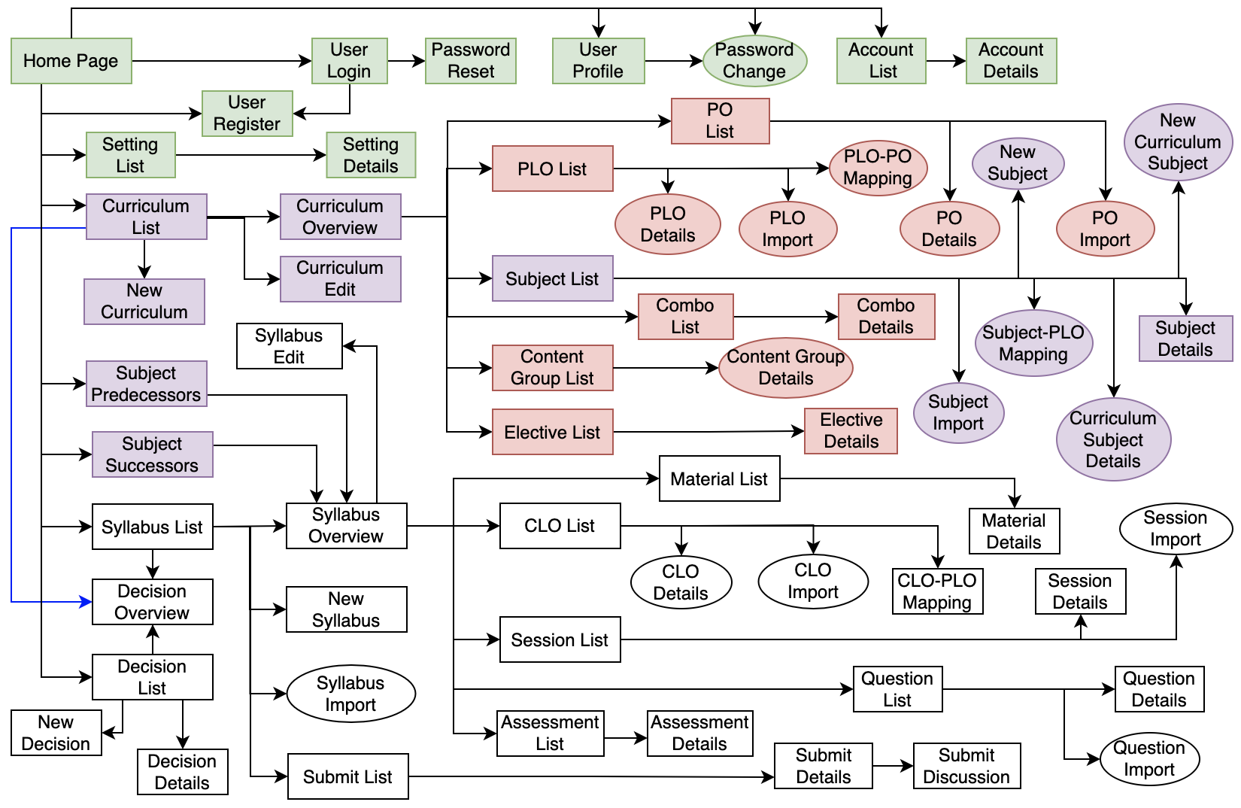

## 2. Functionalities

| **#** | **Feature** | **Use Case** | **Screen/Function** | **Screen/Function Details** |
| --- | --- | --- | --- | --- |
| 1 | User Access | View home page | Home Page | View homepage:  - Get some basic infor |
| 2 | User Access | Register new account | User Register | Register new account:  - Input information of new account  - Get email or phone number of new user  - Insert that data into database of system |
| 3 | User Access | Login to the system | User Login | Login to website:  - Input account/email/phone number and password  - Check that account correct or not |
| 4 | User Access | Reset password | Password Reset | Reset password:  - Input mail/phone number  - Send, check verification code  - Set new password |
| 5 | User Access | Update user profile | User Profile | View user profile:  - View  - Update information  - Send, check verification code when add mail or mobile |
| 6 | User Access | Change password | Password Change | Change password:  - Input old, new password  - Check  - Update new password |
| 7 | System Admin | View list account | Account List | View account list:  - Filter  - Search  - View |
| 8 | System Admin | View account details | Account Detail | View account detail:  - View information of a account  - Update role |
| 9 | System Admin | View setting list (view master data) | Setting List | View setting list:  - Filter  - Search  - View |
| 10 | System Admin | Edit setting infor (edit master data) | Setting Detail | View detail setting:  - View detail master date  - Update |
| 11 | Curriculum Management | View Curriculum List | Curriculum List | View Curriculum List:  - Search  - View  - Filter |
| 12 | Curriculum Management | Add New Curriculum | New Curriculum | Add New Curriculum:  - Insert  - View  - Check |
| 13 | Curriculum Management | View Curriculum Overview | Curriculum Overview | View Curriculum Overview:  - View |
| 14 | Curriculum Management | Edit Curriculum | Curriculum Edit | Edit Curriculum:  - Update  - Check  - View |
| 15 | Subject Management | View Subject List | Subject List | View Subject List:  - Search  - View  - Filter |
| 16 | Subject Management | Add New Subject | New Subject | Add New Subject:  - Insert  - Check  - View |
| 17 | Subject Management | Import Subject | Subject Import | Import Subject:  - Upload file  - Insert  - Check |
| 18 | Subject Management | View Subject Detail | Subject Detail | View Subject Detail:  - View  - Edit |
| 19 | Subject Management | Mapping Subject-PLO | Subject-PLO Mapping | Mapping Subject-PLO:  - Insert  - View  - Check |
| 20 | Subject Management | View Subject Predecessors | Subject Predecessors | View Subject Predecessors:  - Insert  -View |
| 21 | Subject Management | View Subject Successors | Subject Successors | View Subject Successors:  - Insert  -View |
| 22 | Curriculum Subject | View Curriculum Subject Details | Curriculum Subject Details | View Curriculum Subject Details:  - View |
| 23 | Curriculum Subject | Add New Curriculum Subject | New Curriculum Subject | Add New Curriculum Subject:  - View  - Insert  - Check |
| 24 | PLO Management | View PLO List | PLO List | View PLO List:  - View  - Search |
| 25 | PLO Management | View PLO Details | PLO Details | View PLO Details:  - View  - Edit |
| 26 | PLO Management | Import PLO | PLO Import | Import PLO:  - Upload file  - Insert  - Check |
| 27 | PLO Management | Mapping PLO-PO | PLO-PO Mapping | Mapping PLO-PO:  - Insert  - View  - Check |
| 28 | PO Management | View PO List | PO List | View PO List:  - View  - Search |
| 29 | PO Management | Import PO | PO Import | Import PO:  - Upload file  - Insert  - Check |
| 30 | PO Management | View PO Detail | PO Detail | View PO Details:  - View  - Edit |
| 31 | Subject Groups | View Combo List | Combo List | View Combo List:  - View  - Search |
| 32 | Subject Groups | View Combo Detail | Combo Detail | View Combo Details:  - View  - Edit |
| 33 | Subject Groups | View Content Group List | Content Group List | View Content Group List:  - View  - Search |
| 34 | Subject Groups | View Content Group Details | Content Group Details | View Content Group Details:  - View  - Edit |
| 35 | Subject Groups | View Elective List | Elective List | View Elective List:  - View  - Search |
| 36 | Subject Groups | View Elective Details | Elective Details | View Elective Details:  - View  - Edit |
| 37 | Syllabus Management | View Syllabus List | Syllabus List | View Syllabus List:  - View  - Search  - Filter |
| 38 | Syllabus Management | View Syllabus Overview | Syllabus Overview | View Syllabus Overview:  - View |
| 39 | Syllabus Management | Add New Syllabus | New Syllabus | Add Syllabus Subject:  - View  - Insert  - Check |
| 40 | Syllabus Management | Syllabus Edit | Syllabus Edit | Edit Syllabus:  - Update  - Check  - View |
| 41 | Decision Management | View Decision List | Decision List | View Decision List:  - View  - Search  - Filter |
| 42 | Decision Management | View Decision Details | Decision Details | View Decision Details:  - View  - Edit  - Delete |
| 43 | Decision Management | Add New Decision | New Decision | Add Decision Subject:  - View  - Insert  - Check |
| 44 | Decision Management | View Decision Overview | Decision Overview | View Decision Overview:  - View |
| 45 | Syllabus Submit | View Submit List | Submit List | View Submit List:  - View  - Search  - Filter |
| 46 | Syllabus Submit | View Submit Details | Submit Details | View Submit Details:  - View  - Edit |
| 47 | Constructive Questions | View Question List | Question List | View Question List:  - View  - Search  - Filter |
| 48 | Constructive Questions | View Question Details | Question Details | View Question Details:  - View  - Edit  - Delete |
| 49 | Constructive Questions | Import Question | Question Import | Import Question:  - Download template file  - Upload file  - Insert  - Check |
| 50 | Session Management | View Session List | Session List | View Session List:  - View  - Search  - Filter |
| 51 | Session Management | View Session Details | Session Details | View Session Details:  - View  - Edit |
| 52 | Session Management | Import Session | Session Import | Import Session:  - Upload file  - Insert  - Check |
| 53 | CLO Management | View CLO List | CLO List | View CLO List:  - View  - Search  - Filter |
| 54 | CLO Management | View CLO Detail | CLO Detail | View CLO Details:  - View  - Edit |
| 55 | CLO Management | Import CLO | CLO Import | Import CLO :  - Upload file  - Insert  - Check |
| 56 | CLO Management | Mapping CLO-PLO | CLO-PLO Mapping | Mapping CLO-PLO:  - Insert  - View  - Check |
| 57 | Assessment Management | View Assessment List | Assessment List | View Assessment List:  - View  - Search  - Filter |
| 58 | Assessment Management | View Assessment Details | Assessment Details | View Assessment Details:  - View  - Edit |
| 59 | Reference Material | View Material List | Material List | View Material List:  - View  - Search  - Filter |
| 60 | Reference Material | View Material Details | Material Details | View Material Details:  - View  - Edit |
| 61 | Syllabus Management | Import Syllabus | Syllabus Import | Import Syllabus :  - Upload file  - Insert  - Check |

## *3. User Authorization*

| **Screen** | **Role1** | **Role2** | **Role3** | **Role4** | **Role5** | **Role6** | **Role7** |
| --- | --- | --- | --- | --- | --- | --- | --- |
| - Home page | X | X | X | X | X | X | X |
| - User Register | X | X | X |  | X |  |  |
| - User Login | x | x | x | x | x | x | x |
| - Reset password | x | x | x | x | x | x | x |
| - Update user profile | x | x | x | x | x | x | x |
| - Change password | x | x | x | x | x | x | x |
| - View list account |  |  |  |  |  | x |  |
| - View account details |  |  |  |  |  | x |  |
| - View setting list (view master data) |  |  |  |  |  | x |  |
| - Edit setting infor (edit master data) |  |  |  |  |  | x |  |
| View Curriculum List | x | x | x | x | x | x | x |
| Add New Curriculum |  |  |  | x |  |  | x |
| View Curriculum Overview | x | x | x | x | x | x | x |
| Edit Curriculum |  |  |  | x |  |  | x |
| View Subject List |  |  |  | x |  |  | x |
| Add New Subject |  |  |  | x |  |  | x |
| Import Subject |  |  |  | x |  |  | x |
| View Subject Detail | x | x | x | x | x | x | x |
| Mapping Subject-PLO |  |  |  |  |  |  |  |
| View Subject Predecessors | x | x | x | x | x | x | x |
| View Subject Successors | x | x | x | x | x | x | x |
| View Curriculum Subject Details | x | x | x | x | x | x | x |
| Add New Curriculum Subject |  |  |  | x |  |  | x |
| View PLO List | x | x | x | x | x | x | x |
| View PLO Details | x | x | x | x | x | x | x |
| Import PLO |  |  |  | x |  |  | x |
| Mapping PLO-PO | x | x | x | x | x | x | x |
| View PO List | x | x | x | x | x | x | x |
| Import PO |  |  |  | x |  |  | x |
| View PO Detail | x | x | x | x | x | x | x |
| View Combo List | x | x | x | x | x | x | x |
| View Combo Detail | x | x | x | x | x | x | x |
| View Content Group List | x | x | x | x | x | x | x |
| View Content Group Details | x | x | x | x | x | x | x |
| View Elective List | x | x | x | x | x | x | x |
| View Elective Details | x | x | x | x | x | x | x |
| View Syllabus List | x | x | x | x | x | x | x |
| View Syllabus Overview | x | x | x | x | x | x | x |
| Add New Syllabus |  |  |  |  | x |  | x |
| Syllabus Edit |  |  |  |  | x |  | x |
| Import Syllabus |  |  |  | x | x |  | x |
| View Decision List | x | x | x | x | x | x | x |
| View Decision Details | x | x | x | x | x | x | x |
| Add New Decision |  |  |  |  |  |  | x |
| View Decision Overview | x | x | x | x | x | x | x |
| View Submit List |  |  |  | x | x | x | x |
| View Submit Details |  |  |  | x | x | x | x |
| View Question List | x | x | x | x | x | x | x |
| View Question Details | x | x | x | x | x | x | x |
| Import Question |  |  |  | x | x |  | x |
| View Session List | x | x | x | x | x | x | x |
| View Session Details | x | x | x | x | x | x | x |
| Import Session |  |  |  | x | x |  | x |
| View CLO List | x | x | x | x | x | x | x |
| View CLO Detail | x | x | x | x | x | x | x |
| Import CLO |  |  |  | x | x |  | x |
| Mapping CLO-PLO |  |  |  | x | x |  | x |
| View Assessment List | x | x | x | x | x | x | x |
| View Assessment Details | x | x | x | x | x | x | x |
| View Material List | x | x | x | x | x | x | x |
| View Material Details | x | x | x | x | x | x | x |

In which:

* Role1: Student
* Role2: Teacher
* Role3: Guest
* Role4: CRDD Staff
* Role5: Designer
* Role6: Admin
* Role7: CRDD Head

## 4. Entity Relationship Diagram

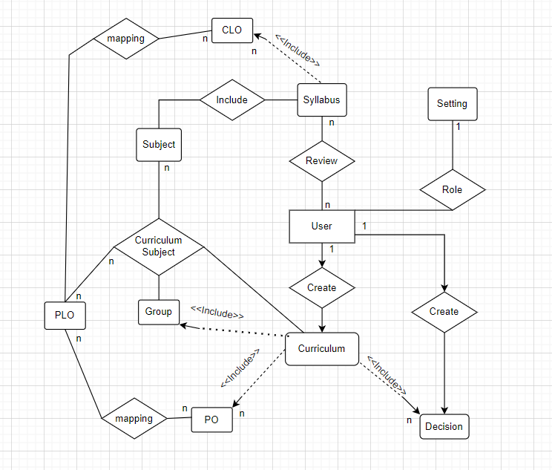

**Entities Description**

| **#** | **Entity** | **Description** |
| --- | --- | --- |
| 1 | User | The user table contains all information about the account's full name, user name, mail, mobile, password, job, and company. |
| 2 | Setting | The ***settings*** table is to store master data:  • user roles  • system pages  • training types  • assessment types  • assessment categories |
| 3 | Syllabus | The syllabustable contains all information about the account's name, No_of_creadit, is_, mobile, password, job, and company. |
| 4 | Subject |  |
| 5 | Curriculum |  |
| 6 | Decision |  |
| 7 | Group |  |
| 8 | PLO |  |
| 9 | PO |  |
|  |  |  |
|  |  |  |

# II. Functional Requirements

## 1. User Access

### a. Home Page

**-Function Trigger:**

The "trigger" in the context of a homepage can refer to various meanings. Here are some analyses of triggering actions on a homepage of a website:

* Load trigger: This is the most basic trigger for a homepage. When a user accesses the URL of a website's homepage, this trigger initiates the loading of the homepage onto the user's browser.
* Scroll trigger: This trigger occurs when a user scrolls on the homepage. It can be used to activate effects or load additional content as the user scrolls down or up the page.
* Click trigger: This trigger happens when a user clicks on a specific element on the homepage. It can activate actions such as navigating to a subpage, opening a modal, or performing another task on the page.
* Interactive trigger: This trigger occurs when a user directly interacts with the homepage. For instance, when a user fills out a form, clicks on an interactive element, or performs another action on the page.

**-Function Description:**

The home page serves as the primary entry point for visitors to our website. Its main functions are:

* Introduction and Branding: The home page provides a brief introduction to our company, organization, or website. It showcases our brand identity, logo, and tagline, helping visitors understand who we are and what we offer.
* Navigation: The home page serves as a central hub for site navigation. It presents a clear and intuitive menu or navigation bar that enables users to access different sections and pages of the website easily. This ensures that visitors can quickly find the information or services they are seeking.
* Content Highlights: The home page features key content highlights to engage visitors and showcase the most important or popular aspects of our website. This may include featured articles, products, promotions, or upcoming events. The goal is to provide visitors with a glimpse of what they can expect and encourage them to explore further.
* News and Updates: Depending on the nature of our website, the home page may display recent news, blog posts, announcements, or updates. This keeps visitors informed about the latest happenings, industry trends, or important information related to our organization.
* Visual Appeal: The home page typically employs visually appealing design elements, including high-quality images, graphics, videos, or animations, to create an attractive and engaging user experience. This helps capture visitors' attention and encourages them to stay on the site.

Overall, the home page functions as a gateway to our website, providing an overview of our brand, guiding visitors to relevant sections, and enticing them to explore further or take desired actions. Its design and content are optimized to deliver a positive first impression, enhance usability, and drive conversions or engagement

**-Screen Layout (Login Screen Mockup):**



**-Function Details**:

The detailed functions of the homepage may vary depending on the purpose and design of the specific website. Here are some common specific functions that may appear on the homepage:

* Introduction and Summary: The homepage often provides a brief introduction to the company, organization, or website. It may provide an overview of the industry, core values, or the main products/services offered by the website.
* Navigation and Structure: The homepage contains clear navigation elements to allow users to easily find different sections of the website. Links or menus may be organized in a logical structure to help users navigate and search for information.
* Highlighted Content: The homepage typically displays prominent content such as the latest articles, important news, featured products, or special services. This helps visitors recognize the key highlights of the website and guides them to explore more detailed content.
* News and Events: The homepage may feature news headlines, the latest blog posts, or information about upcoming events, conferences, or courses. This keeps visitors updated with the latest information and initiates their initial interaction with the website's content.
* User-Friendly Interface: The homepage often has an attractive and user-friendly design to create a positive experience for visitors. The interface may utilize images, charts, icons, or videos to visually convey information and capture user attention.

However, the specific functions of the homepage will depend on the goals, industry, and specific requirements of the website. Homepages can be customized to meet the unique needs of each specific website.

### b. User Register

**-Function Trigger:**

The Activate function of the registration (register) is often used to initiate the process of registering a new user on a website or application. When the user clicks the "Register" link or button on the website, the Activator function will be activated and open a registration interface for the user to fill in personal information and create an account.

**-Function Description:**

Here is a description of the Register function:

* Display registration interface: The Register function presents a user interface that allows users to enter the necessary information to create an account. Typically, this interface includes fields such as name, email address, password, and other personal information.
* Validate information: Before proceeding with account creation, the Register function validates the user-entered information for validity. This may include verifying a valid email format, checking the uniqueness of the username, ensuring a strong password, and enforcing other data input requirements.
* Process registration: Once the registration information has been validated and deemed valid, the Register function proceeds with processing the account creation process. This involves storing the user's information in a database, creating a new account record, and associating the user's information with the corresponding account.
* User authentication: After successful registration, the Register function often requires users to verify their email address or undergo other authentication processes to ensure accuracy and security of user information.
* Notifications and redirection: Upon completion of the registration process, the Register function notifies the user about the successful account creation. This notification may be accompanied by further instructions, such as redirecting the user to a login page or the homepage of the website.

The Register function provides users with the ability to create personal accounts and leverage the features and services of the website or application. It also serves as a user management method, offering customization and personalized interaction capabilities for each individual user.

**-Screen Layout (Login Screen Mockup):**

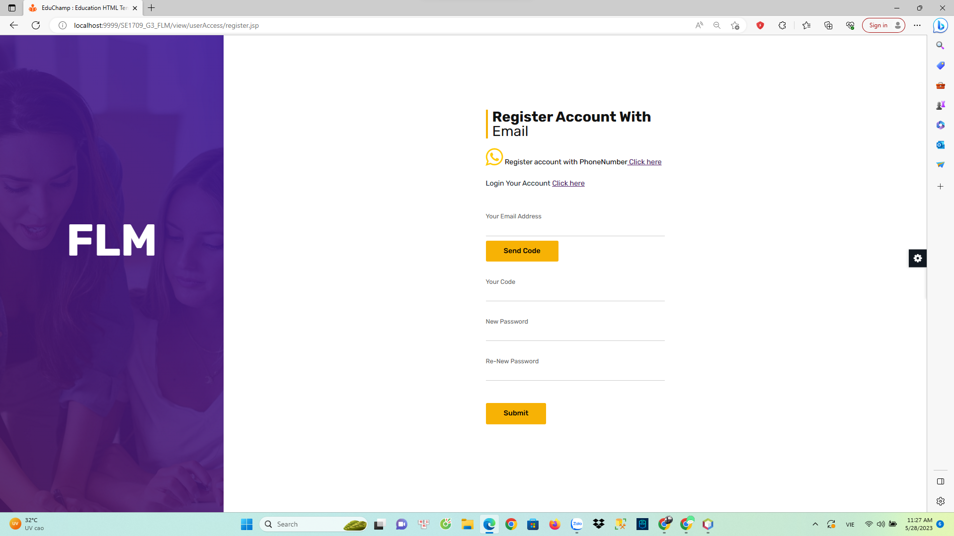

**-Function Details**:

The Register function handles the process of creating a new user account on a website or application. It involves collecting user information, validating inputs, and storing the data for future authentication and access. Here are some key details about the Register function:

* User Input Collection: The Register function prompts the user to provide required information such as username, email address, password, and additional optional details like name, date of birth, or profile picture. The function typically presents a registration form or interface to gather this information.
* Input Validation: The Register function validates the user inputs to ensure they meet the specified criteria. This includes checking for the presence of required fields, verifying the format and uniqueness of email addresses, enforcing password complexity requirements, and validating any other relevant data.
* Account Creation: Once the user inputs have been validated, the Register function proceeds with creating the user account. It typically involves generating a unique identifier for the user, securely storing the provided credentials (such as hashing the password), and associating the account with the provided information.
* Email Verification: In many cases, the Register function incorporates an email verification step to confirm the ownership and validity of the provided email address. This involves sending a verification email containing a unique link or code that the user must click or enter to activate their account.
* Error Handling: The Register function handles various error scenarios that may arise during the registration process. This includes notifying the user about invalid inputs, displaying error messages for duplicate usernames or email addresses, and providing guidance on how to resolve these issues.
* User Feedback: The Register function may provide feedback to the user about the registration status, such as displaying a success message upon successful account creation or indicating any errors or issues that need to be addressed.
* Security Considerations: The Register function takes security measures to protect user data. This includes encrypting sensitive information, implementing secure protocols for data transmission, and following best practices for account creation and password handling
* Integration with User Database: The Register function interacts with a user database or backend system to store the user account information securely. It may utilize a database management system to store and retrieve user data when needed.

The specific implementation and details of the Register function can vary depending on the requirements and design of the website or application. However, these details provide a general overview of the common elements involved in the registration process.

### c. User Login

**-Function Trigger:**

The login function is triggered when a user attempts to access a system or application that requires authentication. Typically, the user encounters a login screen upon opening the application or navigating to a specific URL. The login function may also be triggered when a user session expires or when explicit logout is performed.

**-Function Description:**

* Actors/Roles:
* User: The individual who is attempting to log into the system or application.
* Purpose: The purpose of the login function is to authenticate users and grant them access to the system or application based on their provided credentials. It verifies the identity of the user and ensures that only authorized individuals can access the protected resources.
* Interface: The login function usually presents a login screen to the user, which consists of the following elements:
* Phone/Username/Email field: User enters their username,phone or email address associated with their account.
* Password field: User enters their password.
* "Login" button: User clicks this button to submit their login credentials for authentication.
* Data Processing:

User enters their username/phone/email and password.

The login function takes these inputs and sends them securely to the server for processing.

The server verifies the provided credentials by comparing them against stored user information, such as hashed passwords.

If the credentials are valid, the server grants access to the user and establishes a session.

If the credentials are invalid, the user is typically prompted with an error message indicating the authentication failure.

**-Screen Layout (Login Screen Mockup):**

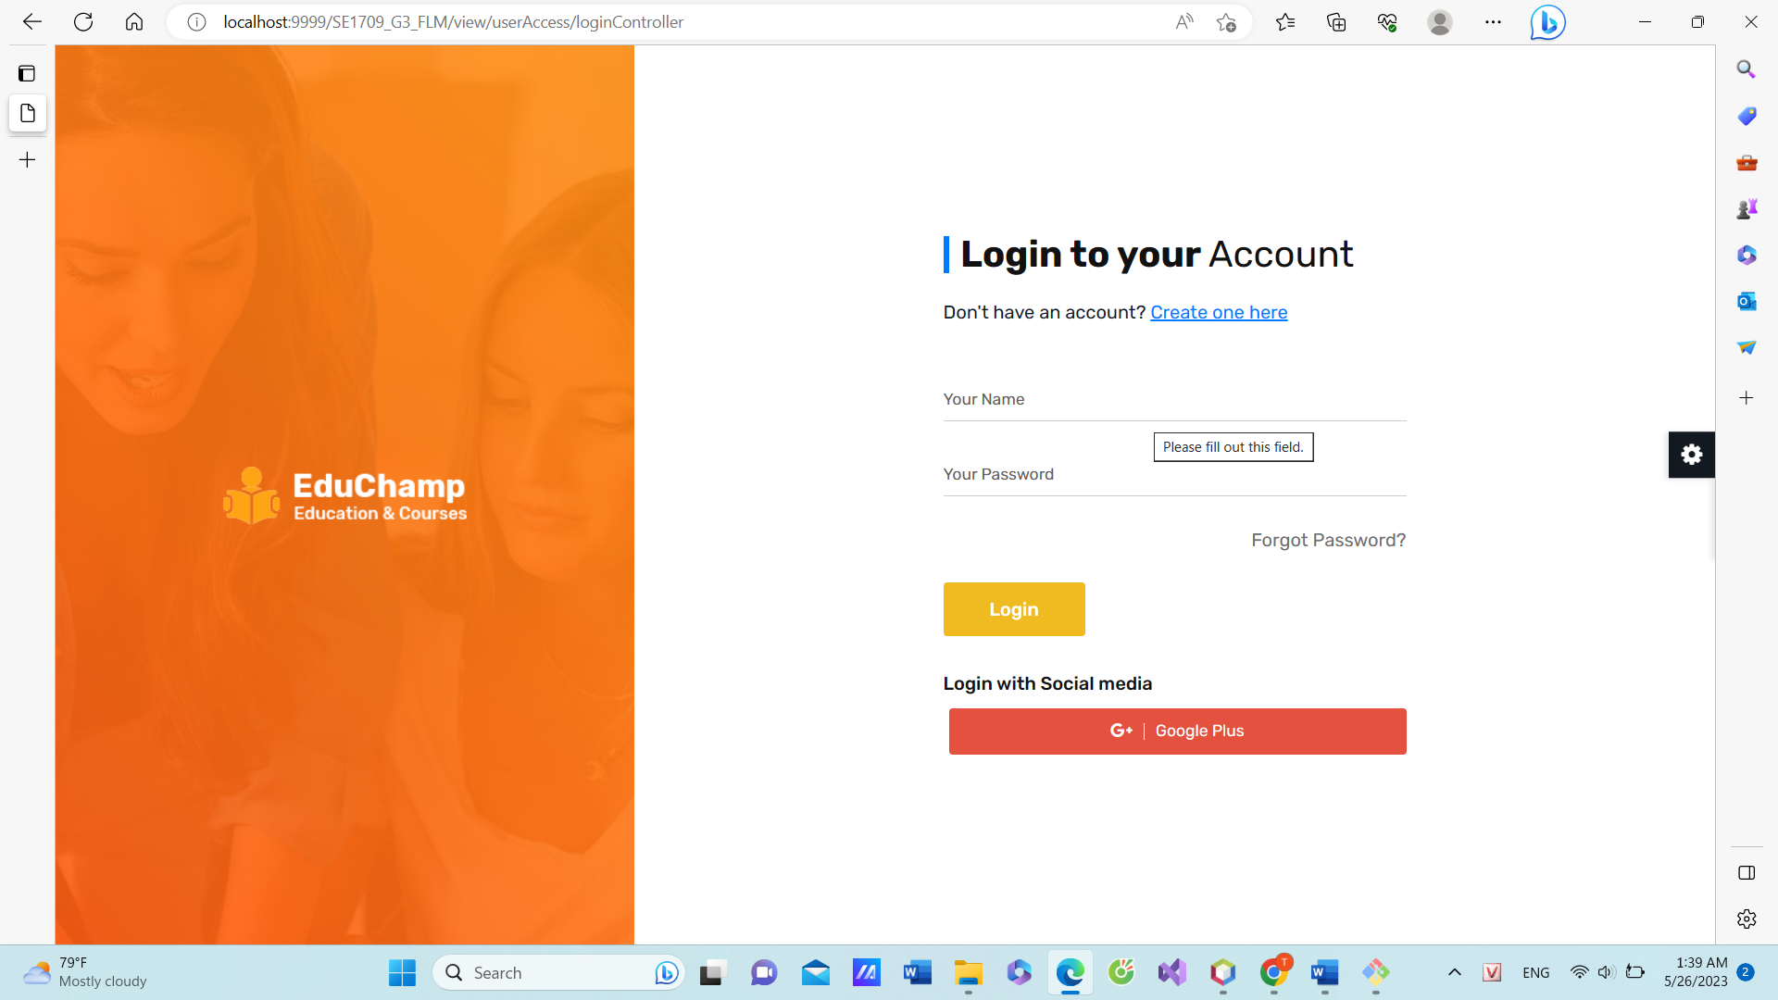

**-Function Details**:

Data Validation: The login function validates the user's input in the following ways:

The username/email field should not be empty.

The password field should not be empty.

The username/email entered should be in a valid format.

The password should meet any specified complexity requirements, such as minimum length or character types.

Business Logic:

Normal Case:

The login function checks if the provided username/email and password match the records stored in the system.

If the credentials are correct, the user is granted access to the system, and a session is established.

The user is redirected to the appropriate landing page or the page they were trying to access before being prompted to log in.

Abnormal Cases:

Invalid Credentials: If the username/email or password is incorrect, the login function displays an error message indicating the authentication failure.

Account Lockout: Some systems may implement a mechanism to lock user accounts temporarily after multiple failed login attempts to prevent brute-force attacks.

Successful Login: Grants access to the system/application and establishes a user session.

Error Handling: Displays appropriate error messages for invalid credentials or other authentication failures.

### d. Forgot Password

**Function Trigger:**

The forgot password function is typically triggered when a user encounters difficulty in logging into a system or application due to a forgotten password. It is commonly accessed through a "Forgot Password" link or button on the login screen.

**Function Description:**

Actors/Roles:

User: The individual who has forgotten their password and needs to reset it.

System/Server: The system or server hosting the application that manages user accounts and password reset functionality.

Purpose:

The purpose of the forgot password function is to allow users who have forgotten their password to reset it securely and regain access to their account. It provides a mechanism for users to verify their identity and set a new password.

Interface:

The forgot password function typically involves the following elements:

Phone/Email field: User enters their Phone or email address associated with their account.

"Submit" button: User clicks this button to initiate the password reset process.

Alternatively, a "Cancel" or "Go back" button may be provided to allow users to return to the login screen without proceeding with password reset.

Data Processing:

User enters their Phone or email address into the designated field.

The forgot password function collects this information and submits it securely to the server for processing.

The server validates the provided Phone/email and generates a unique password reset token or link.

An email containing the password reset link/token is sent to the user's registered email address.

The user receives the email and follows the instructions to reset their password.

The server verifies the password reset token or link and allows the user to set a new password.

The user enters the new password and submits it to the server.

The server securely stores the new password, replacing the old one, and updates the user's account accordingly.

**Screen Layout (Forgot Password Screen Mockup):**

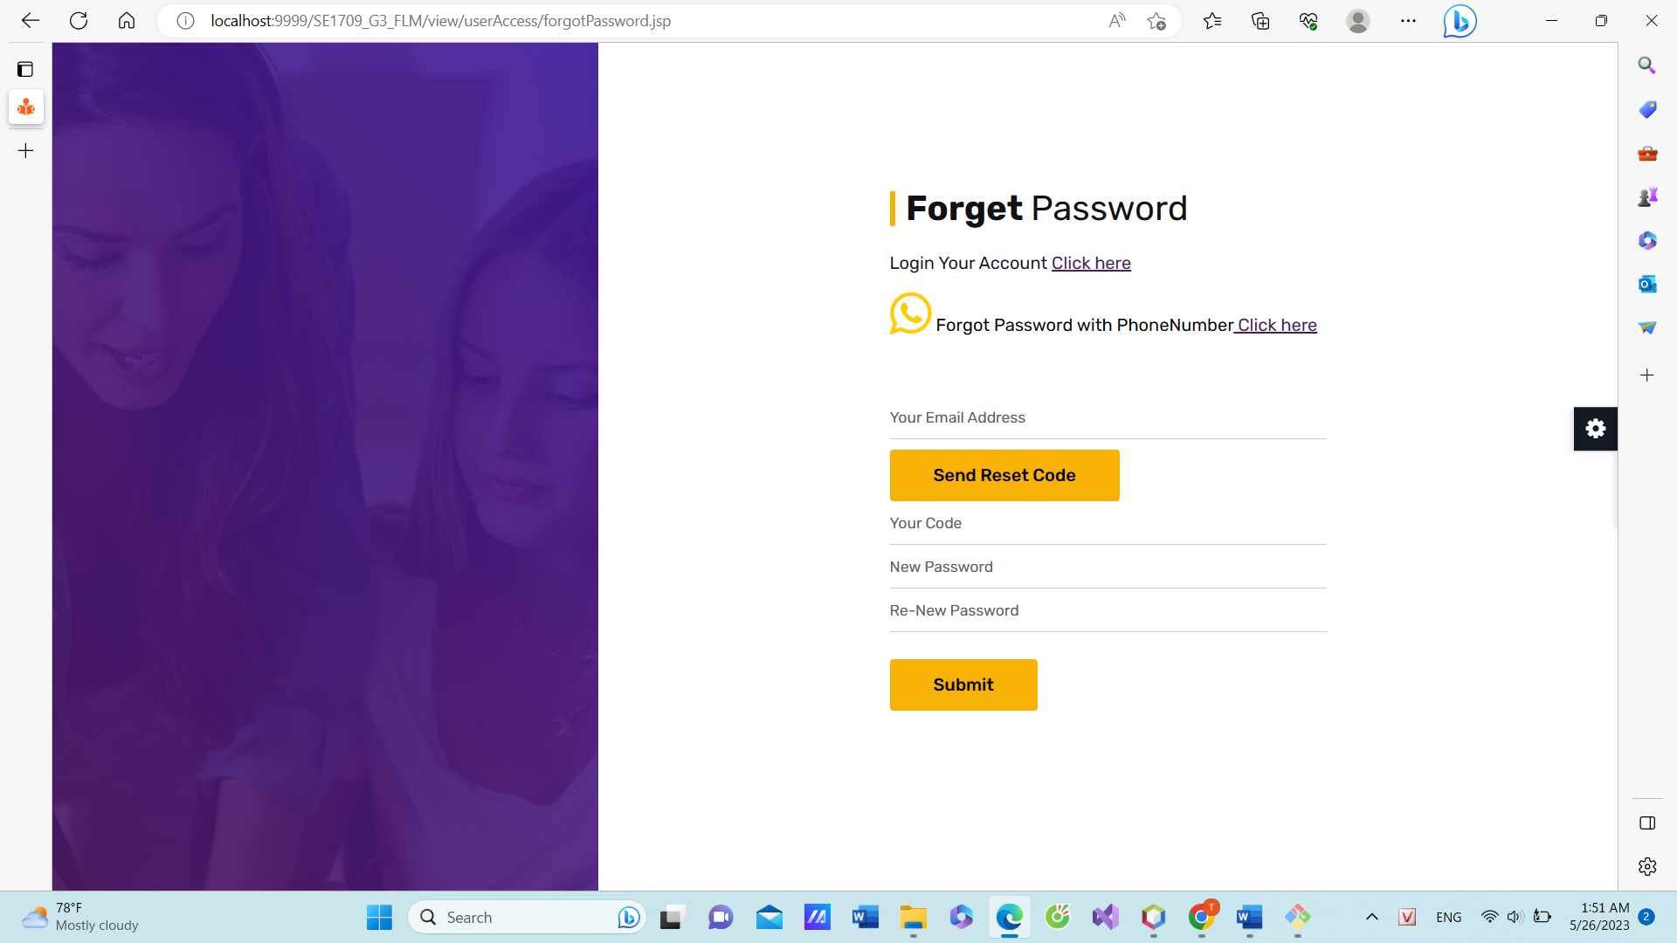

**Function Details:**

Data Validation: The forgot password function validates the user's input in the following ways:

The phone/email field should not be empty.

The phone/email entered should be in a valid format and associated with a registered account.

Additional validation may include checking if the phone/email exists in the system's user database.

Business Logic:

Normal Case:

The forgot password function sends a password reset link/token to the user's registered phone or email address.

The email contains instructions and a unique link/token that expires after a certain period or upon successful password reset.

The user clicks the link or token and is directed to a password reset page.

The user verifies their identity, typically through a security question, phone verification, or email verification.

The user enters a new password and submits it.

The system updates the user's account with the new password, allowing them to log in using the new credentials.

Abnormal Cases:

Invalid phone/Email: If the entered phone/email is not associated with any registered account, the forgot password function displays an error message indicating that no account exists.

Expired or Invalid Reset Link/Token: If the reset link/token is expired or invalid, the user is notified with an error message and prompted to initiate the password reset process again.

New Password and Re-New Password are not the same , the user is notified with an error message and prompted to initiate the password reset process again.

### e. User Profile

Function Trigger:

The View Profile function is typically triggered when a user wants to access and view their own profile information. It can be triggered through a navigation path such as clicking on a "Profile" or "My Account" link/button within the user interface. This function can also be accessed at any time, as per the user's requirement.

Function Description:

Actors/Roles: User, System

Purpose: The purpose of the View Profile function is to allow users to access and view their profile information, including personal details, preferences, settings, and any other relevant information associated with their account.

Interface: The interface for the View Profile function is designed to present the user's profile information in a clear and organized manner. It may include sections or tabs for different categories of information such as personal details, contact information, account settings, privacy settings, and other relevant sections based on the platform or application.

Data Processing: The function retrieves the user's profile information from the backend database or user management system and presents it to the user in a readable format through the user interface. The function does not involve any data processing or modifications, as its primary purpose is to display existing profile information.

Screen Layout:

The screen layout for the View Profile function may include sections for different categories of information, as shown in the mockup below:

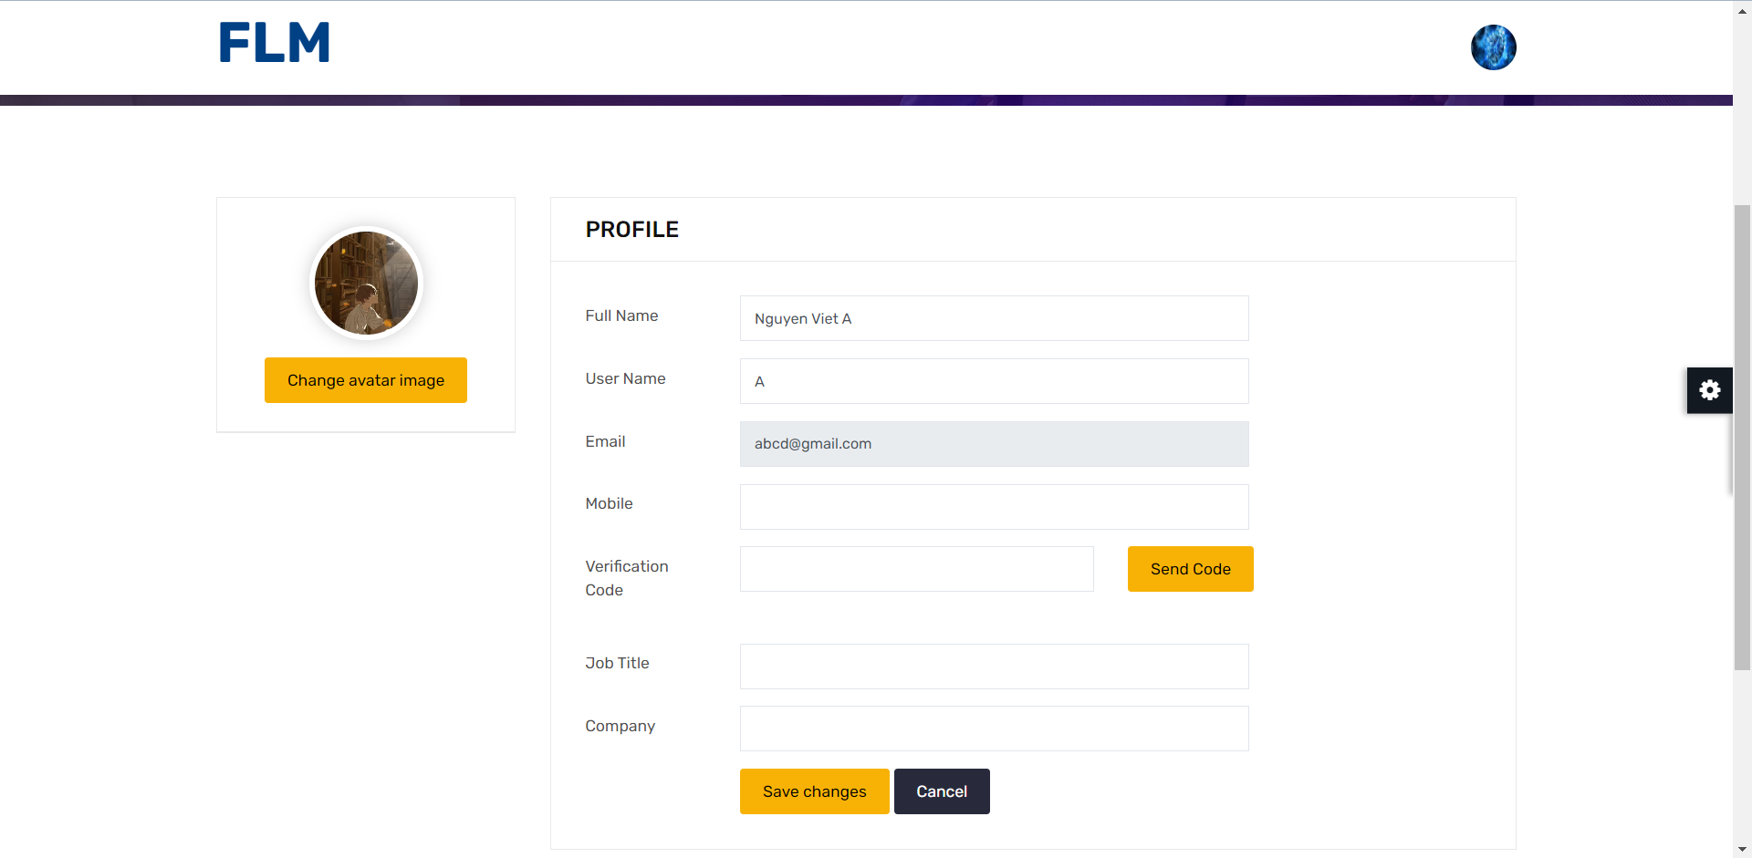

Function Details:

Data: The function retrieves and displays the user's profile information, which may include fields such as name, age, address, email, phone number, preferences, account settings, and privacy settings.

Validation: The function ensures that the retrieved profile information is valid and up-to-date. It may perform basic checks, such as verifying that required fields are populated and validating the format of email and phone number if applicable.

Business Logic: The function does not involve complex business logic. Its main purpose is to retrieve and display the user's profile information accurately and securely.

Functionalities:

Normal Cases: When the function is triggered, it retrieves the user's profile information from the backend system and displays it on the screen in a user-friendly format.

Abnormal Cases: In case of any errors or issues during data retrieval, the function may display an error message to the user, indicating the problem and suggesting appropriate actions (e.g., contacting customer support).

### f. Password Change

Function Trigger:

The Change Password function is typically triggered when a user wants to update their current password for security reasons or as per the platform's password expiration policy. It can be triggered through a navigation path such as clicking on a "Change Password" link/button within the user interface. This function is not triggered automatically but can be accessed by the user as needed.

Function Description:

Actors/Roles: User, System

Purpose: The purpose of the Change Password function is to allow users to update their existing password to ensure account security and confidentiality.

Interface: The interface for the Change Password function typically includes input fields for the current password, new password, and confirm new password. It may also include additional elements such as strength indicators, password requirements, and error/success messages to provide a user-friendly experience.

Data Processing: The function processes the entered password information to validate its correctness and securely update the user's password in the backend system. It may involve encryption or hashing techniques to ensure the security of the password during transmission and storage.

Screen Layout:

The screen layout for the Change Password function may resemble the mockup below:

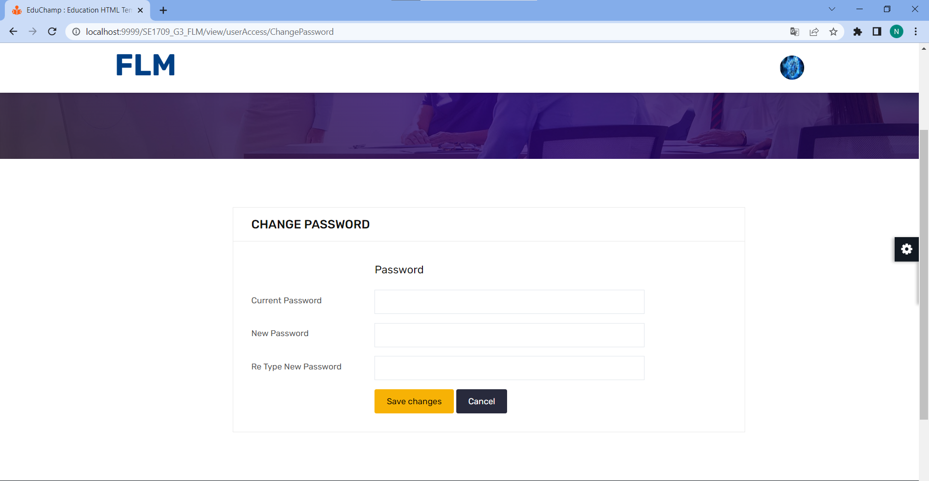

Function Details:

Data: The function requires the user to input the current password, new password, and confirm the new password. This data is used to validate and update the password in the backend system.

Validation: The function performs several validations to ensure the correctness and security of the password change process. It may include checks such as verifying that the current password matches the user's existing password, validating the strength and complexity of the new password, and ensuring that the new password matches the confirmed password.

Business Logic: The function incorporates business logic to enforce password policies and security measures. This may include requirements such as a minimum password length, the inclusion of special characters or numbers, and restrictions on previously used passwords.

Functionalities:

Normal Cases: When the function is triggered, it prompts the user to enter their current password, new password, and confirm the new password. It then validates the entered information, checks for compliance with password policies, and updates the user's password in the backend system if all requirements are met. It displays a success message indicating that the password has been changed.

Abnormal Cases: In case of any errors or issues during the password change process (e.g., incorrect current password, weak new password), the function displays appropriate error messages to the user, indicating the problem and suggesting corrective actions. It ensures that the user is informed about the specific issue encountered and provides guidance on how to rectify it.

## 2. System Admin

### a. Account List

* View list Account
* Function Trigger:

The Account List View function is usually activated when the administrator wants to access and view the list of registered accounts. It can be activated via a navigation link, such as clicking the "Account List" button/link in the Admin interface.

* Function Description:
* Actor / Role: Administrator, System

- Purpose: The purpose of the View account list function is to allow admins to access and view a user's account information, including personal details, preferences, and settings about the account's role.

- Interface: The interface for the account list function is designed to present the user's Account information in a clear and organised manner. It may include sections or tabs for different categories of information, ID , Full name, Email, Mobile and other relevant sections based on platform or application.

- Data processing: The function that retrieves a user's Account from a backend database or user management system and presents that information to the administrator in a readable format through the list account interface. This function does not involve any data processing or modification, as its main purpose is to display existing account information.

Screen layout:

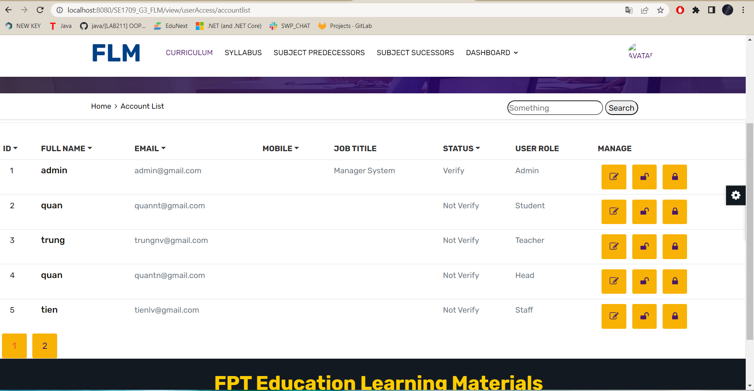

Function details:

Data: The function to retrieve and display the user's account information, which may include fields such as ID , full name , email, mobile, job title, view detail account , delete

Authentication: The function that ensures that the Account information retrieved is valid and up to date. It can perform basic checks, such as verifying that required fields are filled in, and validating the format of the email and phone number if applicable.

Business Logic: Functionality does not involve complex business logic. Its main purpose is to retrieve and display user account information accurately and securely.

function:

Normal case: When the function is activated, it retrieves the user's account information from the backend and displays it on the screen in an admin friendly format

Abnormal case: In case of any error or problem during data retrieval, this function can show an error message to admin, indicating the problem

### b. Account Detail

* View Account Detail
* Function Trigger:

The account detail function is activated when the user wants to access and view the user's account details. It can be activated via a navigation link on the account list page, such as clicking the "Detail" icon. This function can only be accessed from the account list page at the request of the admin.

Function Description:

Actor / Role: Administrator, System

Purpose: The purpose of the function to view the details of the account can update the role for the account

Interface: The interface of the Account detail function usually includes fields Full name, user name, email, mobile, user role, job title, company. It may also include an edit role account link

Data processing: The view account detail function allows the administrator to view the details of the account and can change the account role when the account has verified all the information.

Screen layout:

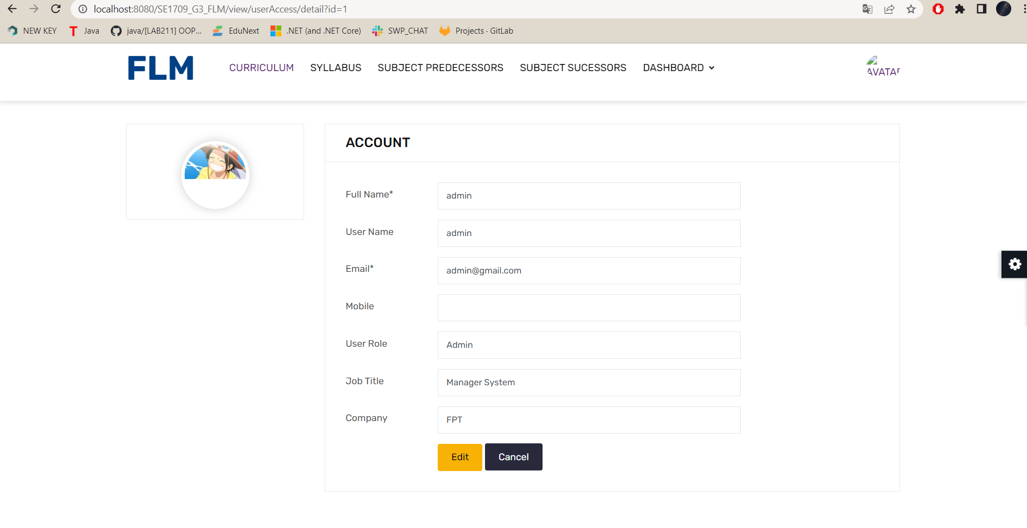

Function details:

Data: Function to retrieve and display user account information, which may include fields Full name, user name, email, mobile, user role, job title, company, and user role settings.

Authentication: A function that ensures that the account information retrieved is valid and up to date

Business Logic: Functionality does not involve complex business logic. Its main purpose is to retrieve and display user account information accurately and securely and can grant user roles.

function:

Normal case: When the function is activated, it retrieves the user's account details from the backend and displays it on the screen in a user-friendly format.

Abnormal case: In case of any error or problem during data retrieval, this function can display an error message to the admin, indicating the problem and recommending appropriate action (eg. e.g. contact customer support).

### 

### c. Setting List

**-** Function trigger: Admin wants to view all roles in the system.

- Function description:

Actors/Roles:Admin

Purpose:allow admin to see the entire list of roles in the system

Interface: The interface of the function includes the fields id , name , type , value , display order . It also has search for roles by name and by type

Data Processing: Data processing: Get the entire list of roles in the system displayed on the screen when running. Get the name or type from the user and then find the corresponding role and show it to the user

- Function detail:

Data: get data from table setting at database

Validation: Quickly and accurately display roles

Functionalities:

Normal Cases:

When the function is activated it will display a list of roles available in the system

Interface: The interface of the function includes the fields id , name , type , value , display order .

Abnormal Cases:

when the activation function on the "Setting List" page is not displayed or the roles are missing in the system

- Screen layout :

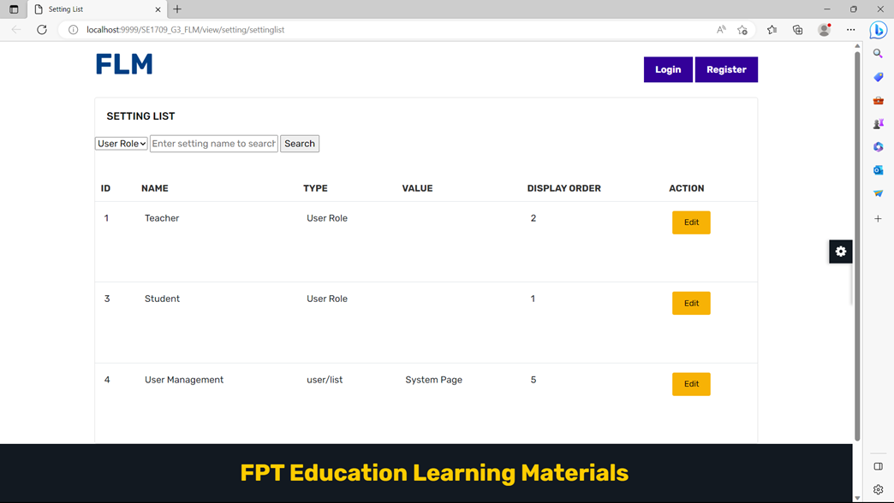

### 

### d. Setting Detail

* Update Role

- Function trigger: Admin Nurse wants to edit a role in the system.  
 - Function description:

Actors/Roles:Admin

Purpose:allow admin to update the entire list of roles in the system

Interface: it has a submit button for the system to update information and the user has just changed, a reset button to return to the original before editing

Data Processing: When the function activates, the role information that needs to be changed will be retrieved from the database

- Function detail:

Normal Cases:

When the function is activated, the role information will be displayed, when the user presses the "Submit" button, the system will update the information and return to the "Setting List" page.

Abnormal Cases:

when the activation function does not display information about the role that needs to be changed or displayed, but when pressing the "Submit" button, the system does not update new information.

- Screen layout :

- Screen layout :

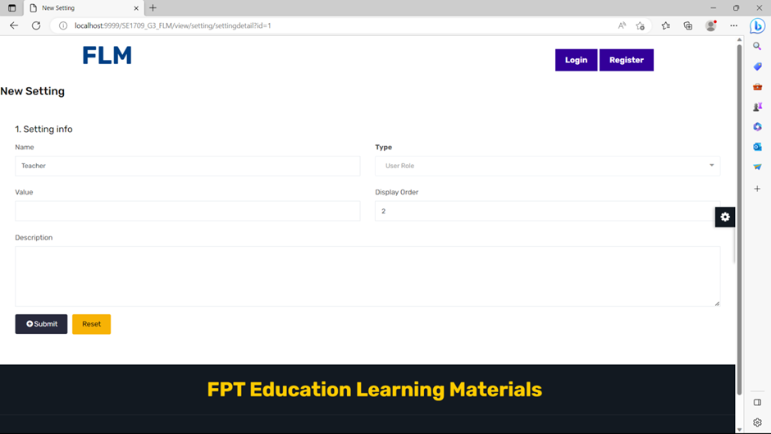

## **3.Curriculum** management

### a.Curriculum List

Function Trigger:

The Curriculum List function is typically triggered when a user navigates to the "Curriculum" section of the application or when they search for a specific course or program. It can also be accessed through a direct link or from a user's dashboard.

Function Description:

Actors/Roles:

Students: Users who are enrolled in courses or programs and want to explore the available curriculum.

Instructors: Users who create and manage the curriculum content.

Purpose:

The purpose of the Curriculum List function is to provide students and instructors with an overview of all the available courses or programs and their associated curricula. It allows users to browse through different curriculum offerings and access detailed information about each one.

Interface:

The Curriculum List function is typically presented through a screen interface. Users can view a list of courses or programs, along with relevant details such as the course/program title, description, duration, and any other pertinent information. The interface may also include filters or sorting options to help users refine their search.

Data Processing:

The function retrieves curriculum data from a database or a content management system. The data includes information about each course or program, such as its title, description, duration, prerequisites, and other relevant details. The function processes this data and presents it in a structured and user-friendly format for users to browse.

*Screen layout:*

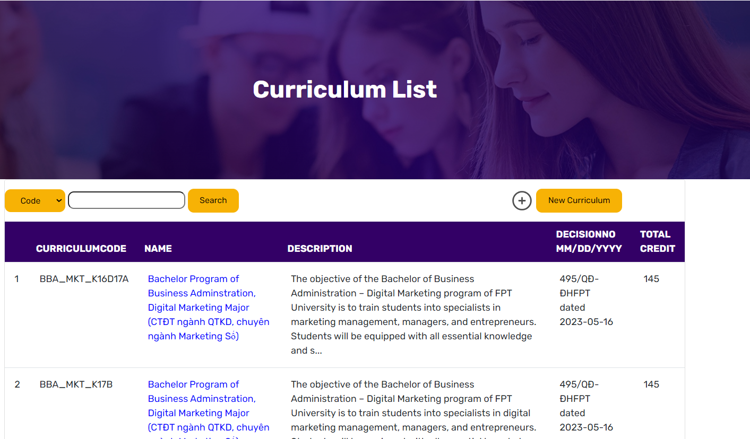

*Function Details:*

*Data: The Curriculum List function retrieves and displays the following information for each course or program:*

*Course/Program Title: The name or title of the course or program.*

*Description: A brief description or overview of the course or program.*

*Duration: The estimated duration or timeline for completing the course or program.*

*Other Details: Additional relevant information, such as prerequisites, certifications, or special requirements.*

*Validation: The function validates the user's access privileges to ensure that only authorized users can view the curriculum list. It may also perform data validation to ensure the integrity and correctness of the displayed information.*

*Business Logic: The function handles various business logics, such as:*

*Role-based Access: The function restricts access to the curriculum list based on user roles. For example, only registered students or authorized instructors can view the curriculum offerings.*

*Enrollment Status: The function may display an indicator or status for each course or program to indicate whether the user is already enrolled or if enrollment is open.*

*Dynamic Updates: If new courses or programs are added or existing ones are modified, the function should handle the synchronization and display the latest information to users.*

*Functionalities:*

*Course/Program Exploration: Users can browse through the list of available courses or programs to discover new curriculum offerings.*

*Sorting and Filtering: The function may provide sorting options (e.g., alphabetical, popularity) and filtering options (e.g., by category, duration, level) to help users narrow down their search and find relevant curriculum options.*

*Detailed View: Users can select a specific course or program from the list to access more detailed information about its curriculum, learning objectives, and associated resources.*

*Enrollment: If enrollment is open for a course or program, the function may provide a button or link for users to initiate the enrollment process.*

*Abnormal Cases:*

*Limited Access: If a user does not have the necessary privileges or authorization, the function should display an appropriate error message or prompt the user to log in or request access.*

*Empty Curriculum List: If no courses or programs are available, the function should display a message indicating that there are currently no curriculum offerings to show.*

### b.View Curriculum

Function Trigger:

The View Curriculum function can be triggered by navigating to the "Curriculum" section of the application. It can also be accessed through a direct search or by clicking on a specific course or program.

Function Description:

Actors/Roles:

Students: Users who are enrolled in a course or program and want to access the curriculum.

Instructors: Users who create and manage the curriculum content.

Purpose:

The purpose of the View Curriculum function is to provide students and instructors with a comprehensive view of the curriculum for a specific course or program. It allows users to access the learning materials, assignments, assessments, and other related content.

Interface:

The View Curriculum function is typically accessed through a screen interface. Users can navigate through different sections of the curriculum using tabs, side menus, or a hierarchical structure. The interface provides a clear and organized presentation of the curriculum content, making it easy for users to find the information they need.

Data Processing:

The function retrieves curriculum data from a database or a content management system. The data includes the course or program structure, learning objectives, lesson plans, resources, assessments, and any other relevant information. The function processes this data and presents it to the user in a structured and user-friendly format.

Screen Layout (Mockup Prototype):



Function Details:

Data: The View Curriculum function retrieves and displays the following information:

Course/Program Information: This section provides an overview of the course or program, including its title, description, duration, prerequisites, and any other relevant details.

Curriculum Tree: The hierarchical structure of the curriculum is presented in this section. It shows the different modules, units, lessons, and topics included in the course or program. Users can expand and collapse the tree to navigate through the curriculum.

Lesson Information and Resources: When a specific lesson or topic is selected from the curriculum tree, this section displays detailed information about the selected item. It may include the lesson objectives, content, multimedia resources, readings, and additional references.

Assignments: If there are any assignments associated with the curriculum, they are listed in this section. Users can view the assignment details, due dates, submission guidelines, and their own progress or grades.

Validation: The View Curriculum function validates the user's access privileges to ensure that only enrolled students and authorized instructors can view the curriculum for a particular course or program. Additionally, the function checks for data integrity, ensuring that the curriculum information is correctly linked and displayed.

Business Logic: The function handles various business logics, such as:

Tracking User Progress: The function may keep track of a student's progress within the curriculum, indicating which lessons have been completed or marking milestones achieved.

Dynamic Content Updates: If the curriculum content undergoes updates or revisions, the function should handle the synchronization and display the latest information to users.

Access Control: The function enforces role-based access control, allowing only authorized users (students and instructors) to view specific curriculum content.

Functionalities:

Navigation and Browsing: Users can navigate through the curriculum by expanding and collapsing the curriculum tree, selecting different modules, units, lessons, or topics.

Searching and Filtering: The function may provide search functionality to help users quickly find specific lessons, topics, or keywords within the curriculum.

### c.Add Curriculum

Function Trigger:

The Add Curriculum function is typically triggered by an authorized user with the role of an instructor or administrator. It can be accessed through a navigation path specific to the user's role, such as an "Admin Panel" or "Instructor Dashboard." The function is typically used when creating a new course or program and designing its curriculum.

Function Description:

Actors/Roles:

Instructors: Users with the role of instructors or administrators who have the authority to create and manage curriculum content.

Purpose:

The purpose of the Add Curriculum function is to enable instructors to create and define the curriculum for a new course or program. It allows them to structure the learning content, set objectives, organize lessons, and associate resources and assessments.

Interface:

The Add Curriculum function is usually presented through a screen interface. The interface provides a form or a series of input fields where instructors can enter the necessary details and configure the curriculum structure. The form may include fields for curriculum title, description, objectives, lessons, resources, assessments, and other relevant information.

Data Processing:

The function processes the data entered by instructors and stores it in a database or a content management system. The data includes curriculum information such as title, description, objectives, lesson details, resource links, assessment criteria, and any other pertinent information. The function ensures the integrity and consistency of the entered data before saving it.

Screen Layout (Mockup Prototype):

Function Details:

Data: The Add Curriculum function allows instructors to enter and configure the following data:

Curriculum Information: Instructors can provide the title, description, duration, prerequisites, and other relevant details of the curriculum.

Objectives: Instructors can set the learning objectives and goals of the curriculum, outlining what students should achieve upon completion.

Lessons: Instructors can define and organize individual lessons or topics within the curriculum. They can specify the lesson titles, descriptions, content, multimedia resources, and any additional materials.

Resources: Instructors can associate various resources, such as readings, videos, external links, or documents, with specific lessons or topics to provide additional learning materials.

Assessments: Instructors can define assessments or evaluations associated with the curriculum. This may include quizzes, exams, projects, or assignments, along with the respective instructions, criteria, and due dates.

Validation: The Add Curriculum function performs validation checks to ensure the entered data is complete and valid. It may verify that all required fields are filled, check for data consistency and correctness, and enforce any specific constraints or rules defined for curriculum creation.

Business Logic: The function incorporates various business logics, such as:

Authorization: The function restricts access to authorized instructors or administrators to prevent unauthorized users from creating or modifying the curriculum.

Curriculum Structure: The function enforces rules for curriculum structure, such as ensuring the presence of at least one lesson, setting minimum or maximum limits on objectives or assessments, or enforcing a hierarchical organization of lessons.

Workflow and Collaboration: The function may include workflow features, such as allowing multiple instructors to collaborate on curriculum creation, review and approval processes, or version control of curriculum revisions.

Functionalities:

Form Input: Instructors can enter the curriculum details, including the title, description, objectives, lessons, resources, and assessments, using the provided input fields in the interface.

Curriculum Configuration: Instructors can organize the curriculum by defining the order and hierarchy of lessons, associating resources and assessments with specific lessons, and setting any prerequisites or dependencies between lessons.

Save or Submit: The function provides options for instructors to save the curriculum configuration as a draft for later modifications or submit it for final creation and availability to students.

Abnormal Cases:

Insufficient Privileges: If a user without the appropriate instructor or administrator role attempts to access the Add Curriculum function, the function should display an error message or restrict access.

Incomplete Data: If any required fields are left empty or necessary data is missing, the function should display validation errors and prompt the user to fill in the required information.

Data Conflict: If there are conflicts or inconsistencies in the entered curriculum data, such as duplicate lesson titles or conflicting prerequisites, the function should detect and notify the user to resolve these conflicts.

### d. Edit Curriculum

Function Trigger:

To edit the curriculum on a school website, you will typically need access to the website's content management system (FLM) or a similar editing platform. Here are the steps you can follow to edit the curriculum on a school website

Function Description:

* Actors/Roles: User, System
* The purpose of the "Edit Curriculum" function is to improve the quality, relevance, and effectiveness of an educational curriculum. By making modifications and updates to the curriculum, the aim is to enhance the learning experiences and outcomes of students.
* The interface for the "Edit Curriculum" function can vary depending on the specific platform or software used for curriculum management. However, here are some common elements and features you might find in the interface:Dashboard,Course/Unit Editing.
* Data processing refers to the manipulation, organization, and analysis of raw data to generate meaningful information. In the context of the "Edit Curriculum" function, data processing may involve various tasks to manage and analyze curriculum-related data.

Screen Layout:

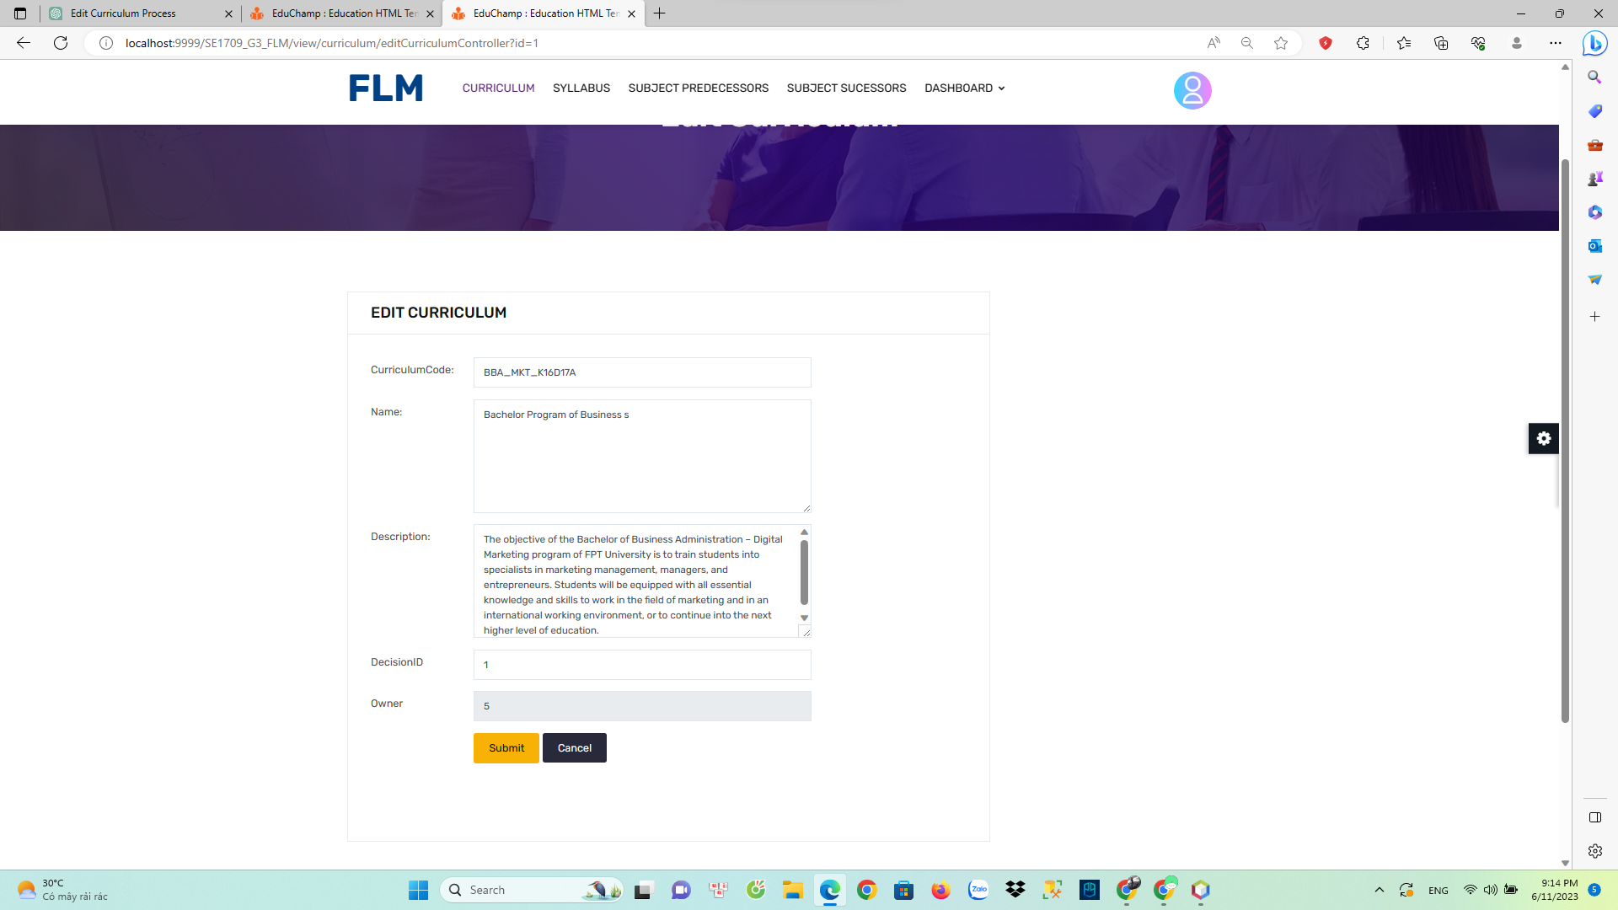

Function Details:

* Description: The "Edit Curriculum" function allows authorized users to modify and update the content, structure, and resources of an educational curriculum. It provides a platform or interface where users can make changes to various elements of the curriculum, such as learning objectives, lesson plans, assessments, resources, and other relevant information. The function aims to improve the quality, relevance, and effectiveness of the curriculum by incorporating feedback, aligning with educational standards, and adapting to changing needs and contexts.
* Input: User credentials: Users need to log in with their authorized credentials to access the curriculum editing platform. Existing curriculum data: The function requires access to the current curriculum data that needs to be edited. This data includes information about courses, units, learning objectives, assessments, and resources.
* Output: Updated curriculum data: After making the desired modifications, the function generates and stores the updated curriculum data reflecting the changes made by the user

Note: The specific details and implementation of the "Edit Curriculum" function may vary depending on the curriculum management system or software used.

Functionalities:

* Edit Course Details: Users can modify the details of individual courses within the curriculum, including course titles, descriptions, objectives, and prerequisites.
* Manage Units and Lessons: Users can add, edit, or delete units and lessons within each course. They can organize the curriculum content into logical sequences and adjust the ordering of units and lessons.
* Modify Learning Objectives: Users can update the learning objectives associated with each course, unit, or lesson to align with educational standards or specific learning outcomes.

## 4. Subject Management

### a. Subject List

Function Trigger:

The Subject List function is typically triggered when a user wants to access a list of subjects or topics available within a system or platform. It can be triggered through a navigation path, such as clicking on a "Subjects" or "Topics" link/button within the user interface. This function can be accessed whenever the user wants to explore or interact with the available subjects.

Function Description:

Actors/Roles: User, System

Purpose: The purpose of the Subject List function is to provide users with a comprehensive list of subjects or topics available within a system or platform. It allows users to browse, search, or select specific subjects of interest for further actions or interactions.

Interface: The interface for the Subject List function typically presents a list or grid view of subjects or topics, along with relevant information or metadata associated with each subject. It may include features such as search functionality, filtering options, pagination, and sorting to enhance user navigation and exploration.

Data Processing: The function retrieves the list of subjects from a backend database or content management system and presents it to the user through the user interface. It may involve data processing operations such as querying the database, sorting the subjects based on certain criteria, and formatting the data for display.

Screen Layout:

The screen layout for the Subject List function may resemble the mockup below:

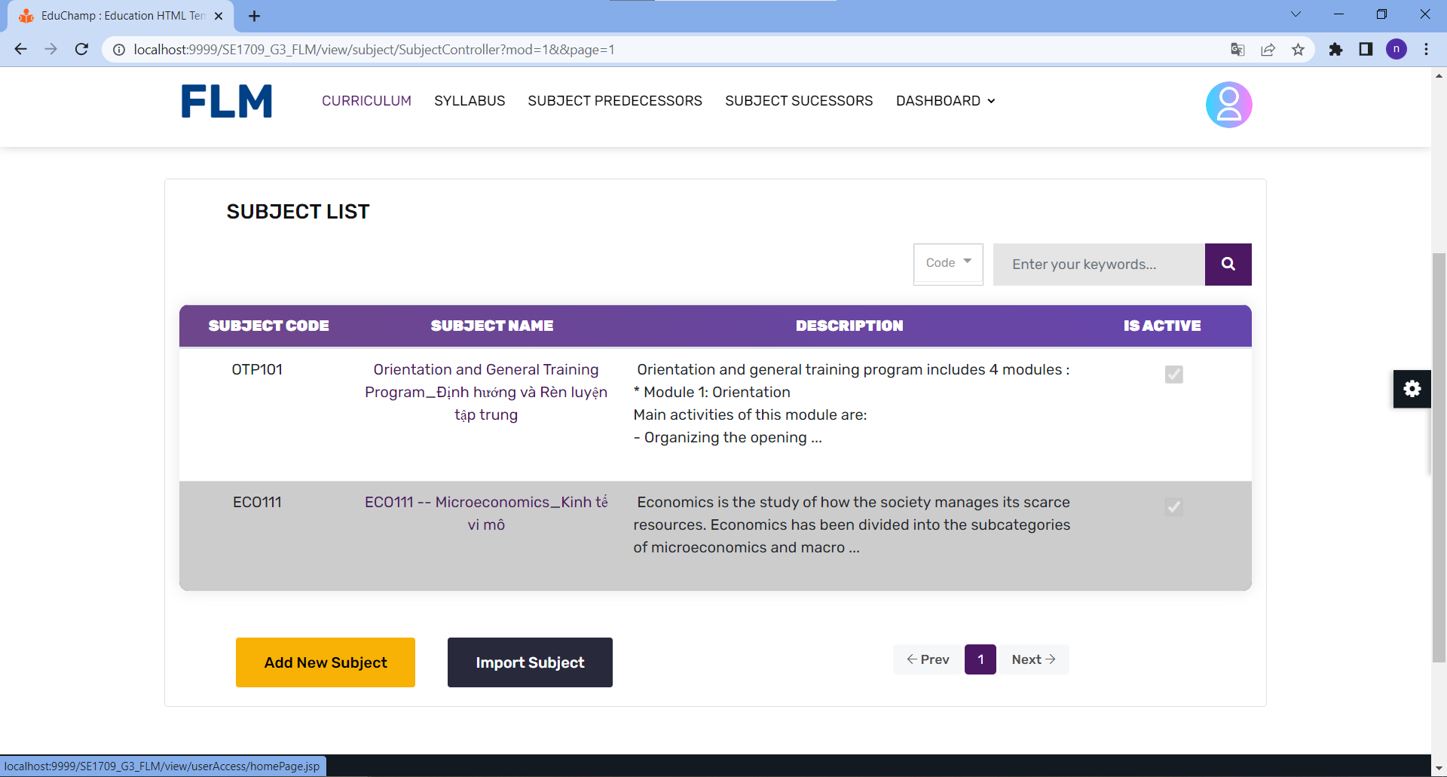

Function Details:

- Data: The function retrieves and displays a list of subjects or topics available within the system or platform. Each subject may have associated metadata such as a name, description, category, date created, or any other relevant information.

- Validation: The function does not involve specific data validation, as it primarily focuses on presenting the subject list retrieved from the backend. However, it may include checks for empty or incomplete data to ensure the list is properly populated.

- Business Logic: The function may incorporate business logic to determine the order or sorting of the subjects, apply filters based on user preferences or permissions, and manage pagination for large subject lists.

- Functionalities:

- Normal Cases: When the function is triggered, it retrieves the list of subjects from the backend system and displays them in the user interface. Users can browse, search, or interact with the subjects, such as selecting a subject for further actions or accessing detailed information related to it.

- Abnormal Cases: In case of any errors or issues during data retrieval, the function may display an error message to the user, indicating the problem and suggesting appropriate actions (e.g., retrying the operation, contacting customer support).

Overall, the Subject List function provides users with an organized and easily navigable view of the available subjects or topics within a system or platform. It allows users to explore and interact with the subjects based on their interests or requirements, enabling efficient access to relevant information or functionalities associated with each subject.

### b. New Subject

Function Trigger:

The Add New Subject function is typically triggered when a user wants to add a new subject or topic to a system or platform. It can be triggered through a navigation path, such as clicking on an "Add Subject" or "New Topic" button within the user interface. This function is typically accessed when a user wants to contribute or create a new subject within the system.

Function Description:

Actors/Roles: User, System

Purpose: The purpose of the Add New Subject function is to allow users to contribute and add new subjects or topics to the system or platform. It enables users to expand the available subject catalog and provide valuable content to other users.

Interface: The interface for the Add New Subject function typically includes input fields or forms to gather relevant information about the new subject. It may include fields such as subject name, description, category, tags, and other details depending on the requirements of the system or platform. The interface may also include buttons for submitting or canceling the subject creation process.

Data Processing: The function processes the entered subject information, validates it, and stores the new subject in the backend database or content management system. It may involve data processing operations such as data validation, formatting, and database insertion.

Screen Layout:

The screen layout for the Add New Subject function may resemble the mockup below:

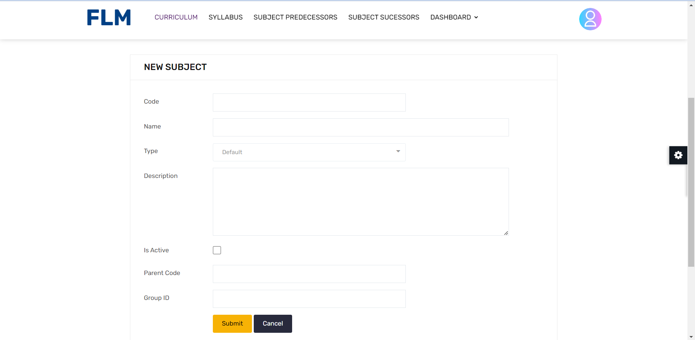

Function Details:

- Data: The function collects data related to the new subject, including the subject name, description, category, tags, or any other relevant information. This data is used to create a new subject within the system or platform.

- Validation: The function performs validation checks on the entered subject information to ensure its correctness and completeness. It may include checks for required fields, data format, character limits, and uniqueness of subject names or tags.

- Business Logic: The function may incorporate business logic to enforce specific rules or restrictions on subject creation. This can include checks for duplicate subjects, authorization or permission requirements, or adherence to specific guidelines or policies.

- Functionalities:

- Normal Cases: When the function is triggered, it presents the user with input fields to enter the subject details. The user fills in the required information and submits the form. The function then validates the entered data, creates a new subject record in the backend system, and displays a success message indicating that the subject has been added.

- Abnormal Cases: In case of any errors or issues during data validation or subject creation, the function may display appropriate error messages to the user, indicating the problem and suggesting corrective actions. It ensures that the user is informed about the specific issue encountered and provides guidance on how to rectify it.

Overall, the Add New Subject function empowers users to contribute and expand the subject catalog within a system or platform. It provides a user-friendly interface to gather subject details and ensures the validation and secure storage of the new subject information. This functionality encourages user engagement and collaboration, allowing the platform to evolve with a broader range of subjects contributed by its users.

### c. Subject Import

Function Trigger:

The Import Subject from Excel File function is typically triggered when a user wants to import a batch of subjects or topics from an Excel file into a system or platform. It can be triggered through a navigation path, such as clicking on an "Import Subjects" or "Upload Excel" button within the user interface. This function is typically accessed when a user wants to bulk import subjects rather than manually entering them one by one.

Function Description:

Actors/Roles: User, System

Purpose: The purpose of the Import Subject from Excel File function is to enable users to import multiple subjects or topics from an Excel file into the system or platform. It facilitates the efficient and streamlined addition of subjects in bulk.

Interface: The interface for the Import Subject from Excel File function typically includes a file upload input field or a drag-and-drop area where users can select or drop the Excel file containing the subject data. It may also include buttons for uploading, canceling, or clearing the selected file. Additionally, the interface may display information or messages about the import process, such as the number of subjects imported or any encountered errors.

Data Processing: The function processes the uploaded Excel file, extracts the subject data, validates it, and adds the subjects to the backend database or content management system. It may involve parsing the Excel file, data validation, mapping data fields, and database insertion.

Screen Layout:

The screen layout for the Import Subject from Excel File function may resemble the mockup below:

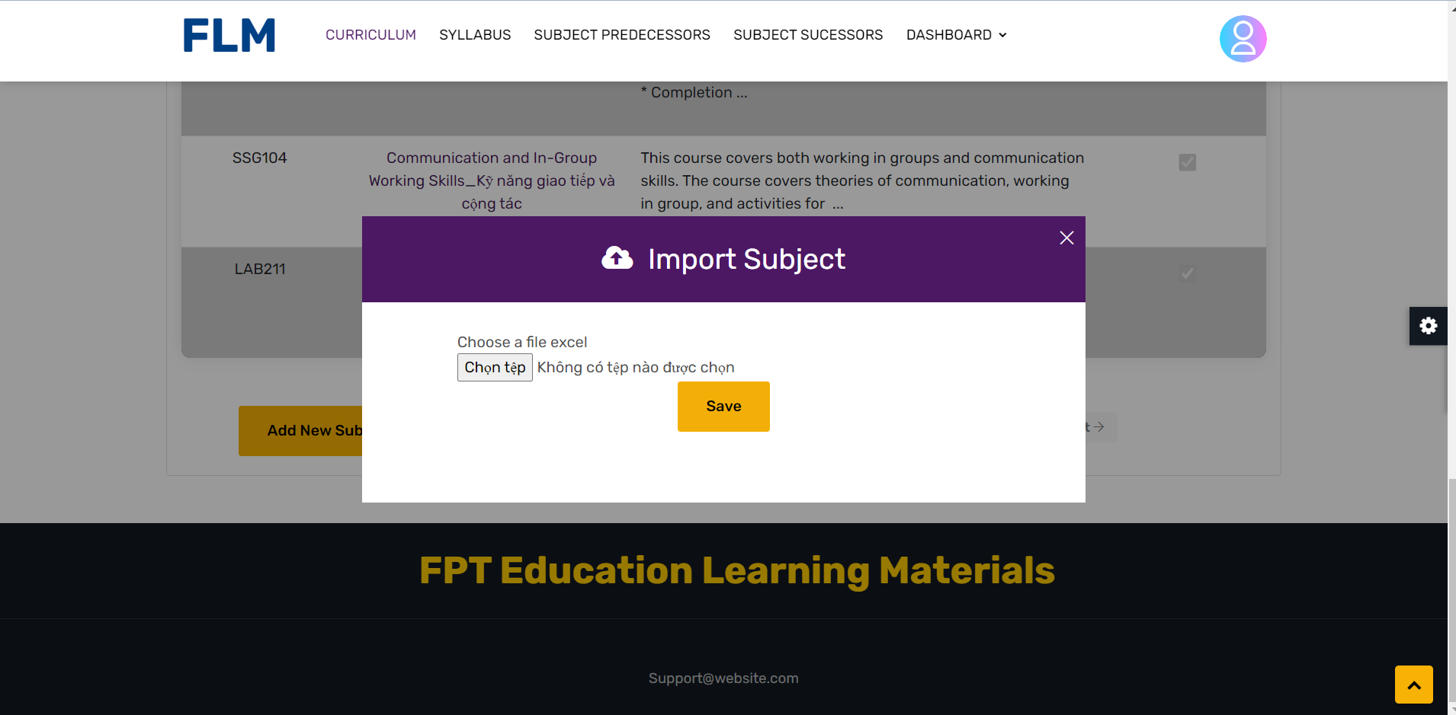

Function Details:

- Data: The function expects an Excel file containing subject data. The Excel file may include columns for subject name, description, category, tags, or any other relevant information. The function extracts and processes this data to create new subject records within the system or platform.

- Validation: The function performs validation checks on the imported subject data to ensure its correctness and completeness. It may include checks for required fields, data format, character limits, and uniqueness of subject names or tags. Additionally, it may verify the integrity and validity of the Excel file structure.

- Business Logic: The function may incorporate business logic to handle specific scenarios during the import process. This can include handling duplicate subjects, resolving conflicts, and applying any relevant business rules or restrictions.

- Functionalities:

- Normal Cases: When the function is triggered, the user selects or drops an Excel file containing subject data. The function then processes the Excel file, extracts the subject data, validates it, and creates new subject records in the backend system based on the extracted information. It displays a success message indicating the number of subjects imported and any additional information relevant to the import process.

- Abnormal Cases: In case of any errors or issues during the file upload, data extraction, or data validation, the function may display appropriate error messages to the user, indicating the problem and suggesting corrective actions. It ensures that the user is informed about the specific issue encountered and provides guidance on how to rectify it.

Overall, the Import Subject from Excel File function provides users with a convenient method to import a large number of subjects or topics from an Excel file. It streamlines the process of adding subjects in bulk, minimizing manual data entry and saving time. The function ensures the validation and secure storage of the imported subject data, allowing users to quickly integrate new subjects into the system or platform.

### d. Subject Detail

Function Trigger:

The View Subject Detail function is typically triggered when a user wants to view the detailed information of a specific subject or topic within a system or platform. It can be triggered through a navigation path, such as clicking on a subject from a subject list or search results. This function is accessed when a user wants to explore the specific details and content associated with a subject.

Function Description:

Actors/Roles: User, System

Purpose: The purpose of the View Subject Detail function is to provide users with comprehensive and detailed information about a specific subject or topic within the system or platform. It allows users to access and review the content, attributes, and related data associated with the subject.

Interface: The interface for the View Subject Detail function typically presents the subject's detailed information in a structured and organized manner. It may include sections or tabs to display various aspects of the subject, such as description, category, tags, related content, comments, or any other relevant information. The interface may also include buttons or links for performing actions related to the subject, such as editing, deleting, or interacting with the content.

Data Processing: The function retrieves the detailed information of the selected subject from the backend database or content management system and presents it to the user through the user interface. It may involve data processing operations such as querying the database, retrieving associated content, and formatting the data for display.

Screen Layout:

The screen layout for the View Subject Detail function may resemble the mockup below:

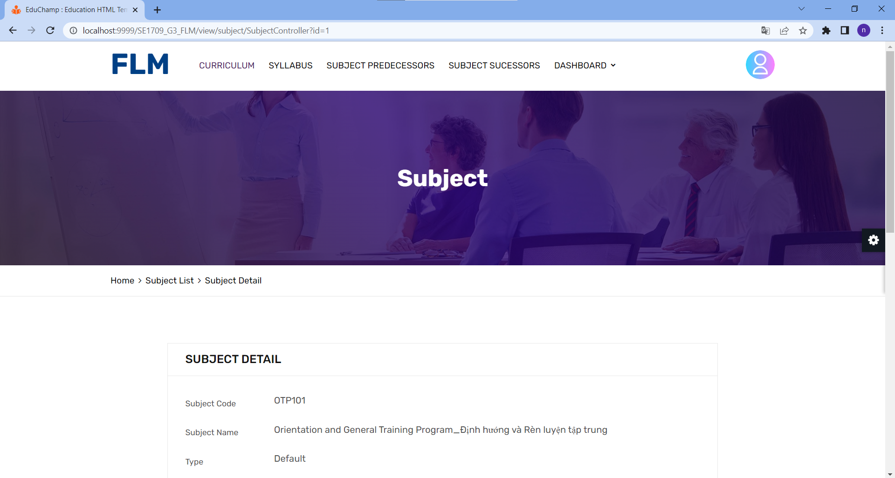

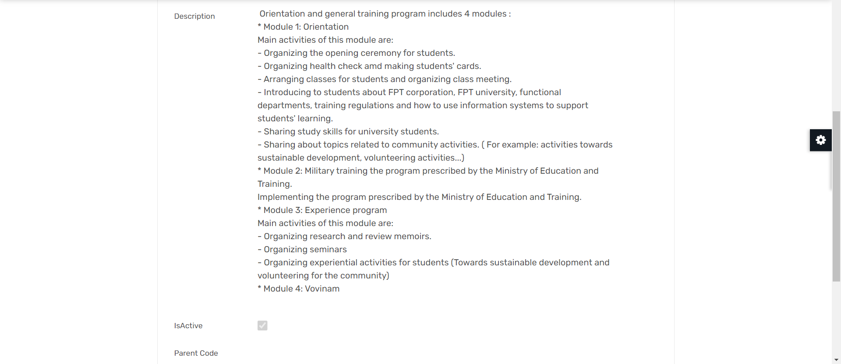

Function Details:

- Data: The function retrieves and displays detailed information about a specific subject or topic. This information may include the subject's name, description, category, tags, related content, comments, or any other relevant data associated with the subject.

- Validation: The function does not involve specific data validation, as it primarily focuses on presenting the subject details retrieved from the backend. However, it may include checks to ensure that the subject exists and is accessible to the user.

- Business Logic: The function may incorporate business logic to determine the permissions or access rights of the user to view the subject details. It may also include logic to fetch and present related content or comments associated with the subject.

- Functionalities:

- Normal Cases: When the function is triggered, it retrieves the detailed information of the selected subject and presents it in the user interface. Users can view the subject's attributes

, such as description, category, tags, related content, and comments. They can also perform actions such as editing or deleting the subject if they have the appropriate permissions.

- Abnormal Cases: In case the subject does not exist or the user does not have the necessary permissions to view the subject details, the function may display an appropriate error message indicating the issue and provide guidance on how to proceed. It ensures that the user is informed about the limitation and prevents unauthorized access to subject information.

Overall, the View Subject Detail function allows users to explore and review the comprehensive details and content associated with a specific subject or topic within the system or platform. It presents the subject information in an organized manner, facilitating easy navigation and access to relevant data. This functionality enhances user understanding and engagement with the subjects available in the system, enabling them to make informed decisions and interact with the subject's content effectively.

### e. Subject-PLO Mapping

Function Trigger:

* The function shows the relationship between plo and po.

Function Description:

The "Subject-PLO Mapping" function provides the user with information about the relationship between plo and subject . It provides a comprehensive overview of the subject's content,

Screen Layout:

Function details:

* The function"Subject-PLO Mapping" provides the relationship between Subject and plo.
* Make it easy for users to understand the relationship of Subjectand plo

### f. Subject Predecessors

Function Trigger:

The Subject Predecessors function is usually activated when the user wants to see a list of predecessor subjects. It can be activated via a navigation link, such as clicking a link in a toolbar or on the desktop. This function is accessed when the user wants to know the predecessor subjects

Function Description:

Actor/Role: User, System

Purpose: The purpose of the function to display the list of prepaid subjects in the program. It displays the list of subjects that have been replaced by new subjects

Interface: The interface to the Subject Predecessors function typically presents a list of topics in a structured and organised manner. It can include sections or tabs to show different aspects of the theme, such as description, categories, tags, and is active. The interface can also include a search bar to search for subjects by name or code.

Data processing: The function that takes details of the selected topic from the backend database or content management system and presents that information to the user through the user interface. It may involve data processing operations such as querying databases, retrieving related content, and formatting data for display.

Screen layout:

The screen layout for the Theme Details function can be similar to the model below:

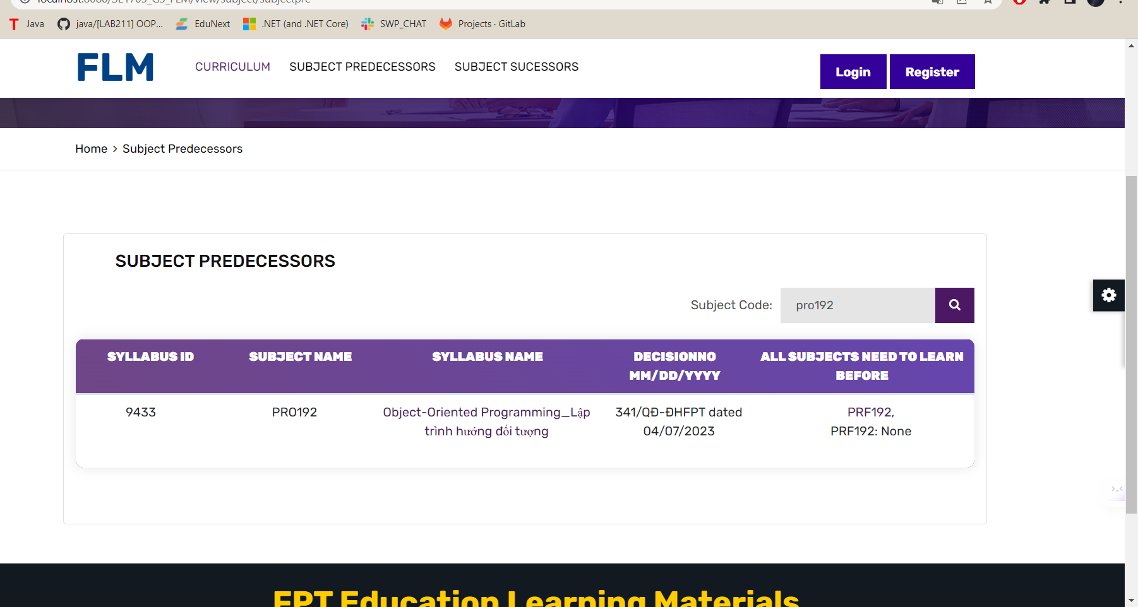

Function details:

- Data: Function to retrieve and display the list of Subject Predecessors . Each topic can have related metadata like name, description, category, other related information.

- Validation: This function is not related to data validation specifically, as it mainly focuses on presenting the topic list taken from the backend. However, it may include checking for empty or incomplete data to ensure the list is populated correctly.

Business logic: Functions can combine business logic to define ordering or sorting of topics, apply filters based on user preferences or permissions, and manage pagination for subject lists big topic.

- Function:

- Normal case: When the function is activated, it will take the list of predecessor subjects from the backend and display them in the user interface. Users can browse, search, or interact with topics, such as choosing a topic for further actions or accessing detailed information related to that topic.

- Abnormal cases: In case of any error or problem during data retrieval, the function can display an error message to the user, indicating the problem and recommending appropriate action (e.g. retry the operation, contact customer support).

Overall, the Subject Predecessors functionality provides users with an organised and easy-to-navigate view of the available topics or topics within a system or platform. It allows users to discover and interact with objects based on their interests or requirements, allowing efficient access to related information or functions associated with each object.

### g. Subject Successors

Function Trigger:

The Substitute Subject function is usually activated when the user wants to see a list of suffix subjects. It can be activated via a navigation link, such as clicking a link in a toolbar or on the desktop. This function is accessed when the user wants to know the predecessor objects

Function Description:

Actor/Role: User, System

Purpose: The purpose of the function to display the list of prepaid subjects in the program. It displays the list of subjects that have been replaced by new subjects

Interface: The interface of the Theme Predecessor function typically presents a list of topics in a structured and organized manner. It can include sections or tabs to show different aspects of the theme, such as description, categories, tags, and activity. The interface can also include a search bar to search for topics by name or code.

Data processing: The function that takes details of the selected topic from the backend database or content management system and presents that information to the user through the user interface. It may involve data processing operations such as querying databases, retrieving related content, and formatting data for display.

Screen layout:

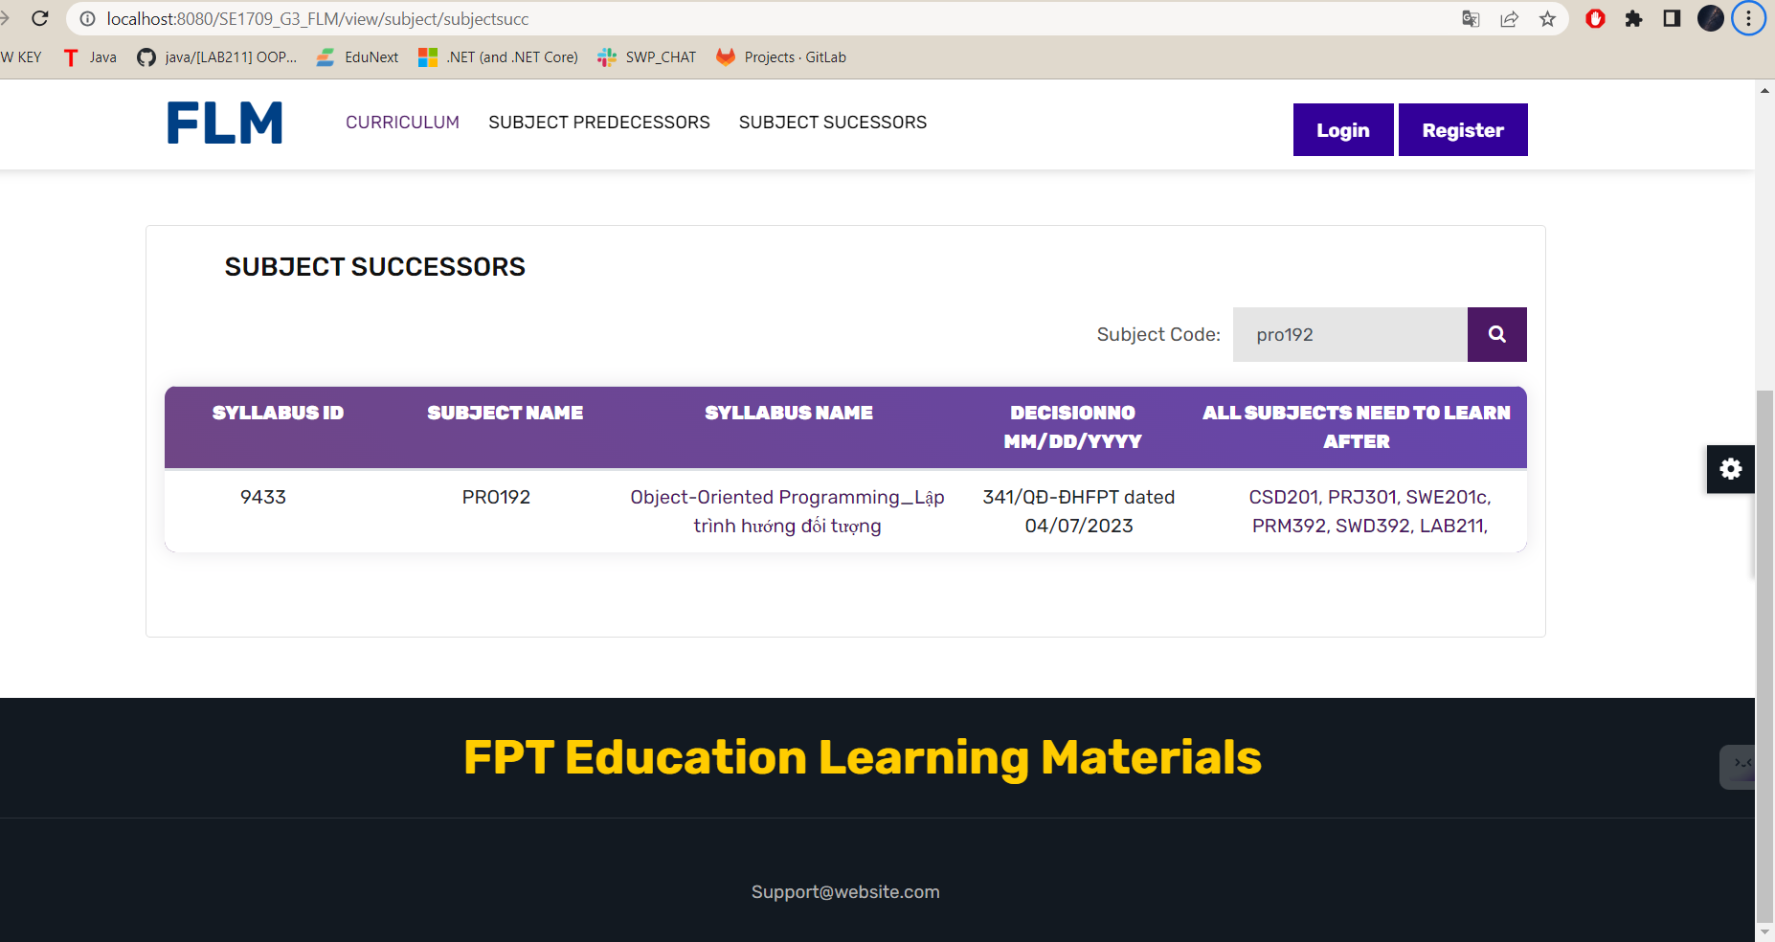

Function details:

- Data: Function to retrieve and display the list of Subject Predecessors . Each topic can have related metadata like name, description, category, other related information.

- Validation: This function is not related to data validation specifically, as it mainly focuses on presenting the topic list taken from the backend. However, it may include checking for empty or incomplete data to ensure the list is populated correctly.

Business logic: Functions can combine business logic to define ordering or sorting of topics, apply filters based on user preferences or permissions, and manage pagination for subject lists big topic.

- Function:

- Normal case: When the function is activated, it will take the list of predecessor subjects from the backend and display them in the user interface. Users can browse, search, or interact with topics, such as choosing a topic for further actions or accessing detailed information related to that topic.

- Abnormal cases: In case of any error or problem during data retrieval, the function can display an error message to the user, indicating the problem and recommending appropriate action (e.g. retry the operation, contact customer support).

Overall, the Subject Successors functionality provides users with an organised and easy-to-navigate view of the available topics or topics within a system or platform. It allows users to discover and interact with objects based on their interests or requirements, allowing efficient access to related information or functions associated with each object.

## 5. PLO Management

### a. PLO List

Function Trigger:

The PLO List function is activated when the user wants to see a list of PLOs.

Function Description:

Actor/Role: User, System

Purpose: The purpose of the PLO list display function in the program. It displays the list of PLOs included in the Curriculums, showing which PLOs are included in a curriculum

Interface: The interface of the PLO List function presents the list of PLOs in a structured and organized manner. It includes the PLO numbered ID sections, the name of the PLO, the PLO specification, below the pagination, with one page containing a list of 10 PLOs.

Data processing: When the function is activated, the system will execute a statement to get the PLO table data according to the curriculum_id from the PLO table in the database, then from the database to return to the server for display.

Function details:

- Data:Function to retrieve and display the PLO list. Each PLO has related data such as name, description, category, other relevant information.

- Validation: This function is not related to data validation specifically, as it mainly focuses on presenting the topic list taken from the backend. However, it may include checking for empty or incomplete data to ensure the list is populated correctly.

Business logic: Functions can combine business logic to define ordering or sorting of topics, apply filters based on user preferences or permissions, and manage pagination for subject lists big topic.

- Function:

- Normal case: When the function is fired, it takes the list of PLO objects and displays them in the user interface. Users can view with PLOs, such as choosing a topic for further actions, or accessing detailed information related to that topic.

- Abnormal cases: In case of any error or problem during data retrieval, the function can display an error message to the user, indicating the problem and recommending appropriate action (e.g. retry the operation, contact customer support).

### b. PLO Details

### c. PLO Import

* Function Trigger:

The Program Learning Outcomes Import function is typically triggered when an administrator or program coordinator wants to import a set of program learning outcomes into an educational management system or platform. It can be triggered through a navigation path, such as accessing the "Program Learning Outcomes Import" page or by selecting an import option within the system. This function is accessed when there is a need to efficiently import a large number of learning outcomes into the system.

* Function Description:

- Actors/Roles: User (Administrator, Program Coordinator), System

- Purpose: The purpose of the Program Learning Outcomes Import function is to enable users to import a batch of program learning outcomes, usually in a structured format such as a CSV or Excel file, into an educational management system or platform. It allows administrators or program coordinators to streamline the process of updating program outcomes and ensure consistency across the system.

- Interface: The interface for the Program Learning Outcomes Import function typically includes a file upload field or a browse button to select the file containing the learning outcomes data. It may also display validation options or settings to configure how the system should handle the import, such as handling duplicates or mapping data fields. Additionally, the interface may provide feedback on the import progress and any errors encountered during the process.

- Data Processing: The function processes the imported data, typically in CSV or Excel format, to extract and validate the program learning outcomes. It checks for data consistency, ensures the required fields are present, and performs any necessary transformations or mappings to match the system's data structure. The function updates the program's learning outcomes database or repository with the imported data.

* Screen Layout:

The screen layout for the Program Learning Outcomes Import function may resemble the mockup below:

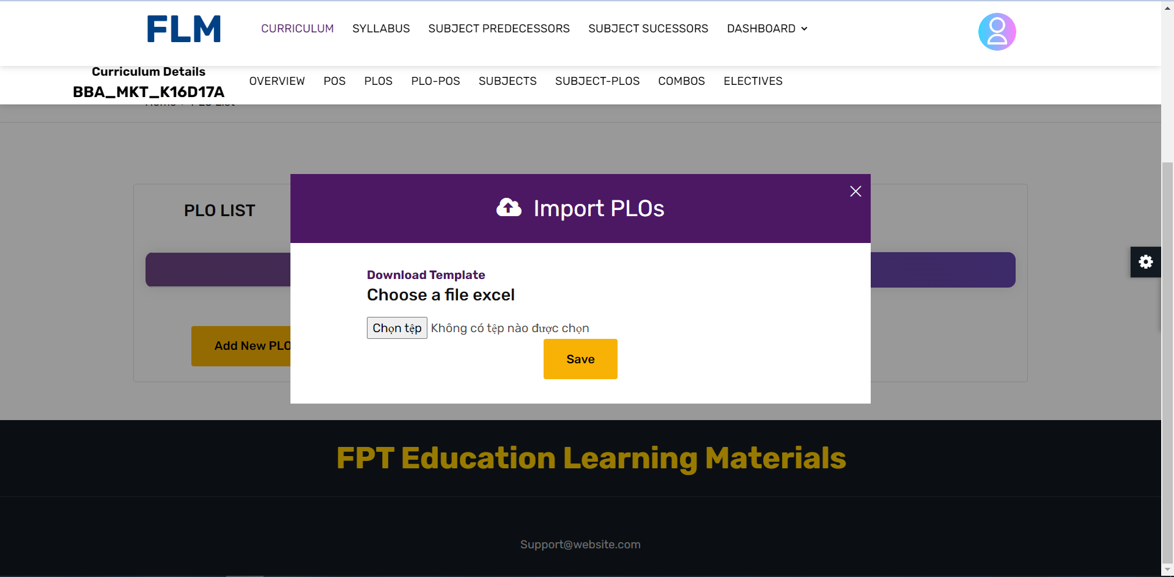

* Function Details:

- Data: The function processes the imported data, which is typically in CSV or Excel format. The data includes program learning outcomes, including their codes, descriptions, and associated information.

- Validation: The function performs validation checks on the imported data to ensure its correctness and completeness. It verifies that the required fields are present, checks for any formatting or data type errors, and identifies any duplicates or conflicts with existing learning outcomes.

- Business Logic: The function incorporates business logic to handle various scenarios and requirements related to program learning outcomes. This can include rules for handling duplicates (e.g., updating or skipping duplicates) or specific mappings for data fields to match the system's structure.

- Functionalities:

+ Normal Cases: When the function is triggered, the user selects the file containing the learning outcomes data and configures validation settings if applicable. The function then processes the imported data, validating it for consistency and completeness. It updates the program's learning outcomes database with the imported data, ensuring that the program's outcomes are up-to-date and accurately reflected in the system.

+ Abnormal Cases: In case of any errors or issues during the import process, such as missing required fields or data format errors, the function may provide error messages or warnings to the user. It informs the user about the specific issues encountered and may suggest corrective

actions or provide guidance on resolving the errors.

### d. PLO - PO Mapping

Function Trigger:

* The function shows the relationship between plo and po.

Function Description:

The "PLO - PO Mapping" function provides the user with information about the relationship between plo and po. It provides a comprehensive overview of the subject's content,

Screen Layout:

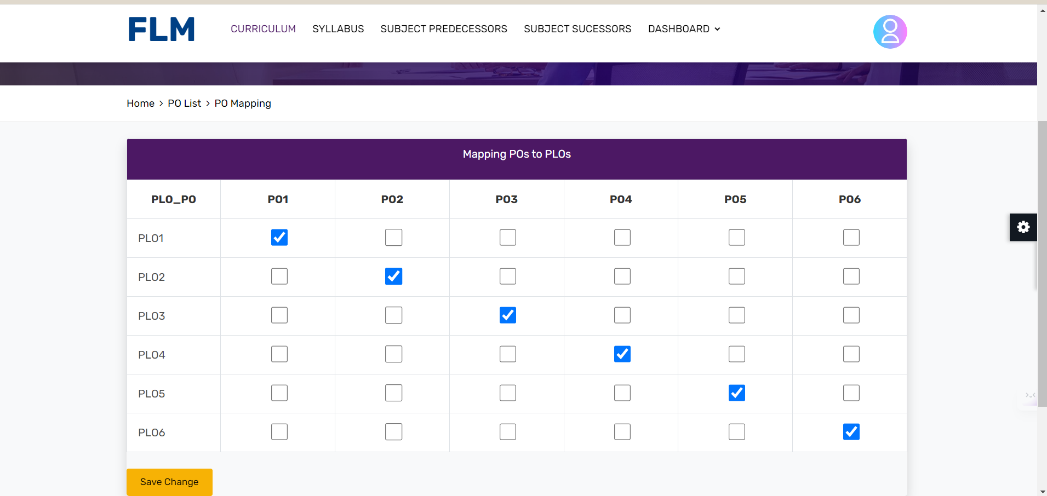

Function details:

* The function "PLO - PO Mapping" provides the relationship between po and plo.
* Make it easy for users to understand the relationship of po and plo

## 6. Curriculum Subject

### a. Curriculum Subject Detail

Function Trigger:

* Users input or select the subject they want to explore in detail from a list or search function.The function presents a list of learning objectives associated with the subject. These objectives outline the specific knowledge, skills, or competencies that students are expected to gain upon completion of the subject.

Function Description:

* The "Curriculum Subject Detail" function provides users with in-depth information about a specific subject within the curriculum. It offers a comprehensive overview of the subject's content, learning objectives, resources, assessments, and any other relevant details. This function allows users to access detailed information about each subject to gain a better understanding of its scope and requirements

Screen Layout:

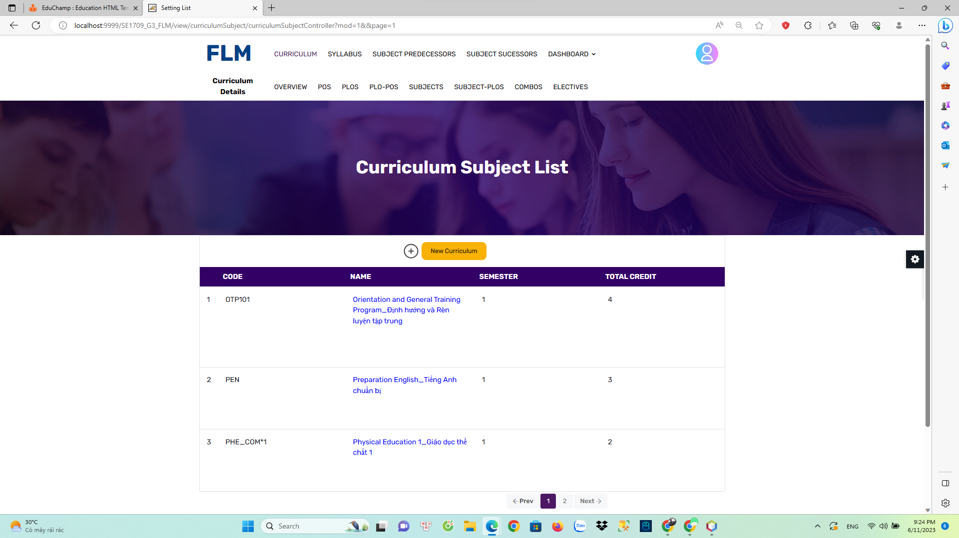

Function Details:

* The function "Curriculum Subject Detail" is a term you provided, but it seems to be incomplete or unclear. However, I can provide you with general information about curriculum subjects and their details.
* education, a curriculum refers to the overall plan and framework for teaching and learning within a specific academic program or institution. It typically includes a set of subjects or courses that students are expected to study.
* Curriculum subjects are individual areas of knowledge or disciplines that form the content of a curriculum. They can vary depending on the educational level, institution, and country. Common curriculum subjects include:
* Mathematics: This subject covers topics such as arithmetic, algebra, geometry, statistics, and calculus.
* Science: It encompasses subjects like biology, chemistry, physics, environmental science, and astronomy.
* Language Arts: This subject area focuses on developing skills in reading, writing, listening, and speaking. It may include literature, grammar, composition, and communication skills.
* Social Studies: It includes subjects like history, geography, civics, economics, and sociology, aiming to develop an understanding of society, culture, and human behavior.
* Foreign Languages: These subjects involve the study of languages other than the native language, such as Spanish, French, Mandarin, or German.
* Physical Education: This subject promotes physical fitness, health, and sportsmanship through activities like sports, exercise, and games.
* Fine Arts: It encompasses subjects like visual arts (painting, drawing, sculpture), music, dance, drama, and creative writing.
* Computer Science: This subject focuses on computer programming, algorithms, data structures, software development, and information technology.
* Career and Technical Education (CTE): These subjects provide practical skills and knowledge in specific career fields, such as automotive technology, culinary arts, graphic design, or nursing.
* The detail of each curriculum subject may vary depending on the educational standards and goals of the curriculum. Typically, subject details include specific learning objectives, content topics, skills to be developed, assessment methods, and suggested resources or materials.

If you can provide more specific information or context about the "Curriculum Subject Detail" you mentioned, I'll be happy to assist you further.

Functionalities:

Here are some common functionalities found in curriculum or educational systems:

* Course Management: This functionality allows administrators or instructors to create, manage, and organize courses within the curriculum. It includes features like course creation, enrollment management, scheduling, and resource allocation.
* Lesson Planning: This functionality assists teachers in planning and designing lessons. It may include tools for creating lesson objectives, selecting instructional materials, defining activities, and setting assessment criteria.
* Content Management: This functionality enables the organization and storage of educational content, such as textbooks, documents, multimedia resources, and learning materials. It may include features for content creation, version control, and sharing.
* Assessment and Grading: This functionality supports the process of evaluating student performance. It includes features for creating and administering assessments, grading assignments, calculating grades, and generating reports.
* Collaboration and Communication: This functionality facilitates communication and collaboration among students, teachers, and administrators. It may include tools for discussion forums, messaging, file sharing, and virtual classrooms.
* Progress Tracking: This functionality allows educators to monitor and track student progress and performance. It may include features for tracking attendance, grades, completion rates, and generating progress reports.
* Personalization and Adaptive Learning: This functionality enables personalized learning experiences tailored to individual student needs. It may include adaptive learning algorithms, personalized recommendations, and differentiated instruction.

These are just a few examples of functionalities that can be found in curriculum or educational systems. The specific functionalities may vary depending on the purpose, scope, and design of the system.

### b. Add curriculum subject

Function Trigger:

* Based on your prompt, it seems that you are looking for the trigger function that initiates the process of adding a curriculum subject. The trigger function can vary depending on the specific curriculum management system or platform you are using.

Function Description:

* Actors/Roles: staff , System
* To provide you with a detailed description of functions, it would be helpful to know the specific function or system you are referring to. Please provide more context or specify the function you would like a description for, and I'll be glad to assist you further.
* An interface refers to the point of interaction between a user and a system or software application. It is the visual and interactive component that allows users to communicate with and control the functionalities of a system

Screen Layout:

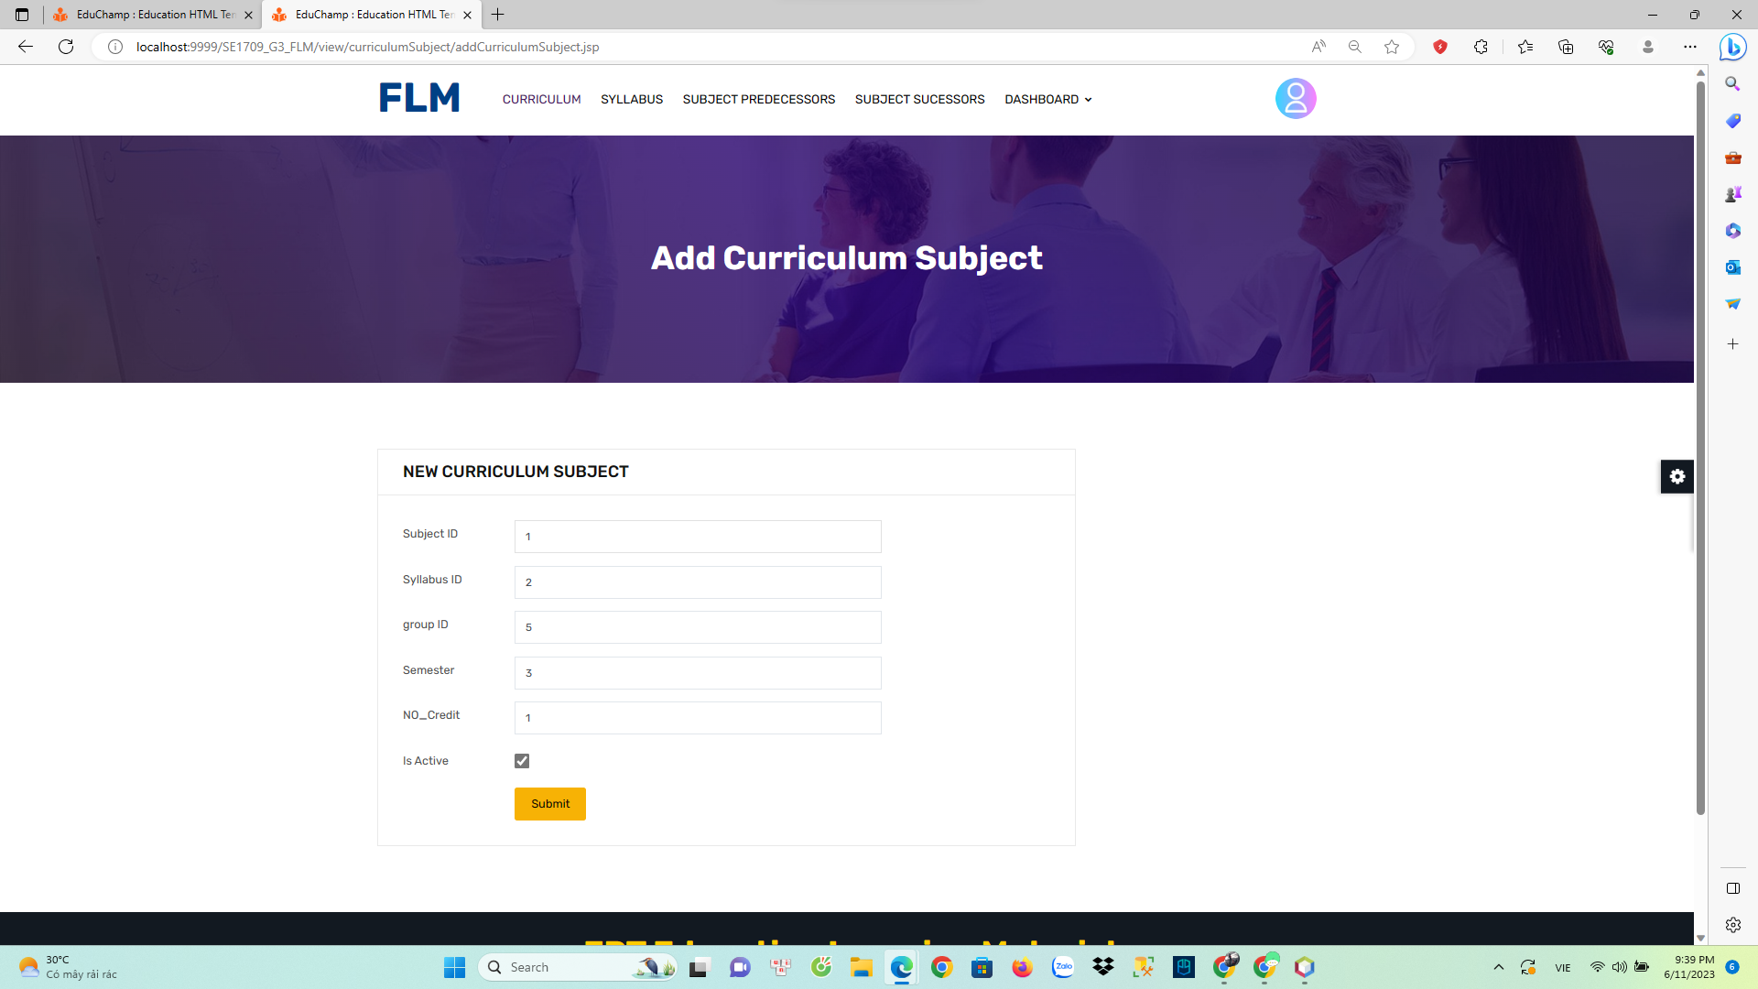

Function Details:

* Create: This function allows users to create new entities or objects within the system. It typically involves filling out relevant information or providing necessary inputs to generate the desired entity.
* Read/View: The read/view function enables users to access and view existing data or information within the system. It allows users to retrieve and review data that has been previously saved or entered.
* Update/Edit: The update/edit function allows users to modify or update existing data or information within the system. Users can make changes to fields, update values, or edit content to reflect new or revised information.

Functionalities:

* User Authentication and Authorization: This functionality ensures that users can securely log in to the system using their credentials and verifies their access rights and permissions based on their roles and privileges.
* Data Management: This functionality involves storing, organizing, and manipulating data within the system. It includes features like data entry, storage, retrieval, update, and deletion.
* Reporting and Analytics: This functionality allows users to generate reports and analyze data within the system. It may include features for creating custom reports, visualizing data through charts and graphs, and applying filters or parameters for data analysis.

These are just a few examples of functionalities commonly found in software applications or systems. The specific functionalities may vary depending on the nature and purpose of the software or system you are referring to.

## 7. PO Management

### a. PO List

Function Trigger:

* The PO List function is activated when the user wants to see a list of POs.

Function Description:

* Actor/Role: Staff
* Purpose: The purpose of the PO list function is to provide Staff with a complete list of Pos or topics available in a system or platform. It allows Staff to browse, search or select specific topics of interest for further actions or interactions.
* Interface: The interface for the PO list function typically presents a list or grid view of POs, along with related information.
* Data processing: The function takes the list of POs from the backend database or content management system and presents it to the Staff through the user interface.

Screen Layout: 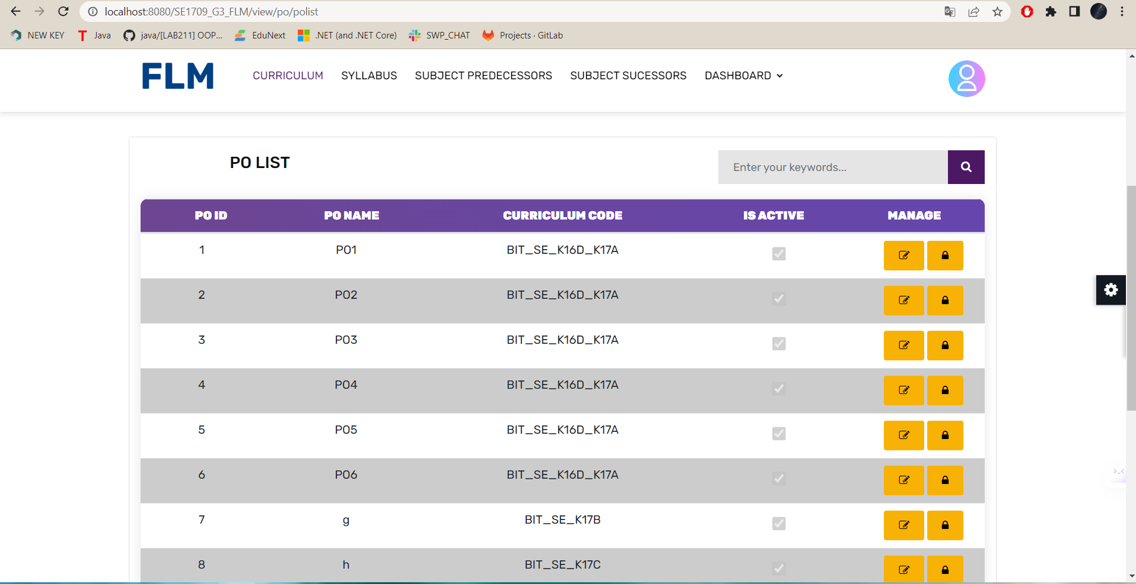

Function details:

- Data: Function to retrieve and display the list of POs. Each Po can have associated metadata like name, CURRICULUM CODE, IS ACTIVE

- Validation: This function is not related to data validation specifically, as it is mainly focused on presenting the list of POs taken from the backend. However, it may include checking for empty or incomplete data to ensure the list is populated correctly.

- Function:

- Normal case: When the function is activated, it will get the list of POs from the backend and display them in the Staff interface. Staff can browse, search or interact with POs

- Abnormal cases: In case of any error or problem during data retrieval, the function can display an error message

Overall, the PO List function provides staff with an organised and easy-to-navigate view of the topics or topics available in a system or platform. It allows staff to discover and interact with objects based on their interests or requirements,

### b. PO Import

Function Trigger:

* The PO import from Excel file function is usually activated when a staff member wants to import a series of POs from an Excel file into a system or platform. It can be activated via a navigation link, such as clicking the "Import Subject" or "Upload to Excel" button in the user interface.

Function Description:

* Actor/Role: Staff
* Purpose: The purpose of Import PO from Excel file is to allow Staff to import multiple POs from one Excel file into the system or platform. It facilitates the efficient and streamlined batch addition of objects.
* Interface: The interface of the Import PO from Excel file function usually includes an upload file input field or a drag and drop area where the user can select or drop the Excel file containing the PO data. It may also include buttons to upload, cancel, or delete the selected file.
* Data Processing: This function processes the uploaded Excel file, extracts the PO data, validates it, and adds the POs to a backend database or content management system. It may involve parsing Excel files, validating data, mapping data fields, and inserting databases.

Screen layout:

* The screen layout for the Import Theme from Excel File function might look like the sample model below:
* 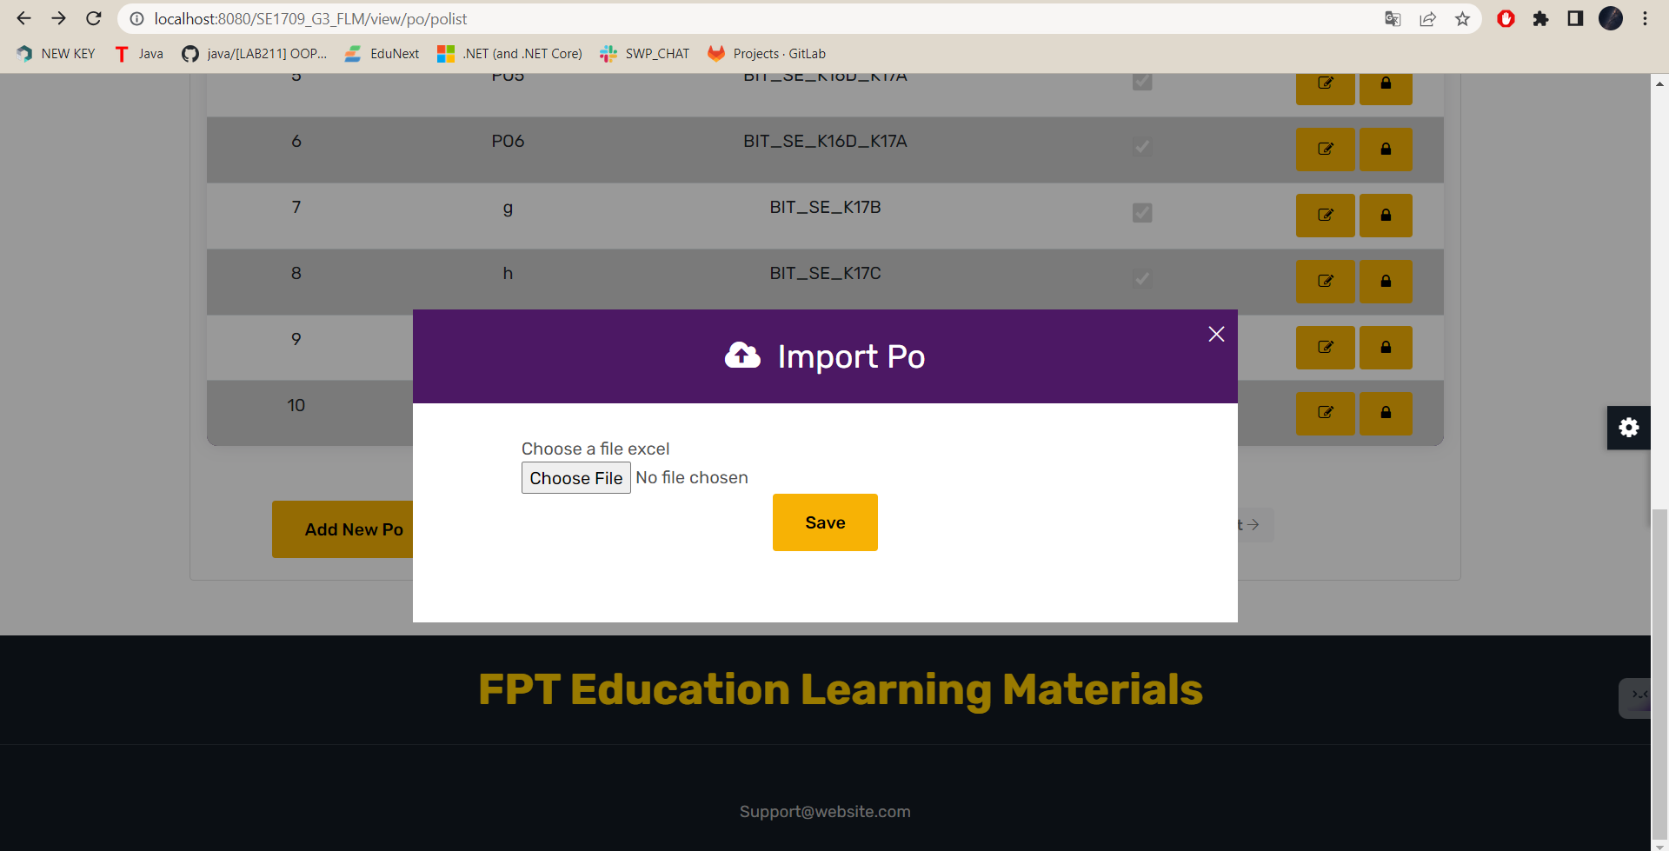
* Function details:
* - Data: The function expects an Excel file containing PO data. Excel files can include columns Po name, description. The function extracts and processes this data to create a new topic record in the system or platform.
* - Validity check: The function performs a validity check on the entered PO data to ensure its accuracy and completeness. In addition, it can verify the integrity and validity of the Excel file structure.
* - Business logic: The function can combine business logic to handle specific situations during import. This may include dealing with duplicate topics, resolving conflicts, and applying any relevant business rules or restrictions.
* - Function:
* - Normal case: When activating the function, the user selects or drops the Excel file containing the PO data. The function then processes the Excel file, extracts the PO data, validates it, and creates a new PO record in the backend based on the extracted information. It displays a success message indicating the number of imported objects and any additional information related to the import process.
* - Abnormal cases: In case of any error or problem during file upload, data extraction or data validation, the function can display the appropriate error message to the user, indicate the problem and suggest corrective action. It ensures that the user is informed of the specific problem encountered and provides instructions on how to fix it.
* Overall, the Import PO from Excel File function provides users with a convenient method to import a large number of topics or topics from an Excel file. It streamlines the process of bulk adding objects, minimising manual data entry and saving time. The function ensures the authentication and secure storage of imported topic data, allowing users to quickly integrate new themes into the system or platform.

### c. Po Detail

Function Trigger:

* The View PO Detail function is typically triggered when a user wants to view the detailed information of a specific PO or topic within a system or platform. It can be triggered through a navigation path, such as clicking on a subject from a subject list or search results.

Function Description:

* Actors/Roles: Staff
* Purpose: The purpose of the View Po Detail function is to provide Staff with comprehensive and detailed information about a specific subject or topic within the system or platform. It allows Staff to access and review the content, attributes, and related data associated with the subject.
* Interface: The interface for the View PO Detail function typically presents the subject's detailed information in a structured and organized manner. It may include sections or tabs to display various aspects of the subject, such as description, category, tags, related content
* Data Processing: The function retrieves the detailed information of the selected subject from the backend database or content management system and presents it to the user through the user interface. It may involve data processing operations such as querying the database, retrieving associated content, and formatting the data for display.

Screen layout:

* The screen layout for the Import Theme from Excel File function might look like the sample model below:

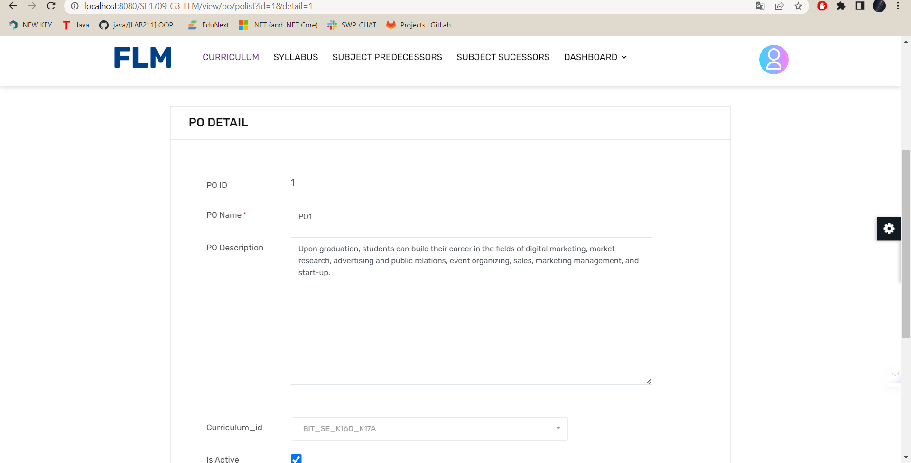

Function Details:

- Data: The function retrieves and displays detailed information about a specific PO. This information may include the Po name, description, or any other relevant data associated with the PO .

- Validation: The function does not involve specific data validation, as it primarily focuses on presenting the PO details retrieved from the backend. However, it may include checks to ensure that the PO exists and is accessible to the Staff.

- Business Logic: The function may incorporate business logic to determine the permissions or access rights of the user to view the Po details. It may also include logic to fetch and present related content or comments associated with the PO .

- Functionalities:

- Normal Cases: When the function is triggered, it retrieves the detailed information of the selected PO and presents it in the user interface. Staff can view the PO attributes

, such as description, category, tags, related content, and comments. They can also perform actions such as editing or soft erase the PO if they have the appropriate permissions.

- Abnormal Cases: In case the PO does not exist , the function may display an appropriate error message indicating the issue and provide guidance on how to proceed. It ensures that the user is informed about the limitation and prevents unauthorized access to PO information.

Overall, the View PO Detail function allows staff to explore and review the comprehensive details and content associated with a specific PO or topic within the system or platform. It presents the PO information in an organized manner, facilitating easy navigation and access to relevant data.

## 8. Subject Groups

### Combo List

* **Function Trigger:**

The "Combo List" function is usually activated when users and administrators want to select, view, and combine multiple subjects in an application or system. It can be triggered through user interaction, such as clicking a drop-down menu or selecting an option from a list.

* **Function Description:**

Actors/Roles: User (Administrator, Content Manager), System

Purpose: The purpose of the Combo List function is to enable users to select and combine multiple subjects or topics within an application or system. It allows users to customise their experience and access specific content or features related to the chosen subjects or topics.

Interface: The interface for the Combo Subject function typically includes a dropdown menu or list of available subjects or topics. Users can select multiple options from the list to create a combination. The interface may also provide additional controls or options for filtering, searching, or organising the subjects or topics.

Data Processing: The function processes user selections and performs actions based on the chosen subjects or topics. It may involve retrieving relevant data or content associated with the selected subjects, adjusting the available options based on the chosen combination, or triggering specific functionalities related to the selected subjects or topics.

Benefits: The Combo Subject function enhances user flexibility and personalization by allowing them to select multiple subjects or topics of interest. It enables a tailored experience, ensuring users can access content or features that align with their specific preferences or needs. The function promotes efficient navigation and exploration within the application or system by providing a customised selection of relevant content or functionalities based on the user's choices.

* **Screen Layout:**

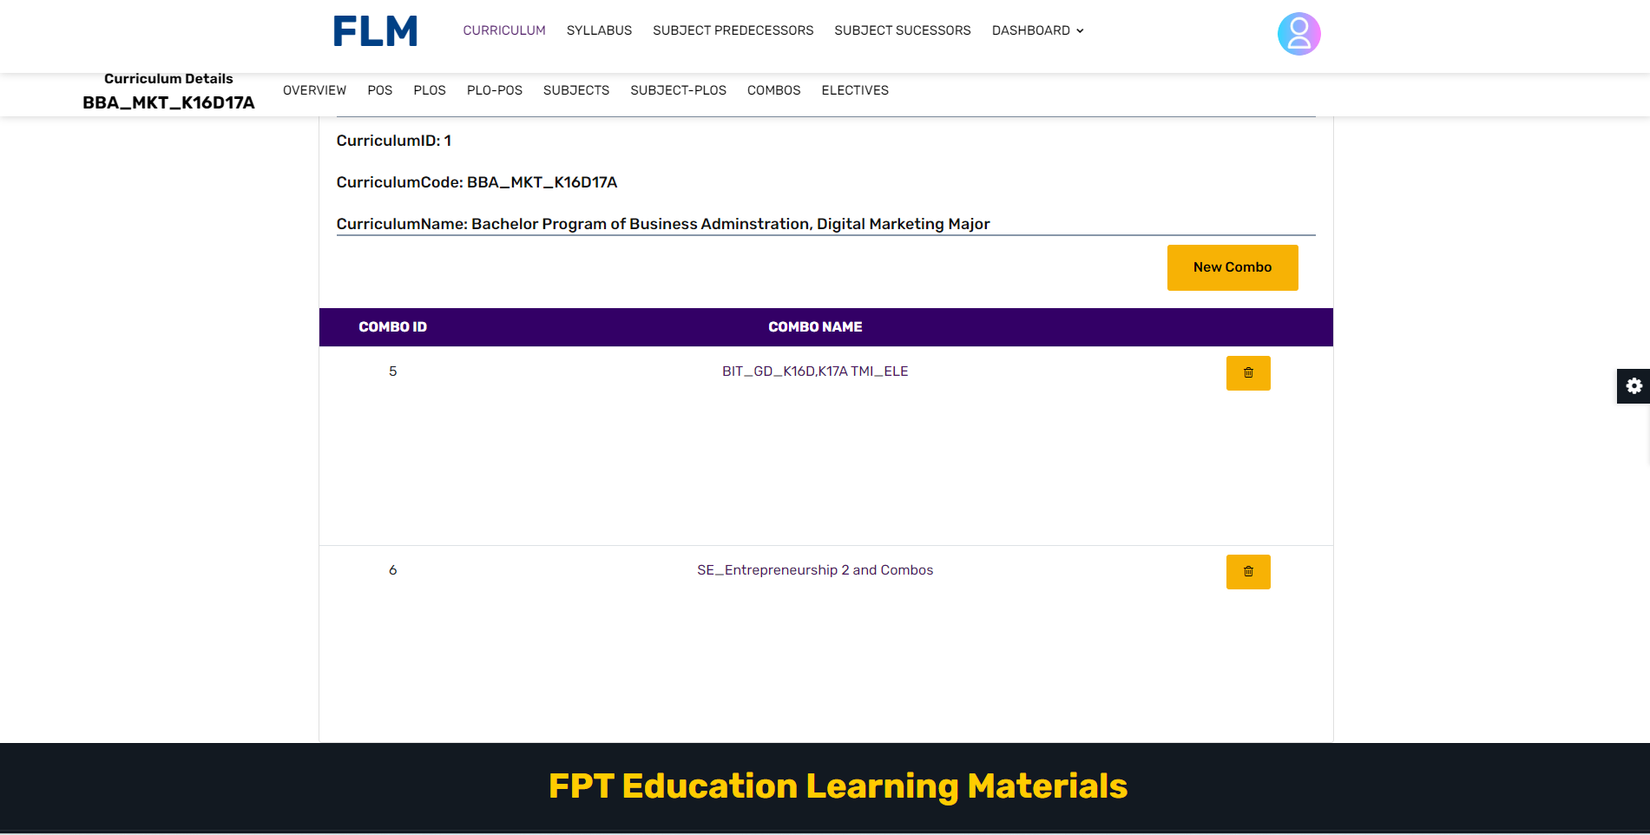

* **Function Details:**
* Data: The Combo Subject function retrieves and presents data related to available subjects or topics. This data includes information such as subject names, descriptions, or any other relevant details necessary for selection and combination.
* Validation: The function may include validation checks to ensure the accuracy and consistency of the retrieved data. It may verify that the selected subjects or topics are valid and permissible within the system. Validation can also include checks for dependencies or constraints related to the combination of certain subjects or topics.
* Business Logic: The function incorporates business logic to handle specific scenarios and requirements related to subject combination. This can include rules for subject availability, prerequisite subjects, subject grouping guidelines, or any other policies defined by the platform or organisation.
* Functionalities:
* Normal Cases: When the function is triggered, it presents the list of available subjects or topics to the user. The user can select multiple subjects to create a combination. The function may provide options for filtering, searching, or organising the subjects. The selected combination can be used to access corresponding content or features tailored to the user's preferences.
* Abnormal Cases: In case of any errors or limitations, such as unavailable subjects, invalid combinations, or technical issues, the function may display appropriate error messages to the user. It informs the user about the specific issue encountered and provides guidance on how to resolve or seek assistance for the problem.

### Combo Detail

* **Function Trigger:**

The "Combo Detail" function is typically triggered when a user wants to view detailed information or data related to a specific combination or selection made within an application or system. It can be triggered through user interaction, such as clicking on a specific combination, accessing a detailed view option, or selecting an item from the combo subject.

* **Function Description:**

Actors/Roles: User (Administrator, Content Manager), System

Purpose: The purpose of the Combo Detail function is to provide users, such as administrators or content managers, with a comprehensive and detailed view of specific combinations or selections made within an application or system. It allows users to access in-depth information, insights, or data associated with their chosen combination.

Interface: The interface for the Combo Detail function typically presents the detailed view of the selected combination. It may include visualizations, charts, tables, or any other appropriate representation of the detailed information. Users can interact with the interface to explore different aspects, apply filters, or perform additional actions to further analyze the data.

Data Processing: The function processes the user's selected combination and retrieves the relevant detailed information or data associated with it. It may involve querying the database, performing calculations, aggregating data, or applying algorithms to generate meaningful insights specific to the chosen combination.

Benefits: The Combo Detail function offers several benefits to users. It enables them to gain a deeper understanding of their selected combinations by providing comprehensive and relevant information. Users can make informed decisions, perform detailed analysis, or identify patterns and trends within the data. The function promotes effective utilization of the application or system by offering customized and detailed insights based on the user's selected combination.

* **Screen Layout:**

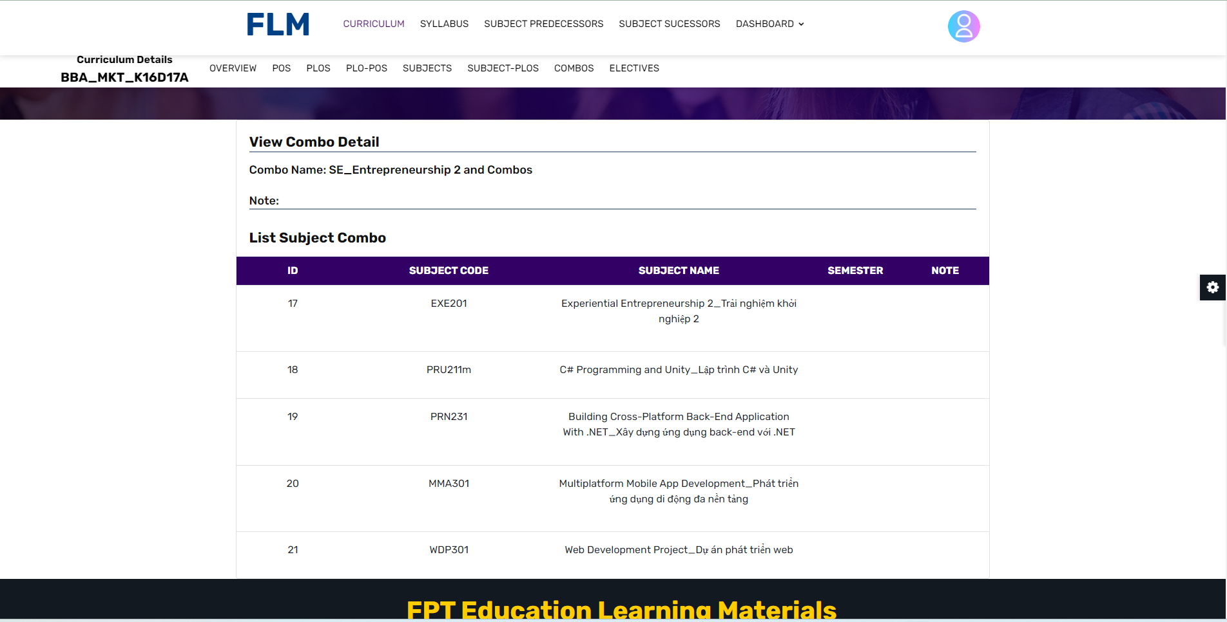

* **Function Details:**

Data: The Combo Detail function retrieves and displays data related to the selected combination. This data includes information specific to the chosen subjects or topics, such as descriptions, attributes, statistics, or any other relevant details needed for analysis or decision-making.

Validation: The function may include validation checks to ensure the correctness and integrity of the retrieved data. It verifies that the data associated with the selected combination is valid, consistent, and meets any predefined criteria or constraints. Validation may involve checking data completeness, accuracy, or adherence to specific rules or guidelines.

Business Logic: The function incorporates business logic to handle various scenarios and requirements specific to the Combo Detail functionality. This can include rules for data processing, data presentation, or any other specific policies defined by the platform or organization. Business logic ensures that the detailed information provided aligns with the intended purpose and objectives of the application or system.

Functionalities:

* Normal Cases: When the function is triggered, it retrieves the detailed information or data related to the selected combination. The user can view and analyze the detailed information, explore different aspects, perform calculations, visualize patterns, or any other relevant actions to gain insights. The function facilitates informed decision-making, analysis, or exploration based on the chosen combination.
* Abnormal Cases: In case of any errors or limitations, such as unavailability of detailed information or data for the selected combination, the function may display appropriate error messages to the user. It informs the user about the specific issue encountered and provides guidance on how to resolve or escalate the problem. Error handling ensures a smooth user experience and assists users in troubleshooting or resolving any unexpected issues encountered during the Combo Detail functionality.

### Content Group List

* Function Trigger:

The Content Group List function is typically triggered when a user, such as an administrator or content manager, wants to access and view a list of content groups within a content management system or platform. It can be triggered through a navigation path, such as accessing the "Content Groups" page or clicking on a specific menu option related to content management. This function is accessed when there is a need to review or manage content groups.

* Function Description:

- Actors/Roles: User (Administrator, Content Manager), System

- Purpose: The purpose of the Content Group List function is to provide users with an overview and management capabilities for content groups within a content management system or platform. It allows administrators or content managers to view existing content groups, organize content within groups, and perform related actions.

- Interface: The interface for the Content Group List function typically presents a list of content groups along with relevant information such as group names, descriptions, creation dates, and associated content items. It may also include options to filter, search, and sort the content groups based on specific criteria. The interface may provide buttons or links for adding new content groups, editing existing groups, or navigating to detailed views of each group.

- Data Processing: The function retrieves and processes data related to content groups from the backend database or content management system. It presents the data in the user interface, handles user interactions such as filtering or sorting, and facilitates content group management actions.

* Screen Layout:

The screen layout for the Content Group List function may resemble the mockup below:

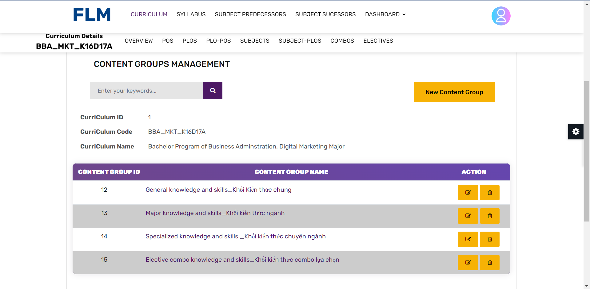

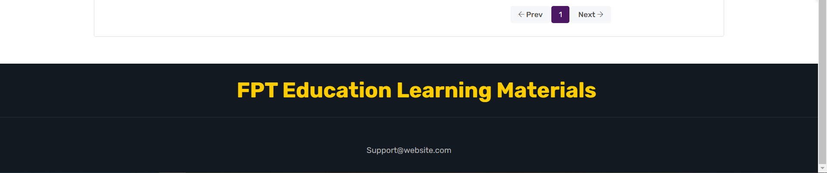

* Function Details:

- Data: The function retrieves and displays data related to content groups. This data includes information such as group names, descriptions, creation dates, and any other relevant details needed for management.

- Validation: The function may include validation checks to ensure the correctness of the retrieved data and the integrity of the content groups. It may verify that required fields are populated and that unique identifiers are properly assigned to each group.

- Business Logic: The function may incorporate business logic to handle various scenarios and requirements related to content group management. This can include rules for group naming conventions, access permissions, content organization guidelines, or any other specific policies defined by the platform or organization.

- Functionalities:

+ Normal Cases: When the function is triggered, it retrieves and displays the list of content groups. The user can browse through the list, search for specific groups, and perform actions such as adding new groups, editing existing groups, or accessing detailed views of each group. The function facilitates the management and organization of content within groups, enabling efficient content management and administration.

+ Abnormal Cases: In case of any errors or limitations, such as a failure to retrieve the content groups or invalid user permissions, the function may display appropriate error messages to the user. It informs the user about the specific issue encountered and provides guidance on how to resolve or escalate the problem.

### Content Group Detail

* Function Trigger:

The Content Group Detail function is typically triggered when a user, such as an administrator or content manager, wants to view the details and manage the content within a specific content group within a content management system or platform. It can be triggered through a navigation path, such as accessing the "Content Group Detail" page from the Content Group List or by clicking on a specific content group within the list. This function is accessed when there is a need to review or modify the content within a particular group.

* Function Description:

- Actors/Roles: User (Administrator, Content Manager), System

- Purpose: The purpose of the Content Group Detail function is to provide users with a comprehensive view and management capabilities for a specific content group within a content management system or platform. It allows administrators or content managers to review the group's details, organize and edit the content items within the group, and perform related actions.

- Interface: The interface for the Content Group Detail function typically presents the details of the selected content group along with the content items contained within it. It may include information such as the group name, description, creation date, associated tags, and a list of content items with their respective titles, types, and statuses. The interface may provide options to add new content items, reorder or rearrange the items, edit existing items, or delete items within the group.

- Data Processing: The function retrieves and processes data related to the selected content group and its associated content items from the backend database or content management system. It presents the data in the user interface, handles user interactions such as adding or editing content items, and updates the group and item information accordingly.

* Screen Layout:

The screen layout for the Content Group Detail function may resemble the mockup below:

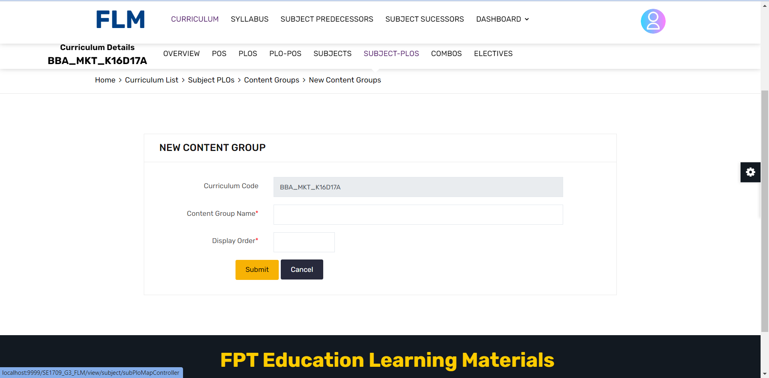

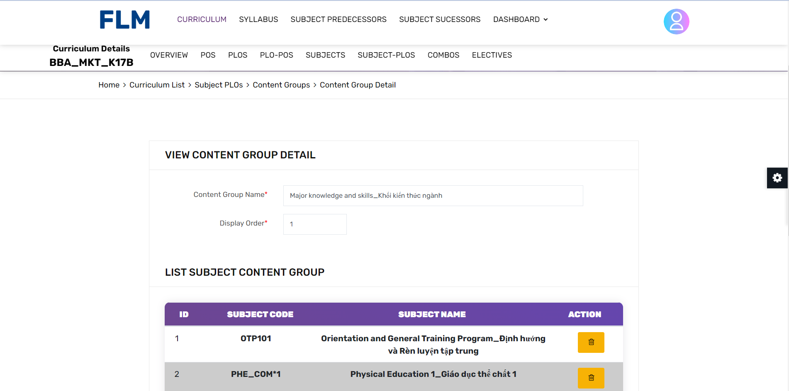

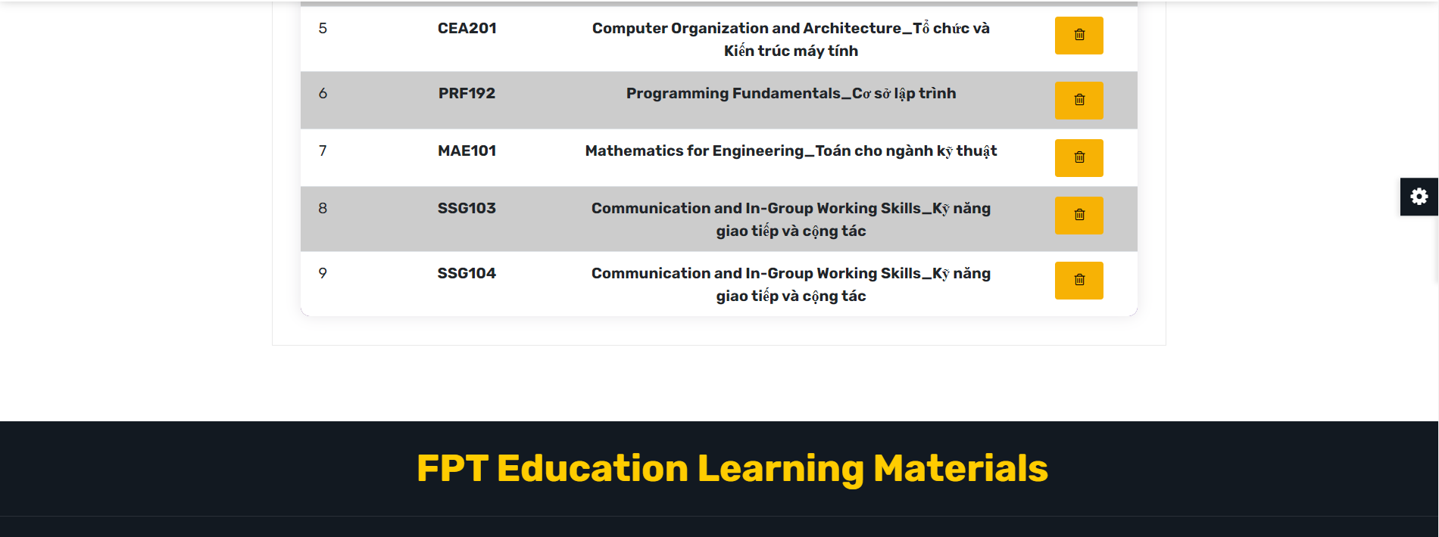

* Function Details:

- Data: The function retrieves and displays data related to the selected content group and its associated content items. This data includes information such as the group name, description, creation date, tags, and details of each content item within the group.

- Validation: The function may include validation checks to ensure the correctness and consistency of the data, such as verifying the existence and integrity of the content group and its associated items.

- Business Logic: The function may incorporate business logic to handle various scenarios and requirements related to content group management. This can include enforcing content item types or formats, validating user permissions for editing or deleting items, or applying specific rules defined by the platform or organization.

- Functionalities:

+ Normal Cases: When the function is triggered, it retrieves and displays the details of the selected content group, including its name, description, creation date, and associated tags. The user can view the list of content items within the group, including their titles, types, and statuses. The function provides options to add new content items, edit existing items, or delete items within the group. The function facilitates the organization and management of content within the selected group, allowing administrators or content managers to maintain and update the content effectively.

+ Abnormal Cases: In case of any errors or limitations, such as a failure to retrieve the content group details or invalid user permissions, the function may display appropriate error messages to the user. It informs the user about the specific issue encountered and provides guidance on how to resolve or escalate the problem.

### Elective List

* **Function Trigger:**

The Elective List function is typically triggered when users or administrators want to access, view, and select elective subjects within an application or system. It is activated through user interaction, such as clicking on a specific menu option, accessing the "Elective List" page, or interacting with a drop-down menu or list related to elective subject selection.

* **Function Description:**

Actors/Roles: User (Administrator, Content Manager), System

Purpose: The Elective List function is designed to provide users, such as administrators or content managers, with the ability to select and combine multiple elective subjects within an application or system. This function allows users to customize their experience and access specific content or features that are relevant to their chosen subjects or topics of interest.

Interface: The interface for the Elective Subject List function typically includes a dropdown menu or a list that presents the available elective subjects to the user. Users can select multiple subjects from the list to create their desired combination. The interface may also include additional controls or options, such as filters, search functionality, or organization features, to assist users in finding and selecting the desired subjects or topics.

Data Processing: The function processes the user's selections and performs actions based on the chosen elective subjects. This may involve retrieving relevant data or content associated with the selected subjects, adjusting the available options based on the chosen combination, or triggering specific functionalities related to the selected subjects or topics. The function ensures that the selected elective subjects are accurately processed and utilized within the application or system.

Benefits: The Elective List function offers several benefits to users. It enhances flexibility and personalization by allowing users to select multiple subjects or topics of interest. This enables a tailored experience where users can access content or features that align with their specific preferences or needs. The function promotes efficient navigation and exploration within the application or system by providing a customized selection of relevant content or functionalities based on the user's choices.

* **Screen Layout:**

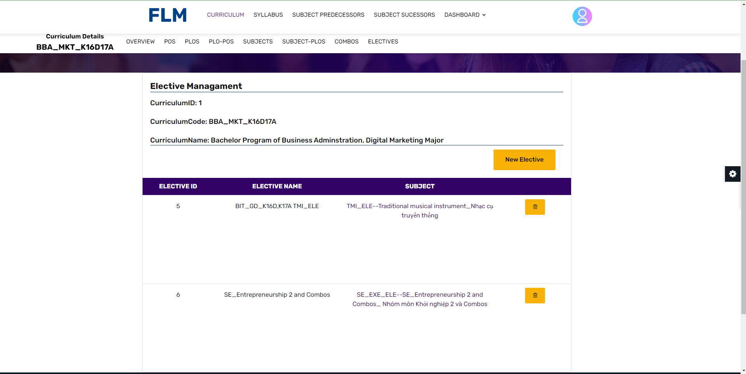

* **Function Details:**

Data: The Elective List function retrieves and presents data related to available subjects or topics within the application or system. This data includes information such as subject names, descriptions, prerequisites, credit hours, or any other relevant details necessary for users to make informed selections and combinations.

Validation: The function incorporates validation checks to ensure the accuracy and consistency of the retrieved data. It verifies that the selected subjects or topics are valid and permissible within the system. Validation may include checks for dependencies, prerequisites, subject availability based on the user's academic program, or any other constraints related to subject combination.

Business Logic: The function incorporates business logic to handle specific scenarios and requirements related to subject combination. This can include rules and policies defined by the platform or organization, such as subject grouping guidelines, credit hour restrictions, or any other constraints that govern the selection and combination of elective subjects.

Functionalities:

* Normal Cases: When the Elective List function is triggered, it presents the user with a comprehensive list of available subjects or topics. Users can select multiple subjects from the list to create their desired combination. The function may provide additional functionalities such as filtering options based on subject attributes, search capabilities to quickly locate specific subjects, or organizational features to categorize subjects by departments or disciplines. The selected combination of subjects can then be used to access corresponding content, materials, or features that are tailored to the user's preferences and academic needs.
* Abnormal Cases: In case of any errors or limitations, such as unavailable subjects, invalid combinations, or technical issues, the function handles such situations by displaying appropriate error messages to the user. These error messages inform the user about the specific issue encountered, such as an unavailable subject due to scheduling conflicts or an invalid combination based on prerequisite requirements. The error messages also provide guidance on how to resolve the issue, such as seeking assistance from an administrator or choosing alternative subjects that align with the user's academic goals

### Elective Detail

* **Function Trigger:**

The Elective Detail function is typically triggered when a user, such as a student or academic advisor, wants to access detailed information about a specific elective subject within the application or system. It can be triggered through user interaction, such as clicking on the subject name or selecting a specific subject from a list or search result. The function is accessed when there is a need to review and gather comprehensive information about the selected elective subject, including its description, prerequisites, credit hours, and related materials.

* **Function Description:**

Actors/Roles: User (Student, Academic Advisor), System

Purpose: The purpose of the Elective Subject Detail function is to provide users with in-depth and comprehensive information about a specific elective subject within an application or system. It aims to assist students in making informed decisions about subject selection and to support academic advisors in providing accurate guidance and advice.

Interface: The interface for the Elective Subject Detail function typically includes a dedicated page or section that displays detailed information about the selected elective subject. The interface may present the subject's name, description, prerequisites, credit hours, instructor details, course materials, and any other relevant details necessary for users to gain a thorough understanding of the subject. It may also provide navigation or links to related subjects or resources.

Data Processing: The function retrieves and processes data related to the selected elective subject from the backend database or data source. It retrieves the subject's information and organizes it in a user-friendly manner for presentation in the interface. The function may also handle user interactions, such as prerequisite validation or accessing subject-specific materials.

Benefits: The Elective Subject Detail function offers several benefits to users. For students, it provides comprehensive information about elective subjects, allowing them to evaluate their suitability, align with their academic goals, and make informed decisions about subject selection. Academic advisors can utilize this function to access detailed information about elective subjects to provide accurate guidance and advice to students. By providing in-depth subject details, the function enhances the overall academic experience and supports effective academic planning.

* **Screen Layout:**

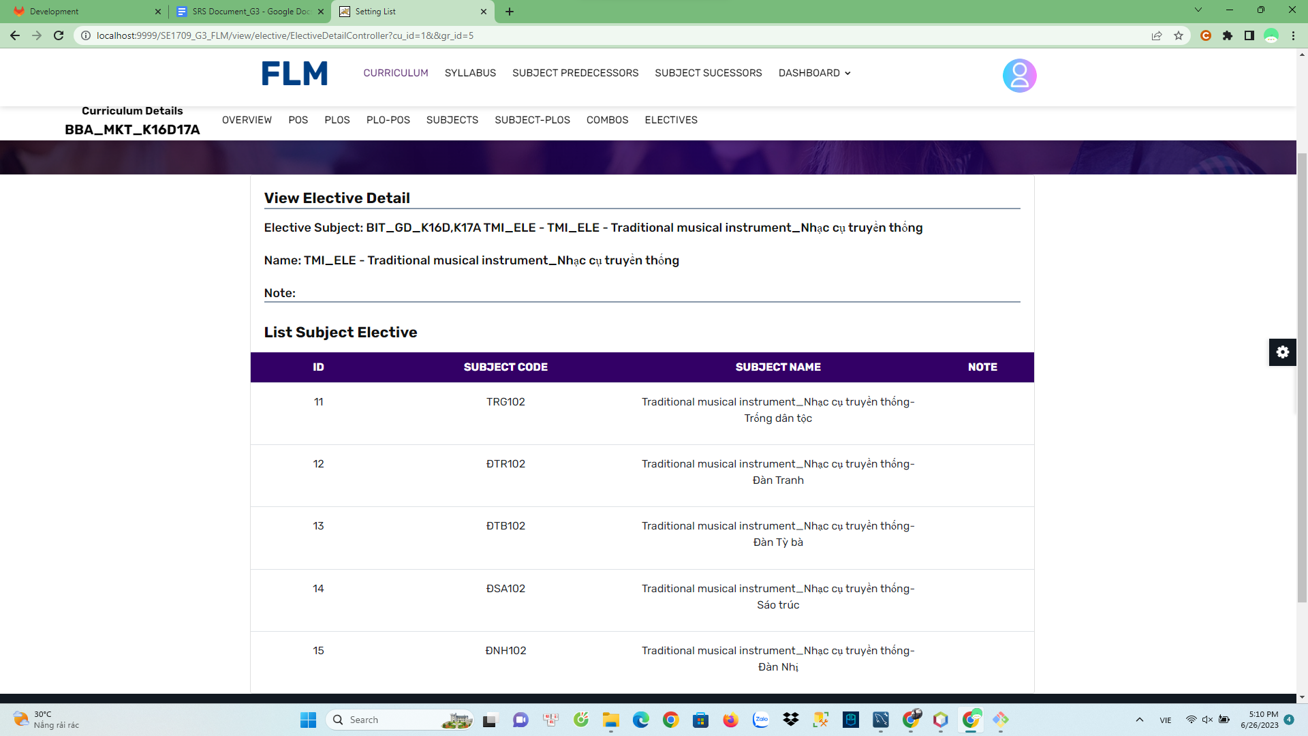

* **Function Details:**

Data: The Elective Subject Detail function retrieves and presents detailed information about a specific elective subject within the application or system. This data includes comprehensive information such as subject name, description, prerequisites, credit hours, instructor details, course materials, and any other relevant details necessary for users to gain a thorough understanding of the subject.

Validation: The function may include validation checks to ensure the correctness and integrity of the retrieved subject data. It may verify that all required information is available and properly associated with the subject. Validation can also include checks for prerequisites, ensuring that users meet the necessary requirements before accessing the subject's content or enrolling in the subject.

Business Logic: The function incorporates business logic to handle specific scenarios and requirements related to elective subject details. This can include rules for displaying subject availability based on the user's academic program, access permissions for certain subject materials, or any other policies defined by the platform or organization.

Functionalities:

* Display Subject Information: When the Elective Subject Detail function is triggered, it retrieves and presents detailed information about the selected elective subject. This includes the subject's name, description, credit hours, prerequisites, instructor details, and any additional resources or materials associated with the subject. The function ensures that users have access to comprehensive information to make informed decisions about the subject.
* Prerequisite Validation: The function may perform prerequisite validation to check if the user meets the necessary requirements to access the subject. It verifies if the user has completed the required prerequisites or if any additional permissions are needed to enroll in the subject.
* Access to Subject Materials: The function provides access to subject-specific materials, such as lecture slides, readings, assignments, or multimedia resources. It ensures that users can access the relevant materials associated with the elective subject they are reviewing.
* Related Subjects: The function may include functionality to display related or recommended subjects that complement the selected elective subject. This can assist users in exploring additional subjects that align with their academic interests or goals.

## 9. Syllabus Management

### Syllabus List

Function Trigger:

The Syllabus List function is typically triggered when a user navigates to the "Syllabus" section of the application or when they search for a specific course or program. It can also be accessed through a direct link or from a user's dashboard.

Function Description:

Actors/Roles:

Students: Users who are enrolled in courses or programs and want to explore the available syllabus.

Instructors: Users who create and manage the syllabus content.

Purpose:

The purpose of the Syllabus List function is to provide students and instructors with an overview of all the available courses or programs and their associated curricula. It allows users to browse through different syllabus offerings and access detailed information about each one.

Interface:

The Syllabus List function is typically presented through a screen interface. Users can view a list of syllabus, along with relevant details such as the syllabus title, designer, decisonno, and any other pertinent information. The interface may also include filters or sorting options to help users refine their search.

Data Processing:

The function retrieves curriculum data from a database or a content management system. The data includes information about each syllabus, such as its title, subject code, decisionno, designer, and other relevant details. The function processes this data and presents it in a structured and user-friendly format for users to browse.

Screen Layout :

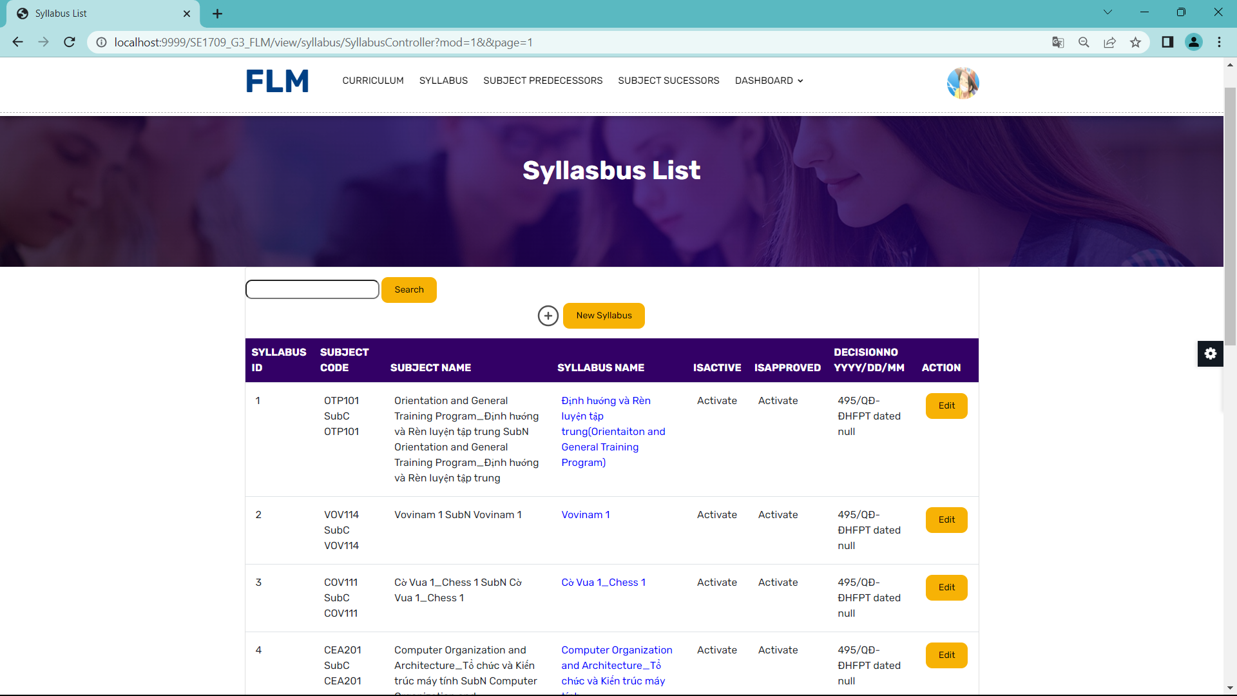

Function Details:

Data: The Syllabus List function retrieves and displays the following information for each syllabus:

Syllabus Name: The name or title of the Syllabus.

Decisionno: Time syllabus is signed and applied

Designer: The one who designed and created Syllabus

Other Details: Additional relevant information, such as active

Validation: The function validates the user's access privileges to ensure that only authorised users can view the syllabus list. It may also perform data validation to ensure the integrity and correctness of the displayed information.

Business Logic: The function handles various business logics, such as:

Role-based Access: The function restricts access to the Syllabus list based on user roles. For example, only registered students or authorised instructors can view the syllabus offerings.

Enrollment Status: The function may display an indicator or status for each syllabus to indicate whether the user is already enrolled or if enrollment is open.

Dynamic Updates: If new syllabus are added or existing ones are modified, the function should handle the synchronisation and display the latest information to users.

Functionalities:

Syllabus Exploration: Users can browse through the list of available syllabus to discover new syllabus offerings.

Sorting and Filtering: The function may provide sorting options (e.g., alphabetical, popularity) and filtering options (e.g., by active, designer) to help users narrow down their search and find relevant syllabus options.

Detailed View: Users can select a specific syllabus from the list to access more detailed information about its syllabus, learning objectives, and associated resources.

Enrollment: If enrollment is open for a syllabus, the function may provide a button or link for users to initiate the enrollment process.

Abnormal Cases:

Limited Access: If a user does not have the necessary privileges or authorization, the function should display an appropriate error message or prompt the user to log in or request access.

Empty Syllabus List: If no syllabus are available, the function should display a message indicating that there are currently no syllabus offerings to show.

### 

### Syllabus Overview

Function Trigger:

The View Curriculum function can be triggered by navigating to the "Syllabus" section of the application.

Function Description:

Actors/Roles:

Students: Users who are enrolled in a course or program and want to access the syllabus.

Instructors: Users who create and manage the syllabus content.

Purpose:

The purpose of the View Syllabus function is to provide students and instructors with a comprehensive view of the syllabus for a specific course or program.

Interface:

The View Syllabus function is typically accessed through a screen interface. Users can navigate through different sections of the syllabus using tabs, side menus, or a hierarchical structure. The interface provides a clear and organized presentation of the syllabus content, making it easy for users to find the information they need.

Data Processing:

The function retrieves curriculum data from a database or a content management system. The data includes Syllabus ID, Syllabus Name, Subject Code, NoCredit, Degree Level,Description,DecisionNo and some other information. The function processes this data and presents it to the user in a structured and user-friendly format.

Screen Layout :

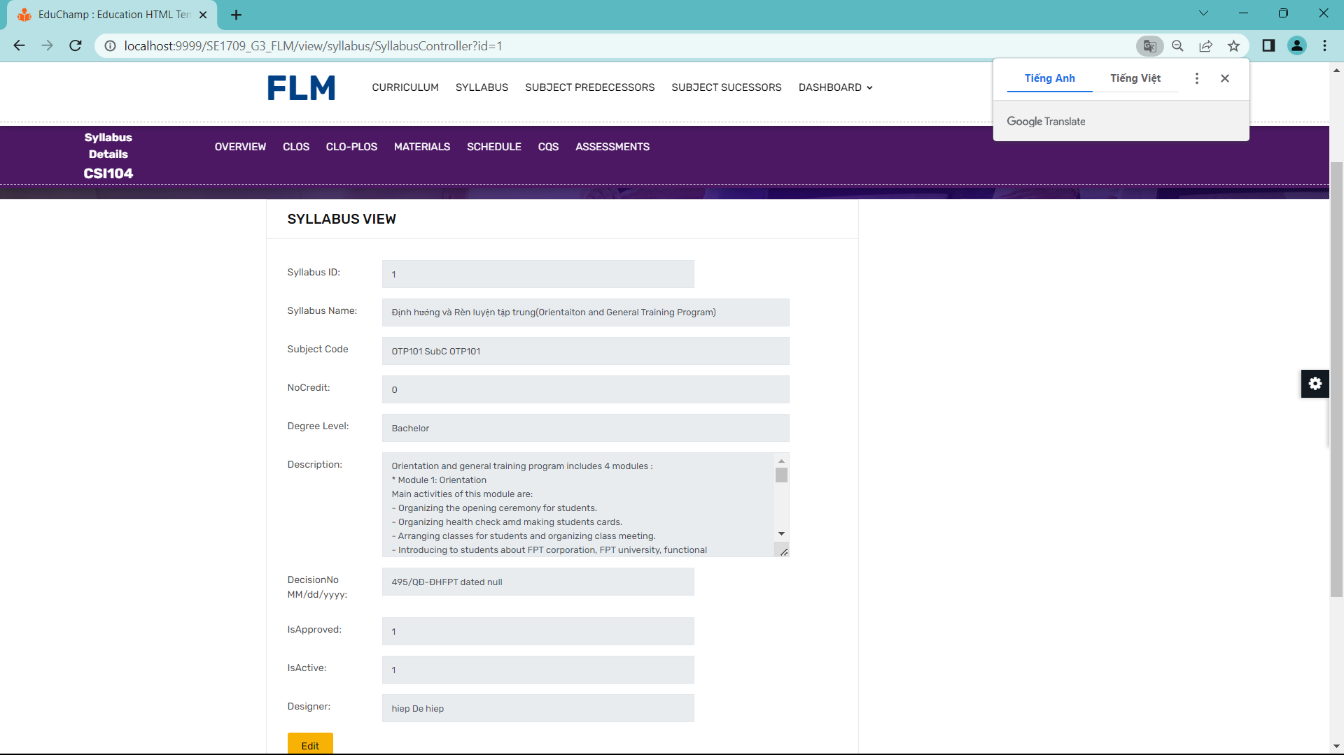

Data: The View Syllabus function retrieves and displays the following information:

Syllabus Name: provide the curriculum name

Subject Code: Provide the subject code for which this course is available

NoCredit: number of credits of the course

Description: Provides a description and overview of the course

StudentTasks: Tasks students need to do

MinAvgMarkToPass: The average number of points students need to achieve to pass the course

Validation: The View Syllabus function validates the user's access privileges to ensure that only enrolled students and authorized instructors can view the syllabus for a particular course or program. Additionally, the function checks for data integrity, ensuring that the syllabus information is correctly linked and displayed.

Business Logic: The function handles various business logics, such as:

Tracking User Progress: The function may keep track of a student's progress within the curriculum, indicating which lessons have been completed or marking milestones achieved.

Dynamic Content Updates: If the curriculum content undergoes updates or revisions, the function should handle the synchronization and display the latest information to users.

Access Control: The function enforces role-based access control, allowing only authorized users (students and instructors) to view specific curriculum content.

Functionalities:

Navigation and Browsing: Users can navigate through the curriculum by expanding and collapsing the curriculum tree, selecting different modules, units, lessons, or topics.

Searching and Filtering: The function may provide search functionality to help users quickly find specific lessons, topics, or keywords within the curriculum.

### New Syllabus

### Syllabus Edit

Function Trigger:

To edit the syllabus on a school website, you will typically need access to the website's content management system (FLM) or a similar editing platform. Here are the steps you can follow to edit the syllabus on a school website

Function Description:

Actors/Roles: User, System

The purpose of the "Edit Syllabus" function is to improve the quality, relevance, and effectiveness of an educational curriculum. By making modifications and updates to the curriculum, the aim is to enhance the learning experiences and outcomes of students.

The interface for the "Edit Syllabus" function can vary depending on the specific platform or software used for curriculum management. However, here are some common elements and features you might find in the interface:Dashboard,Course/Unit Editing.

Data processing refers to the manipulation, organisation, and analysis of raw data to generate meaningful information. In the context of the "Edit Syllabus" function, data processing may involve various tasks to manage and analyse syllabus-related data.

Screen Layout:

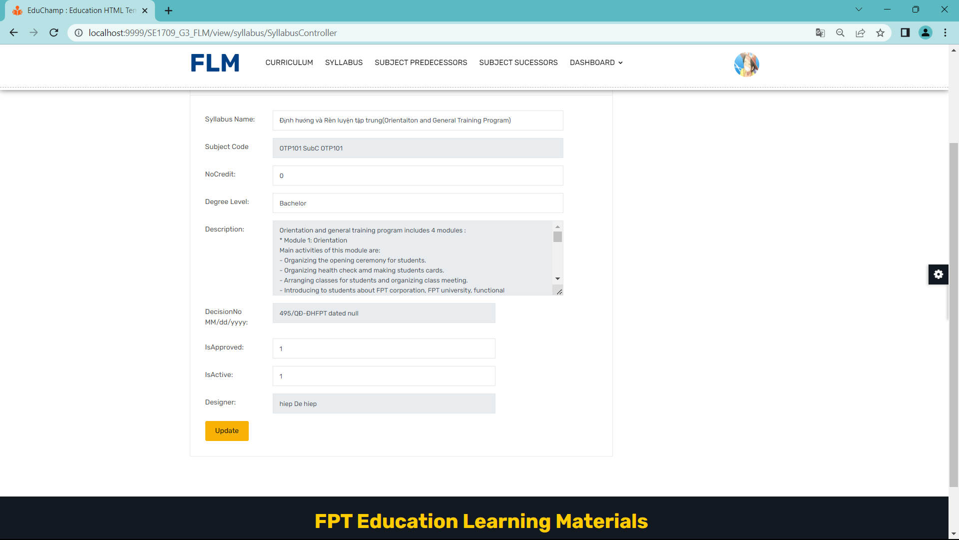

Function Details:

Description: The "Edit Syllabus" function allows authorised users to modify and update the content, structure, and resources of an educational curriculum. It provides a platform or interface where users can make changes to various elements of the curriculum, such as learning objectives, lesson plans, assessments, resources, and other relevant information. The function aims to improve the quality, relevance, and effectiveness of the curriculum by incorporating feedback, aligning with educational standards, and adapting to changing needs and contexts.

Input: User credentials: Users need to log in with their authorised credentials to access the curriculum editing platform. Existing curriculum data: The function requires access to the current curriculum data that needs to be edited. This data includes information about courses, units, learning objectives, assessments, and resources.

Output: Updated curriculum data: After making the desired modifications, the function generates and stores the updated curriculum data reflecting the changes made by the user

Note: The specific details and implementation of the "Edit Syllabus" function may vary depending on the curriculum management system or software used.

Functionalities:

Edit Course Details: Users can modify the details of individual courses within the curriculum, including course titles, descriptions, objectives, and prerequisites.

Manage Units and Lessons: Users can add, edit, or delete units and lessons within each course. They can organize the curriculum content into logical sequences and adjust the ordering of units and lessons.

Modify Learning Objectives: Users can update the learning objectives associated with each course, unit, or lesson to align with educational standards or specific learning outcomes.

### Syllabus Import

* Function Trigger:

The Syllabus Import function is typically triggered when an instructor or administrator wants to import a syllabus file into a learning management system or educational platform. The trigger can vary depending on the specific context and platform. It can be triggered through a navigation path, such as accessing the "Syllabus Import" page or by selecting an import option within the system. This function is accessed when there is a need to efficiently import a syllabus file to populate or update the course syllabus.

* Function Description:

- Actors/Roles: Instructor, Administrator

- Purpose: The purpose of the Syllabus Import function is to enable instructors or administrators to import a syllabus file, usually in a standard format such as PDF or Word document, into a learning management system or educational platform. It allows for automated population or update of the course syllabus, saving time and effort in manual data entry.

- Interface: The interface for the Syllabus Import function typically includes a file upload field or a browse button where users can select the syllabus file to be imported. It may also provide options or settings to configure how the system should handle the import, such as specifying the course to associate the syllabus with or mapping data fields within the syllabus file. Additionally, the interface may provide feedback on the import progress and any errors encountered during the process.

- Data Processing: The function processes the imported syllabus file, extracting the relevant information and converting it into a structured format suitable for the learning management system or educational platform. It may use techniques such as text parsing, data extraction, and data mapping to convert the content of the syllabus file into usable data. The processed data is then stored in the system's database or repository.

* Screen Layout:

The screen layout for the Syllabus Import function may resemble the mockup below:

* Function Details:

- Data: The function processes the imported syllabus file, extracting relevant information such as course title, instructor name, course schedule, learning objectives, assessment methods, and other details contained within the syllabus. The data is typically converted into a structured format suitable for storage in the system's database or repository.

- Validation: The function may include validation checks to ensure the correctness and completeness of the imported syllabus file. It may verify that the file format is compatible, required information is present, and data integrity is maintained during the conversion process.

- Business Logic: The function may incorporate business logic to handle various scenarios and requirements related to syllabus import. This can include data mapping rules to match the content of the syllabus file with the system's data fields, handling of missing or incomplete information, and any specific rules defined by the learning management system or educational platform.

- Functionalities:

+ Normal Cases: When the function is triggered, the user selects the syllabus file to be imported and configures any available options or settings. The function processes the syllabus file, extracting the relevant information and converting it into a structured format suitable for storage in the system. The imported syllabus data is associated with the appropriate course and updates the course syllabus accordingly.

+ Abnormal Cases: In case of any errors or issues during the import process, such as an incompatible file format or missing required information, the function may display appropriate error messages to the user. It informs the user about the specific issues encountered and provides guidance on how to correct the errors or resolve the problems.

## 10. Decision Management

### Decision List

Function Trigger:

The Decision List screen can be triggered by navigating to the "Decision List" section of the application menu. It may also be accessed from other screens or modules that require decision-related information.

Function Description:

Actors/Roles: Users with appropriate access privileges, such as decision makers, administrators, or authorised personnel.

Purpose: The Decision List screen serves as a centralised view for managing and tracking decision-related information within the application.

Interface: The screen typically consists of a table or list view, displaying decision records with relevant details such as decision ID, title, date, status, and related information.

Data Processing: The screen retrieves decision data from a database or backend system and presents it in a user-friendly format for easy viewing, filtering, and sorting.

Screen Layout (Mockup Prototype):

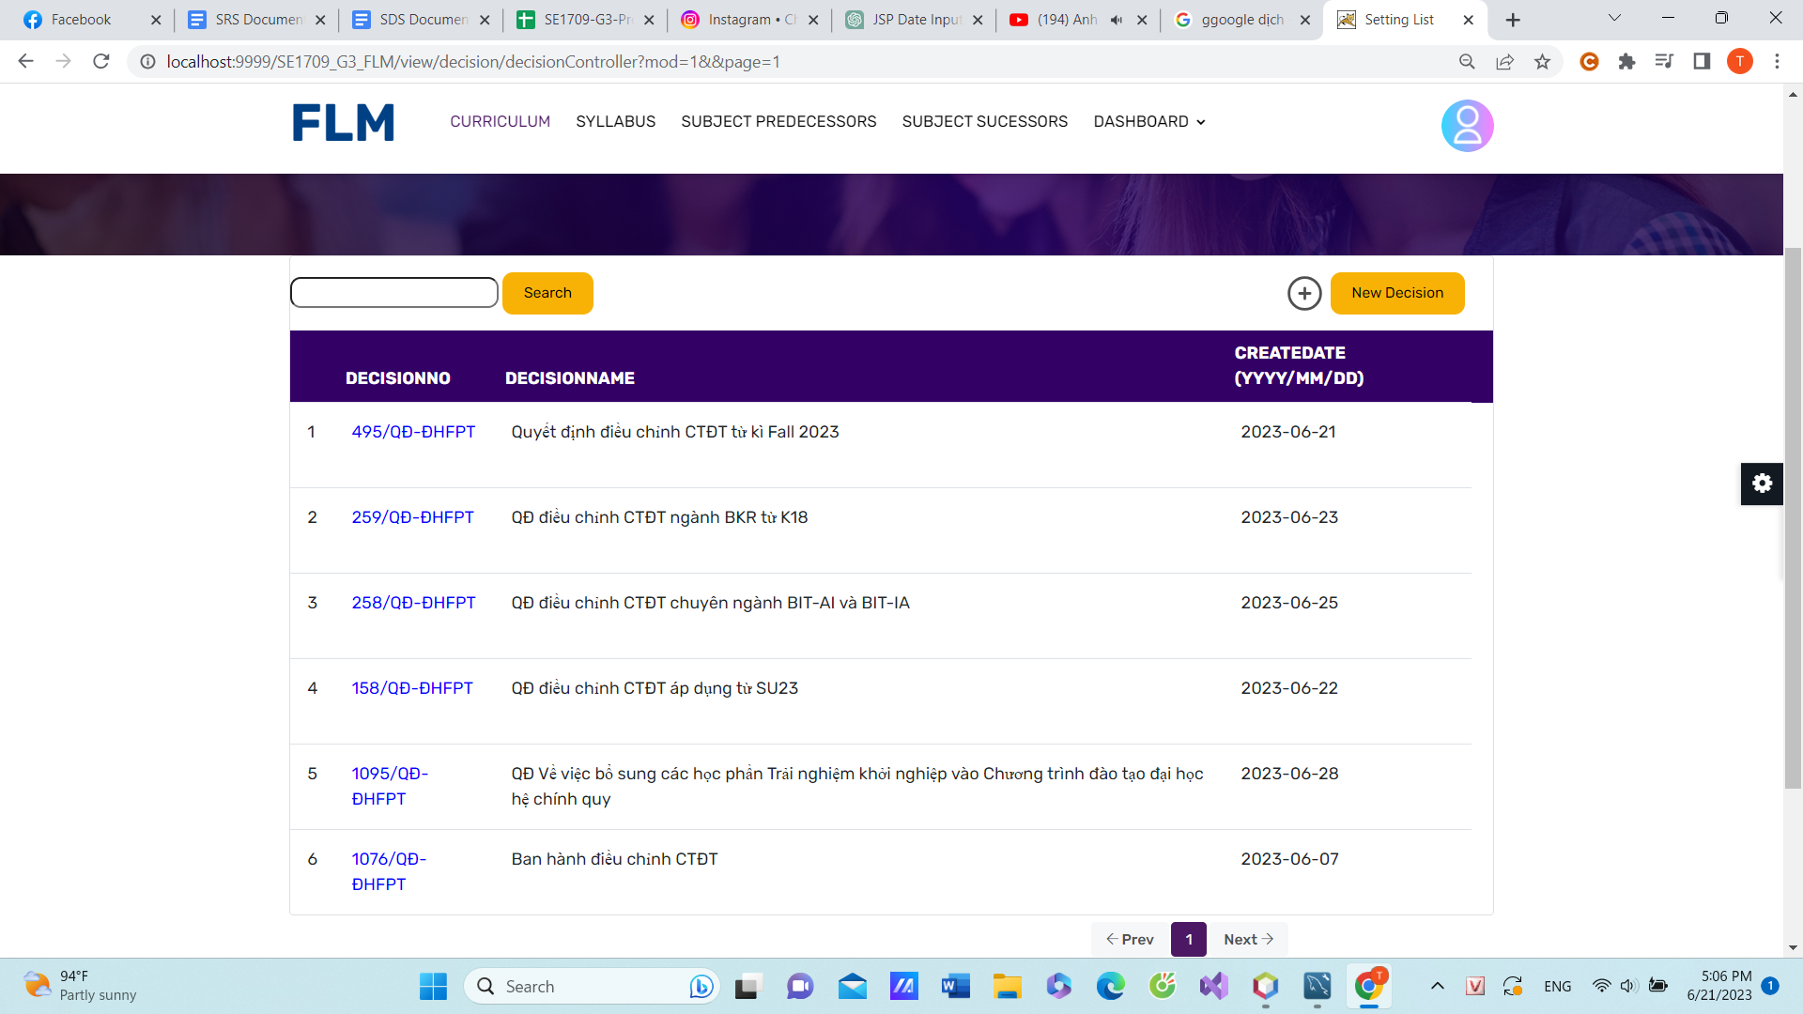

Function Details:

Data: The decision list screen displays decision records fetched from the database, including information such as decision ID, title, date, and status.

Validation: The data displayed on the screen is typically validated at the backend to ensure its accuracy and consistency. For example, date formats are validated, and only authorized decision records are retrieved.

Business Logic: The screen may incorporate business logic to determine the display of decision records based on user roles, permissions, or other criteria. It can also include sorting and filtering options to help users find specific decisions efficiently.

Functionalities:

Normal Cases:

Viewing Decision Details: Clicking on a decision record in the list opens a detailed view of that decision, providing additional information and options for further actions.

Sorting: Users can sort the decision list based on various columns, such as date or status, by clicking on the column headers.

Filtering: Users can apply filters to narrow down the displayed decision records based on specific criteria, such as status, date range, or decision title.

Abnormal Cases:

Error Handling: In case of errors during data retrieval or processing, appropriate error messages are displayed to the user, informing them about the issue and possible actions to resolve it.

Empty State: If no decision records are available or match the applied filters, a message indicating an empty state or no results found is displayed to manage user expectations.

### Decision Detail

Function Trigger:

The Decision Detail screen is typically triggered when a user selects a specific decision from the Decision List screen by clicking on its title or ID. It can also be accessed from other related screens or modules within the application.

Function Description:

Actors/Roles: Users with appropriate access privileges, such as decision makers, administrators, or authorised personnel.

Purpose: The Decision Detail screen provides a comprehensive view of a specific decision, allowing users to access detailed information and perform various actions related to that decision.

Interface: The screen generally includes a combination of text fields, dropdowns, checkboxes, buttons, and other UI components to present decision-specific data and enable user interactions.

Data Processing: The screen retrieves decision data from a database or backend system, processes user input, and updates the decision record accordingly.

Screen Layout (Mockup Prototype):

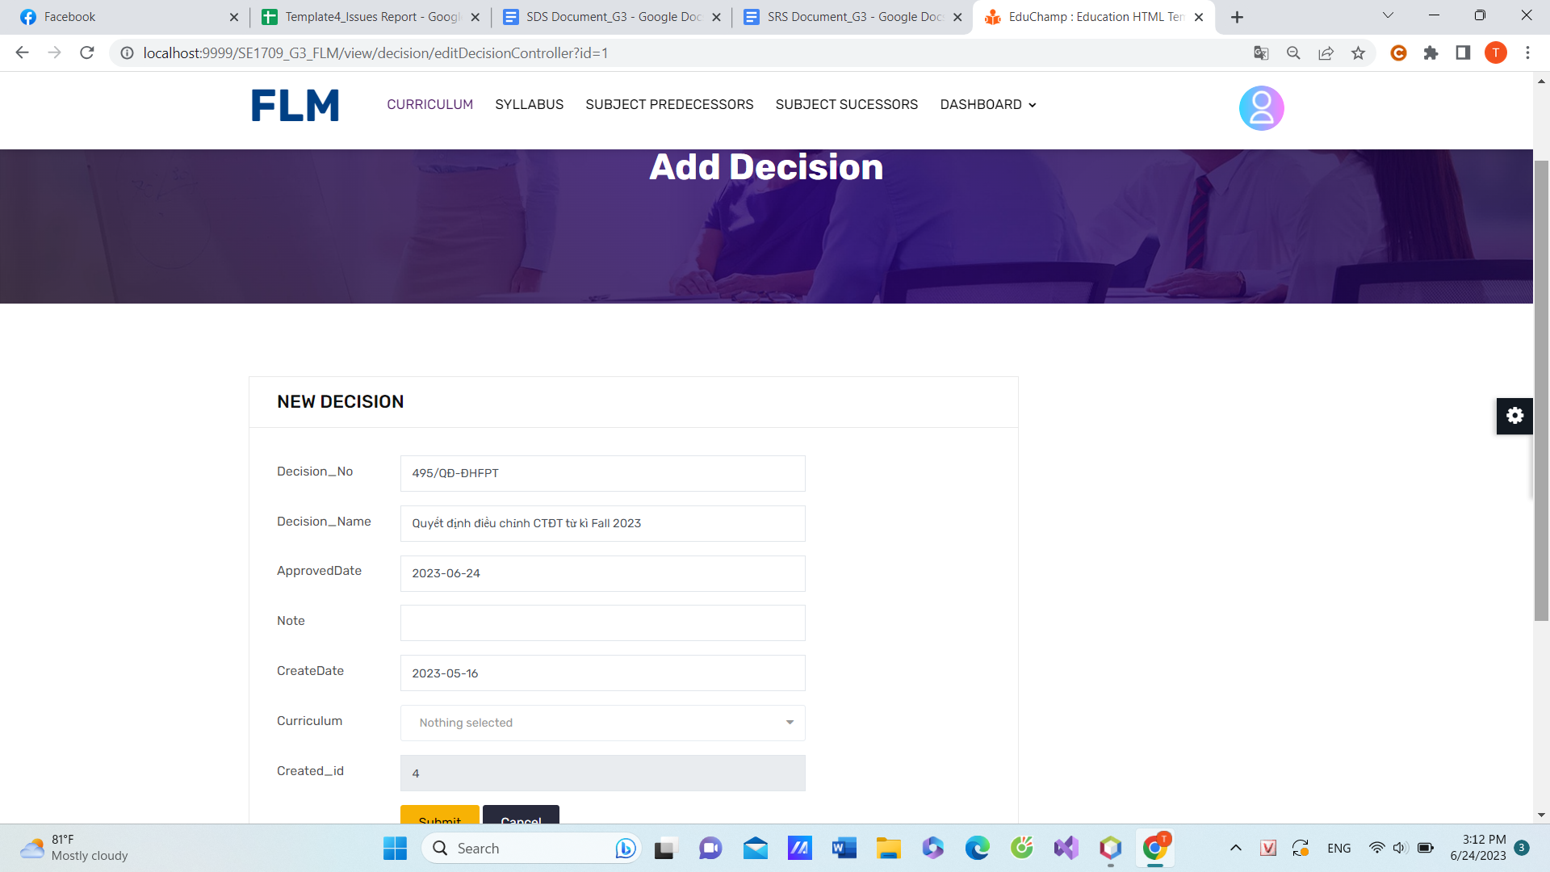

Function Details:

Data: The Decision Detail screen displays and allows modification of decision-specific data, such as decision ID, title, date, status, and description. The data is populated from the database or backend system.

Validation: Input fields on the screen typically include validation to ensure data integrity and consistency. For example, date fields may validate the format and range, while text fields may have length or format restrictions.

Business Logic: The screen may incorporate business logic related to decision management. For example, depending on user roles and permissions, certain fields or actions may be restricted or enabled.

Functionalities:

Normal Cases:

Viewing Decision Details: The screen presents decision details, including the decision ID, title, date, status, and description. This information allows users to understand the decision's context and purpose.

Editing Decision Details: Users can modify decision-related information, such as updating the title, changing the date, selecting a new status, or editing the description. These changes are typically saved upon user confirmation.

Saving Changes: The Save button allows users to save the modifications made to the decision data. Upon clicking Save, the updated information is processed and persisted in the backend system.

Deleting Decision: The Delete button enables users to remove the decision from the system. This action typically prompts a confirmation dialogue to ensure the user's intent.

Abnormal Cases:

Error Handling: In case of errors during data retrieval, processing, or validation, appropriate error messages are displayed to inform the user about the issue and guide them on resolving it.

Input Validation: User inputs are validated to ensure they adhere to the specified requirements. If an input fails validation, the user is notified of the validation error and prompted to correct it.

Access Restrictions: If the user does not have sufficient privileges to edit or delete the decision, appropriate messaging or disabled controls can indicate their limited permissions.

### New Decision

Function Trigger:

The New Decision screen is typically triggered when a user initiates the creation of a new decision within the application. It can be accessed through a specific navigation path, such as a "New Decision" button or menu option, or as part of a workflow that requires decision creation.

Function Description:

Actors/Roles: Users with appropriate access privileges, such as decision makers, administrators, or authorised personnel.

Purpose: The New Decision screen allows users to create a new decision by providing relevant details and configuring decision-specific information.

Interface: The screen consists of input fields, dropdowns, checkboxes, buttons, and other UI components to capture decision-related data from the user.

Data Processing: The screen processes user input, performs validation, and stores the new decision data in a database or backend system.

Screen Layout (Mockup Prototype):

Below is a mockup prototype of the New Decision screen:

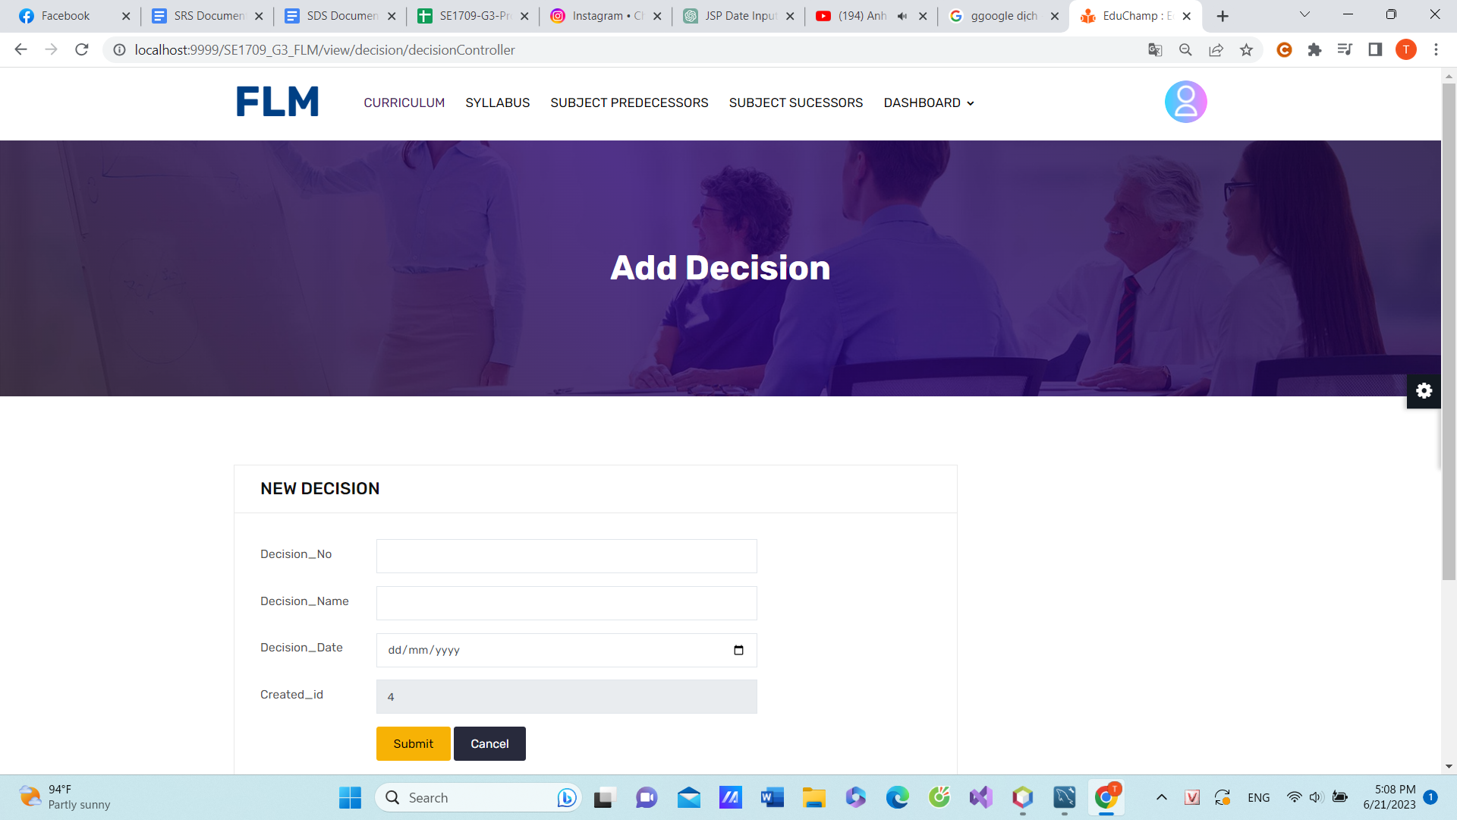

Function Details:

Data: The New Decision screen captures decision-specific data, such as the title, date, status, and description, entered by the user.

Validation: The input fields on the screen typically include validation to ensure data integrity and consistency. For example, the date field may validate the format and range, while the title field may have length restrictions.

Business Logic: The screen may incorporate business logic related to decision creation. For example, default values or predefined options for certain fields can be set based on organisational policies or system configurations.

Functionalities:

Normal Cases:

Entering Decision Details: Users input the decision title, select a date, choose a status from the dropdown, and provide a description. These details collectively define the new decision.

Saving the Decision: The Save button allows users to save the newly created decision. Upon clicking Save, the decision data is processed, validated, and persisted in the backend system.

Cancelling Creation: The Cancel button enables users to abort the decision creation process, discarding any entered data and returning to the previous screen or workflow.

Abnormal Cases:

Error Handling: In case of errors during data validation or processing, appropriate error messages are displayed to inform the user about the issue and guide them on resolving it.

Input Validation: User inputs are validated to ensure they adhere to the specified requirements. If an input fails validation, the user is notified of the validation error and prompted to correct it.

### Decision Overview

Function Trigger:

The Decision Overview screen is typically triggered when a user selects a specific decision from the Decision List screen or from other related screens. It can also be accessed directly through a navigation path or as part of a workflow that requires an overview of decision details.

Function Description:

Actors/Roles: Users with appropriate access privileges, such as decision makers, administrators, or authorised personnel.

Purpose: The Decision Overview screen provides a comprehensive view of a specific decision, presenting a summary of key information and allowing users to analyse and review decision details.

Interface: The screen consists of informative sections, charts, tables, or other visual elements to present decision-related data in a concise and meaningful manner.

Data Processing: The screen retrieves decision data from a database or backend system, performs data calculations or aggregations, and presents the summarised information to the user.

Screen Layout (Mockup Prototype):

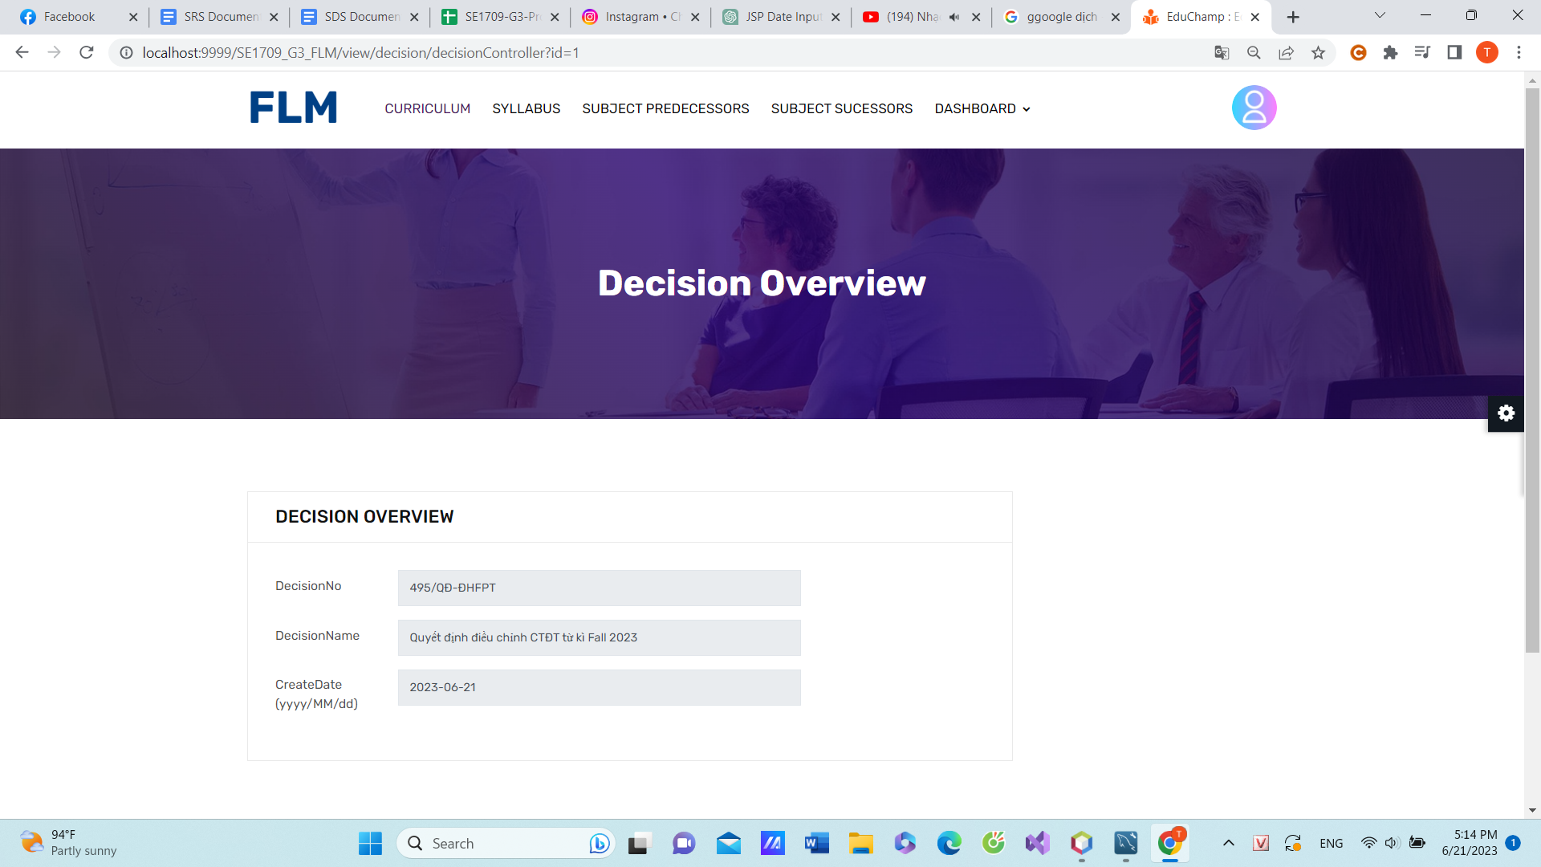

Function Details:

Data: The Decision Overview screen displays summarised decision-related data, such as the decision ID, title, date, and status. It may also include calculated metrics or aggregated information related to the decision.

Validation: As the screen primarily displays pre-existing decision data, validation is typically not a significant factor. However, any dynamic calculations or derived information presented on the screen would be validated to ensure accuracy.

Business Logic: The screen may incorporate business logic related to decision analysis and presentation. For example, it can include data transformations, statistical calculations, or formatting rules to ensure the information is presented in a meaningful and actionable manner.

Functionalities:

Normal Cases:

Decision Statistics: The screen can display charts or visual representations of decision-related statistics, such as the number of decisions by status, decision trends over time, or other relevant metrics.

Decision Details: A table or informative section presents key details and attributes of the decision, allowing users to quickly review important information, such as decision description, associated documents, or relevant stakeholders.

Edit Decision: The Edit Decision button allows users to navigate to the Decision Detail screen to make modifications to the decision's details.

View History: The View History button provides access to the decision's history or audit trail, allowing users to review past changes, comments, or actions associated with the decision.

Abnormal Cases:

Error Handling: In case of errors during data retrieval or processing, appropriate error messages are displayed to inform the user about the issue and guide them on resolving it.

Limited Access: Users without appropriate permissions may have restricted functionality on the Decision Overview screen, such as read-only access or limited visibility of certain sections or data.

## 11. Syllabus Submit

### Submit List

* Function Trigger:

The Submit List function is typically triggered when a user wants to submit a list of items or tasks within a system or platform. The trigger can vary depending on the specific context and application. It can be triggered through a navigation path, such as accessing the "Submit List" page or clicking on a specific menu option. The function is typically accessed when there is a need to submit a collection of items or tasks for processing or completion.

* Function Description:

- Actors/Roles: User, System

- Purpose: The purpose of the Submit List function is to allow users to submit a list of items or tasks within a system or platform. It enables users to provide a set of data or instructions that need to be processed or executed by the system.

- Interface: The interface for the Submit List function typically includes a form or input field where users can enter or select the list of items or tasks they want to submit. It may also provide options or checkboxes to specify additional parameters or preferences. The interface may include buttons or links to initiate the submission process and provide feedback on the status of the submission.

- Data Processing: The function processes the submitted list of items or tasks, which can be in various formats depending on the system requirements. It extracts the relevant data from the user input, performs any necessary validation or formatting, and passes it to the appropriate processing module or component within the system for further action.

* Screen Layout:
* Function Details:

- Data: The function receives the user-inputted list of items or tasks. The data can vary depending on the system requirements and can be in the form of text, numbers, codes, or any other format suitable for the specific use case.

- Validation: The function may include validation checks to ensure the correctness and completeness of the submitted list. It can perform checks such as data format validation, data integrity validation, or any other business rules or constraints specific to the system or platform.

- Business Logic: The function incorporates business logic to handle the submitted list of items or tasks. This can include processing rules, workflows, or algorithms that determine how the submitted list will be used or acted upon within the system.

- Functionalities:

+ Normal Cases: When the function is triggered, the user enters or selects the desired items or tasks in the input field or form. The function validates the submitted data and processes it according to the system's business logic. This can include performing calculations, updating database records, initiating workflows, or triggering further actions within the system.

+ Abnormal Cases: In case of any errors or issues during the validation or processing of the submitted list, the function may display appropriate error messages to the user. It informs the user about the specific issue encountered and provides guidance on how to correct the errors or resolve the problems.

### Submit Details

* Function Trigger:

The Submit Details function is typically triggered when a user wants to submit specific details or information within a system or platform. The trigger can vary depending on the specific context and application. It can be triggered through a navigation path, such as accessing the "Submit Details" page or clicking on a specific button or link within the system. The function is typically accessed when there is a need to provide specific details or data for processing or completion.

* Function Description:

- Actors/Roles: User, System

- Purpose: The purpose of the Submit Details function is to allow users to submit specific details or information within a system or platform. It enables users to provide precise data or instructions that need to be processed or acted upon by the system.

- Interface: The interface for the Submit Details function typically includes input fields, dropdown menus, checkboxes, or other interactive elements that allow users to enter or select the required details. It may also provide options or settings to customize the submission process or specify additional parameters. The interface may include buttons or links to initiate the submission and provide feedback on the status of the submission.

- Data Processing: The function processes the submitted details, extracting and validating the relevant data from the user input. It performs any necessary data formatting, transformation, or validation checks. The processed data is then passed to the appropriate processing module or component within the system for further action.

* Screen Layout:
* Function Details:

- Data: The function collects and processes the user-submitted details. The data can vary depending on the specific requirements of the system or platform. It may include text, numerical values, dates, selections from dropdown menus, checkboxes, or other relevant data types.

- Validation: The function performs validation checks on the submitted details to ensure the correctness, completeness, and integrity of the data. It may include checks such as data format validation, range validation, data consistency validation, or any other business rules or constraints specific to the system or platform.

- Business Logic: The function incorporates business logic to handle the submitted details. This can include data processing rules, workflows, or algorithms that determine how the submitted details will be used or acted upon within the system.

- Functionalities:

+ Normal Cases: When the function is triggered, the user enters or selects the required details in the input fields or interactive elements provided in the interface. The function validates the submitted data, performs any necessary data transformations or calculations, and passes the processed data to the appropriate module or component within the system for further action or processing.

+ Abnormal Cases: In case of any errors or issues during the validation or processing of the submitted details, the function may display appropriate error messages to the user. It informs the user about the specific issue encountered and provides guidance on how to correct the errors or resolve the problems.

## 12. Constructive Questions

### Question List

Function Trigger: The Question List function is typically triggered when a user wants to access a list of questions within a system or platform. The trigger can vary depending on the specific context and application. It can be triggered through a navigation path, such as accessing the "Question List" page or clicking on a specific button or link within the system. The function is typically accessed when there is a need to view, search, or interact with a list of questions.

Function Description:

* Actors/Roles: User, System
* Purpose: The purpose of the Question List function is to provide users with access to a list of questions within the system or platform. It allows users to view, search, and interact with the questions available. The function may be part of a larger system or application that involves surveys, quizzes, knowledge bases, or any other context where questions are relevant.
* Interface: The interface for the Question List function typically includes a display area where the list of questions is shown. Each question may be represented as a separate entry or item in the list. The interface may provide options to filter or sort the questions based on different criteria such as category, date, or popularity. Users may be able to search for specific questions using keywords or other search parameters. The interface may also include buttons or links to perform actions related to the questions, such as answering, editing, or deleting them.
* Data Processing: The function retrieves the necessary data related to the questions from the system's database or storage. It may perform data queries, filtering, and sorting operations to fetch the relevant questions based on the user's preferences or search criteria. The retrieved data is then formatted and presented in the interface for the user to interact with.

Screen Layout: The screen layout for the Question List function may include the following components:

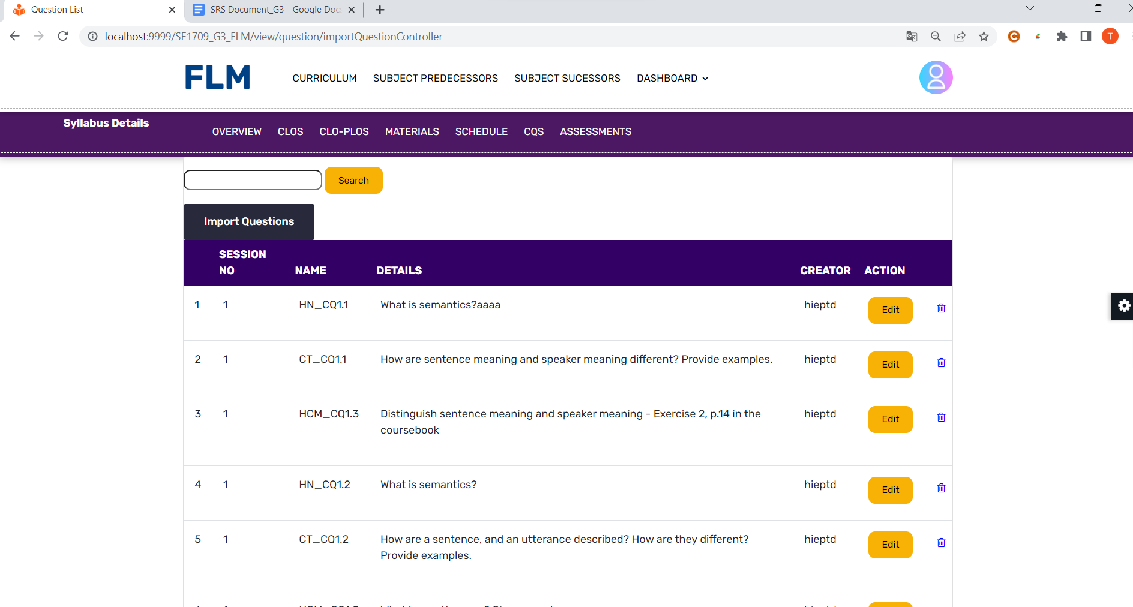

* List area: A section of the screen where the list of questions is displayed. Each question may be represented as a separate item with relevant details such as the question text, category, author, date, or any other pertinent information.
* Search/filter options: Interactive elements such as search bars, dropdown menus, or checkboxes that allow users to filter or search for specific questions based on different criteria.
* Sort options: Interactive elements that enable users to sort the questions in the list based on parameters such as category, date, or popularity.
* Action buttons/links: Buttons or links associated with each question entry in the list that allow users to perform actions such as answering, editing, deleting, or viewing more details about the question.

Function Details:

1. Data: The function retrieves data related to the questions from the system's database or storage. The data may include information such as question text, category, author, date, status, and any other relevant details associated with each question.
2. Validation: The function validates the retrieved data to ensure its integrity and consistency. It may perform checks to verify that the required fields are present, data types are correct, and any constraints or business rules associated with the questions are satisfied.
3. Functionalities:
   1. Normal Cases: In normal cases, when the function is triggered, the system retrieves the list of questions from the database or storage based on the user's preferences or search criteria. The questions are displayed in the interface, allowing users to browse through the list, search for specific questions, or perform actions related to the questions, such as answering or editing them.
   2. Abnormal Cases: In case of any errors or issues during the retrieval or processing of the questions, the function may display appropriate error messages to the user. It informs the user about the specific issue encountered and provides guidance on how to resolve the problems. Abnormal cases can include scenarios such as network connectivity issues, database errors, or invalid search parameters.

### b. Question Details

Function Trigger: The Question Details function is typically triggered when a user wants to view the details and information associated with a specific question within a system or platform. The trigger can vary depending on the specific context and application. It can be triggered by clicking on a question entry in a question list, accessing a "Question Details" page, or selecting a question from a search result. The function is accessed when there is a need to view the complete details of a question.

Function Description:

* Actors/Roles: User, System
* Purpose: The purpose of the Question Details function is to provide users with comprehensive information and details about a specific question within the system or platform. It allows users to access the question's content, additional metadata, associated answers, comments, or any other relevant information related to the question.
* Interface: The interface for the Question Details function typically includes a dedicated page or section that displays the complete details of the selected question. The interface may include the question text, category, author, date, status, and any other relevant metadata associated with the question. It may also display the answers provided for the question, comments or discussions related to the question, and any other pertinent information. The interface may provide options or buttons to perform actions related to the question, such as editing, deleting, or marking it as resolved.
* Data Processing: The function retrieves the necessary data related to the question from the system's database or storage. It may perform data queries, fetch associated answers or comments, and process the data to present it in a user-friendly format within the interface.

Screen Layout: The screen layout for the Question Details function may include the following components:

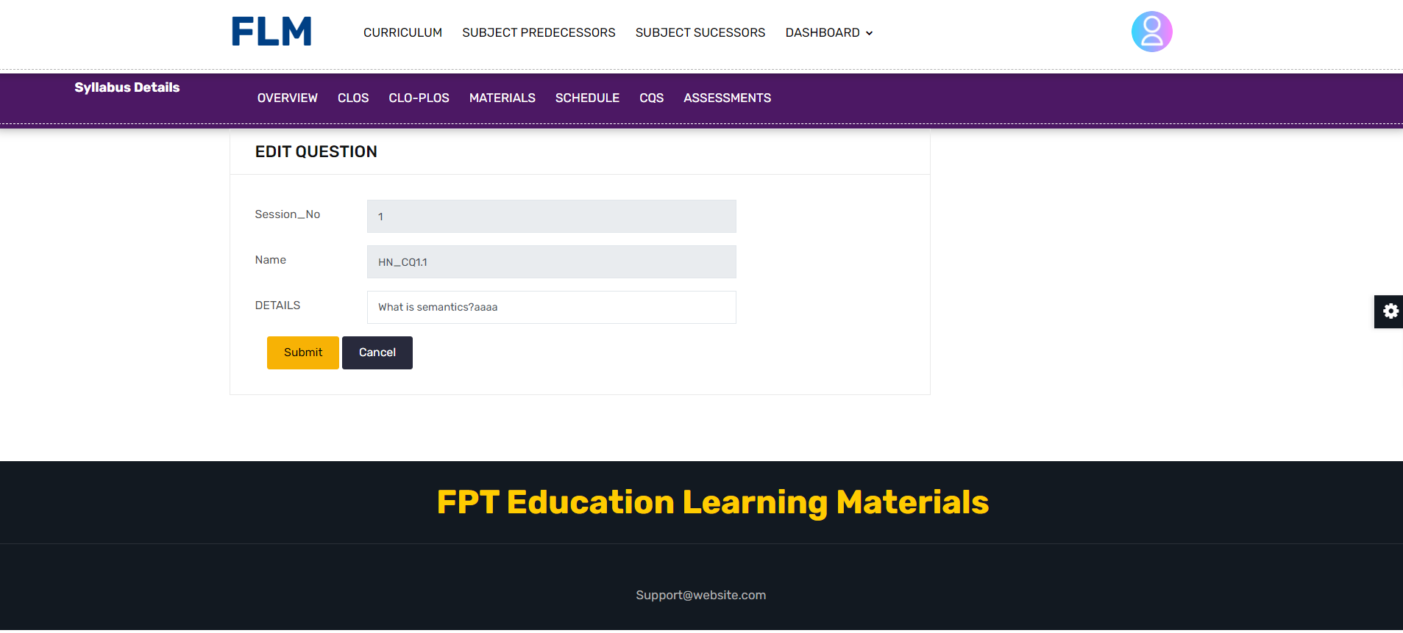

* Question content: The complete text or content of the selected question.
* Metadata: Information such as the category, author, date, status, and any other relevant details associated with the question.
* Answers: The answers provided for the question, including the answer text, author, date, and any other relevant information.
* Comments/Discussions: Any comments, discussions, or interactions related to the question.
* Action buttons/links: Buttons or links that allow users to perform actions related to the question, such as editing, deleting, marking as resolved, or adding comments.

Function Details:

* Data: The function retrieves data related to the selected question from the system's database or storage. The data may include the question text, metadata, associated answers, comments, and any other relevant information.
* Validation: The function performs validation checks on the retrieved data to ensure its integrity and consistency. It may verify that the required fields are present, data types are correct, and any constraints or business rules associated with the question are satisfied.
* Functionalities:
  + Normal Cases: In normal cases, when the function is triggered, the system retrieves the complete details of the selected question from the database or storage. The details are displayed in the interface, allowing users to view the question text, metadata, answers, comments, or any other associated information. Users can interact with the question, read the answers or comments, and perform actions related to the question, such as editing, deleting, or adding comments.
  + Abnormal Cases: In case of any errors or issues during the retrieval or processing of the question details, the function may display appropriate error messages to the user. It informs the user about the specific issue encountered and provides guidance on how to resolve the problems. Abnormal cases can include scenarios such as the selected question not found, database errors, or data inconsistencies.

### c. Import Question

Function Requirement about Import Question function

Function Trigger: The Import Question function is typically triggered when a user wants to import a set of questions from an external source into a system or platform. The trigger can vary depending on the specific context and application. It can be triggered by selecting an "Import Questions" option from a menu, clicking on an import button, or uploading a file containing the questions. The function is accessed when there is a need to bulk import questions into the system.

Function Description:

* Actors/Roles: User, System
* Purpose: The purpose of the Import Question function is to allow users to import a batch of questions from an external source into the system or platform. It enables users to quickly add a large number of questions without manually entering each question individually. The function helps streamline the process of populating the question database or content within the system.
* Interface: The interface for the Import Question function typically includes an option to upload a file containing the questions. Users may be able to select the file from their local device or provide a URL to a file hosted elsewhere. The interface may also include options to specify the format or structure of the imported file, such as CSV, Excel, JSON, or any other supported format. Additionally, the interface may display progress indicators or feedback on the import process.
* Data Processing: The function processes the imported file, extracting the questions and associated information from the file. It performs data parsing, validation, and mapping to transform the data into the appropriate format for the system. The processed questions are then added to the question database or content within the system.

Screen Layout: The screen layout for the Import Question function may include the following components:

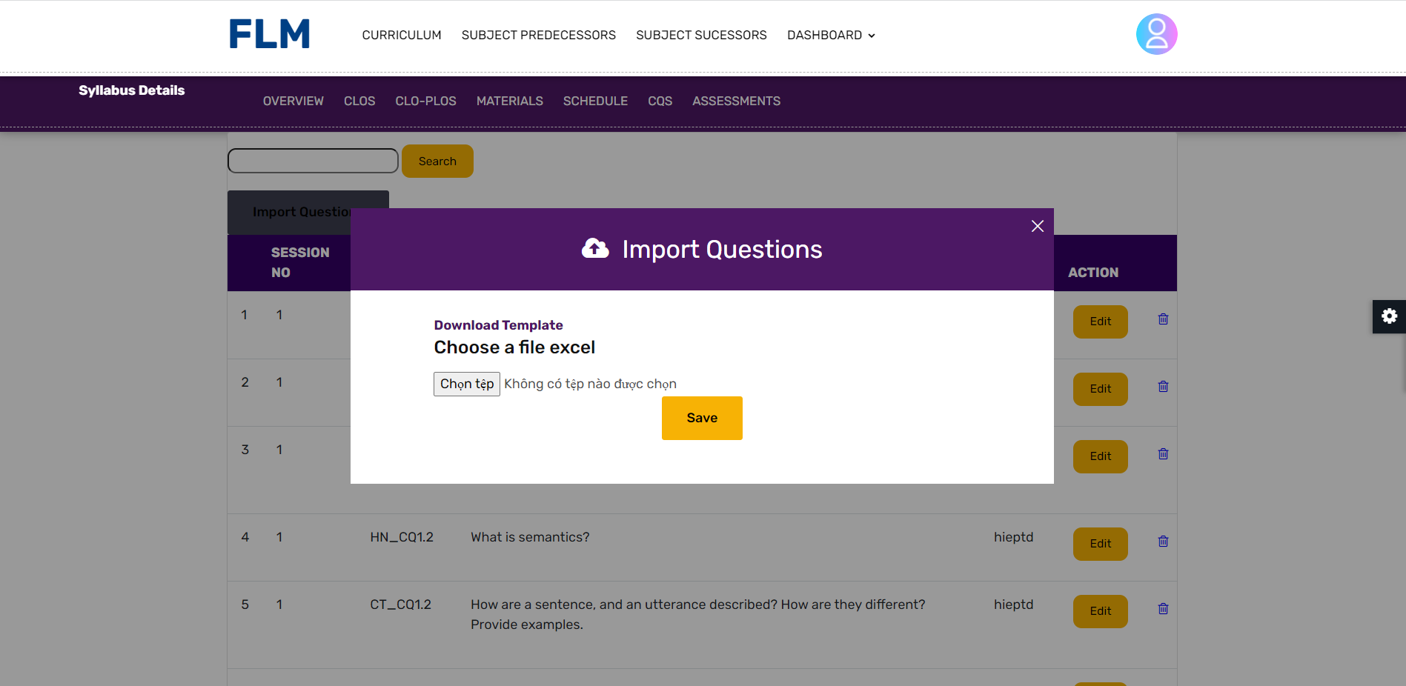

* File upload: A section where users can select and upload the file containing the questions. It may include a file input field, a "Browse" button, or drag-and-drop functionality.
* File format options: Options or settings that allow users to specify the format or structure of the imported file, such as CSV, Excel, JSON, etc.
* Progress indicators: Feedback or progress bars that inform users about the status of the import process, indicating the number of questions processed or any errors encountered.

Function Details:

* Data: The function receives a file containing the questions to be imported. The file may be in various formats such as CSV, Excel, JSON, or any other supported format. The data within the file may include the question text, category, author, options, correct answers, and any other relevant information associated with each question.
* Validation: The function performs validation checks on the imported data to ensure its integrity and consistency. It may include checks for data format validation, required fields, data types, or any other business rules specific to the system. It may also check for duplicate questions or any conflicts with existing data within the system.
* Functionalities:
  + Normal Cases: In normal cases, when the function is triggered, users select and upload the file containing the questions. The function processes the file, parsing and validating the data within it. The imported questions are then added to the question database or content within the system. The function provides feedback to the user on the import process, indicating the number of questions imported successfully and any errors encountered.
  + Abnormal Cases: In case of any errors or issues during the import process, the function may display appropriate error messages to the user. It informs the user about the specific issue encountered, such as invalid file format, missing or incorrect data, or conflicts with existing questions. The function provides guidance on how to resolve the problems and may allow users to review and correct the errors before attempting the import again.

## 13. Session Management

### Session List

* Function Trigger:
* The Session List function is activated when the user wants to view a list of sessions or meetings.
* Function Description:
* Actor/Role: Staff
* Purpose: The purpose of the Session List function is to provide Staff with a comprehensive list of scheduled sessions or meetings available in a system or platform. It allows Staff to browse, search, or select specific sessions of interest for further actions or participation.
* Interface: The interface for the Session List function typically presents a list or calendar view of sessions, along with relevant details such as date, time, location, and participants.
* Data processing: The function retrieves the list of sessions from the backend database or scheduling system and presents it to the Staff through the user interface for easy access and management.
* Screen Layout:

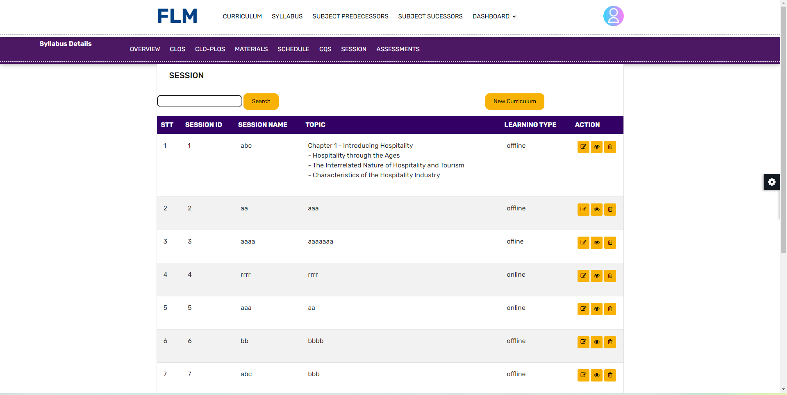

Function details:

- Data: Function to retrieve and display the list of CLOs. Each CLo can have associated metadata like name, SyllabusID, IS ACTIVE

- Validation: This function is not related to data validation specifically, as it is mainly focused on presenting the list of CLo taken from the backend. However, it may include checking for empty or incomplete data to ensure the list is populated correctly.

- Function:

- Normal case: When the function is activated, it will get the list of CLOs from the backend and display them in the Staff interface. Staff can browse, search or interact with CLOs

- Abnormal cases: In case of any error or problem during data retrieval, the function can display an error message

Overall, the CLo List function provides staff with an organised and easy-to-navigate view of the topics or topics available in a system or platform. It allows staff to discover and interact with objects based on their interests or requirements,

### Session Details

Function Trigger:

* The Session Details function is activated when the user selects a specific session from the Session List interface and wants to view detailed information about that particular session or meeting.

Function Description:

* Actor/Role: Staff
* Purpose: The purpose of the Session Details function is to provide Staff with comprehensive and in-depth information about a selected session or meeting from the system or platform. It allows Staff to access essential details such as session name, date, time, location, participants, and any other relevant information associated with the session.
* Interface: The interface for the Session Details function typically presents a dedicated page or modal window displaying all the relevant information related to the selected session. This could include a detailed description of the session's agenda, list of attendees, attachments, and any additional notes or comments.
* Data processing: The function retrieves the specific session details from the backend database or scheduling system based on the user's selection from the Session List. It then presents this detailed information to the Staff through the user interface for a more comprehensive understanding of the session.

Screen Layout: The Session Details interface may be organized with various sections or tabs to display different aspects of the session, such as session overview, participants, agenda, attachments, and comments.

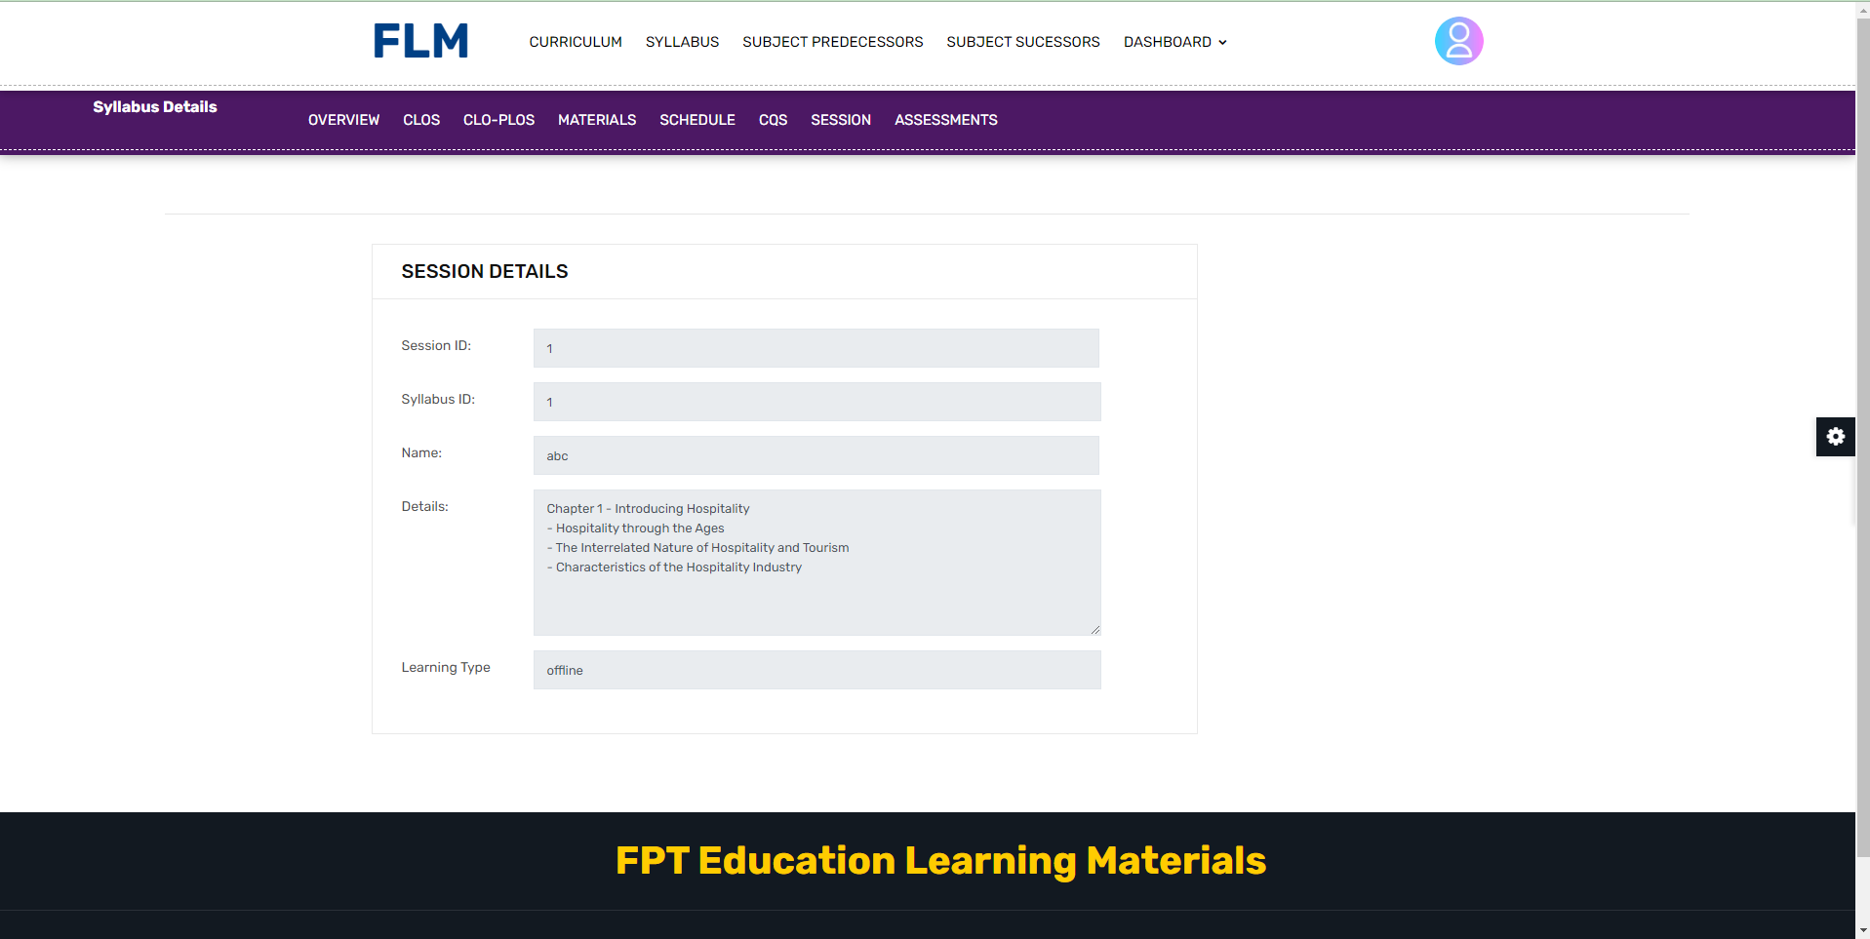

Function details:

* Data: The Session Details function is responsible for retrieving and displaying the detailed information of a selected session. This information can include session name, date, time, location, participants, attachments, and any other relevant data related to the session.
* Validation: The Session Details function may involve some basic validation checks, such as ensuring the session data is complete and correctly formatted before displaying it to the Staff. It may also verify that the selected session exists in the database or scheduling system.
* Function:
* Normal case: When the function is triggered by the user selecting a session from the Session List, it fetches the detailed information of the selected session from the backend and presents it in a structured and easy-to-read manner on the Staff interface.
* Abnormal cases: In case of any errors or issues during data retrieval, such as missing session details or connectivity problems with the backend, the function can display an error message to inform the Staff about the problem.

Overall, the Session Details function enhances the Staff's ability to access comprehensive information about specific sessions or meetings. It provides them with a deeper understanding of the selected session, enabling them to make well-informed decisions, prepare adequately, and participate actively in the scheduled event.

### Import Session

## 14. CLO Management

### CLO List

Function Trigger:

* The CLO List function is activated when the user wants to see a list of POs.

Function Description:

* Actor/Role: Staff
* Purpose: The purpose of the CLO list function is to provide Staff with a complete list of Pos or topics available in a system or platform. It allows Staff to browse, search or select specific topics of interest for further actions or interactions.
* Interface: The interface for the CLO list function typically presents a list or grid view of CLOs , along with related information.
* Data processing: The function takes the list of CLOs from the backend database or content management system and presents it to the Staff through the user interface.

Screen Layout: 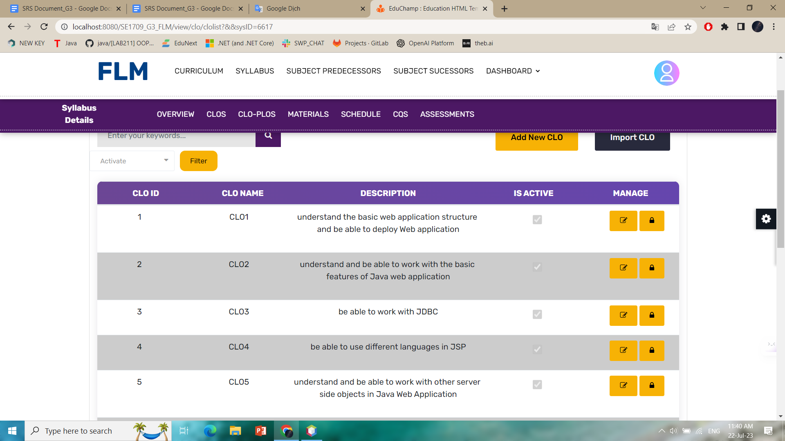

Function details:

- Data: Function to retrieve and display the list of CLOs. Each CLo can have associated metadata like name, SyllabusID, IS ACTIVE

- Validation: This function is not related to data validation specifically, as it is mainly focused on presenting the list of CLo taken from the backend. However, it may include checking for empty or incomplete data to ensure the list is populated correctly.

- Function:

- Normal case: When the function is activated, it will get the list of CLOs from the backend and display them in the Staff interface. Staff can browse, search or interact with CLOs

- Abnormal cases: In case of any error or problem during data retrieval, the function can display an error message

Overall, the CLo List function provides staff with an organised and easy-to-navigate view of the topics or topics available in a system or platform. It allows staff to discover and interact with objects based on their interests or requirements,

### CLO Details

Function Trigger:

* The View CLO Detail function is typically triggered when a user wants to view the detailed information of a specific CLO or topic within a system or platform. It can be triggered through a navigation path, such as clicking on a subject from a subject list or search results.

Function Description:

* Actors/Roles: Staff
* Purpose: The purpose of the View CLO Detail function is to provide Staff with comprehensive and detailed information about a specific subject or topic within the system or platform. It allows Staff to access and review the content, attributes, and related data associated with the subject.
* Interface: The interface for the View CLO Detail function typically presents the subject's detailed information in a structured and organized manner. It may include sections or tabs to display various aspects of the subject, such as description, category, tags, related content
* Data Processing: The function retrieves the detailed information of the selected subject from the backend database or content management system and presents it to the user through the user interface. It may involve data processing operations such as querying the database, retrieving associated content, and formatting the data for display.

Screen layout:

* The screen layout for the Import Theme from Excel File function might look like the sample model below: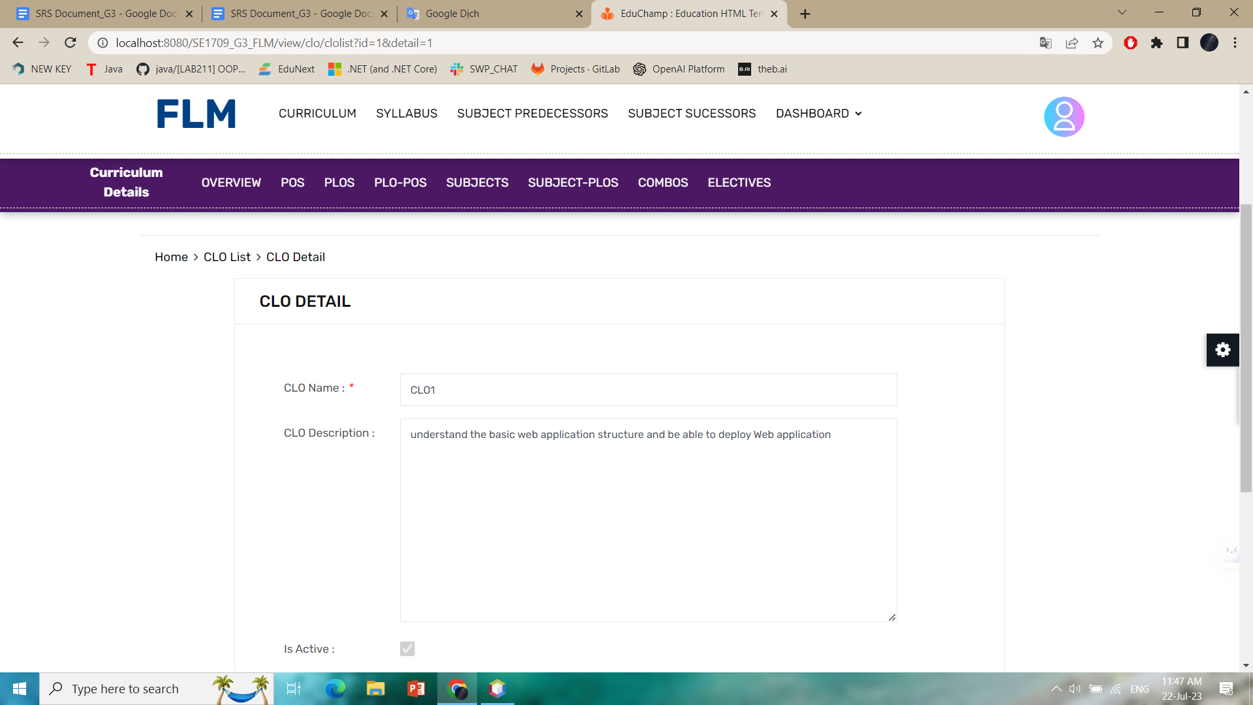Function Details:
* - Data: The function retrieves and displays detailed information about a specific CLO. This information may include the CLO name, description, or any other relevant data associated with the CLO .
* - Validation: The function does not involve specific data validation, as it primarily focuses on presenting the CLO details retrieved from the backend. However, it may include checks to ensure that the CLO exists and is accessible to the Staff.
* - Business Logic: The function may incorporate business logic to determine the permissions or access rights of the user to view the CLO details. It may also include logic to fetch and present related content or comments associated with the CLO .
* - Functionalities:
* - Normal Cases: When the function is triggered, it retrieves the detailed information of the selected CLO and presents it in the user interface. Staff can view the CLO attributes
* , such as description, category, tags, related content, and comments. They can also perform actions such as editing or soft erase the CLO if they have the appropriate permissions.
* - Abnormal Cases: In case the CLO does not exist , the function may display an appropriate error message indicating the issue and provide guidance on how to proceed. It ensures that the user is informed about the limitation and prevents unauthorized access to CLO information.
* Overall, the View CLO Detail function allows staff to explore and review the comprehensive details and content associated with a specific CLO or topic within the system or platform. It presents the CLO information in an organized manner, facilitating easy navigation and access to relevant data.

### Import CLO

Function Trigger:

* The CLO import from Excel file function is usually activated when a staff member wants to import a series of CLOs from an Excel file into a system or platform. It can be activated via a navigation link, such as clicking the "Import Subject" or "Upload to Excel" button in the user interface.

Function Description:

* Actor/Role: Staff
* Purpose: The purpose of Import CLO from Excel file is to allow Staff to import multiple Clos from one Excel file into the system or platform. It facilitates the efficient and streamlined batch addition of objects.
* Interface: The interface of the Import CLO from Excel file function usually includes an upload file input field or a drag and drop area where the user can select or drop the Excel file containing the ClO data. It may also include buttons to upload, cancel, or delete the selected file.
* Data Processing: This function processes the uploaded Excel file, extracts the CLO data, validates it, and adds the CLos to a backend database or content management system. It may involve parsing Excel files, validating data, mapping data fields, and inserting databases.

Screen layout:

* The screen layout for the Import Theme from Excel File function might look like the sample model below: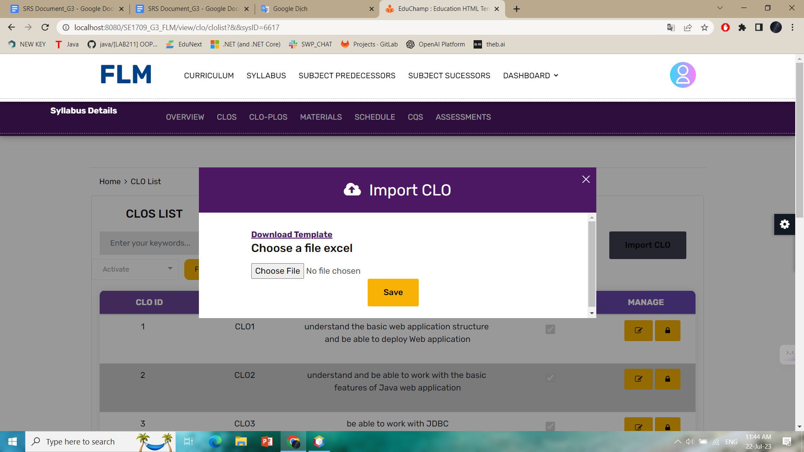
* Function details:
* - Data: The function expects an Excel file containing CLO data. Excel files can include columns CLO name, description. The function extracts and processes this data to create a new topic record in the system or platform.
* - Validity check: The function performs a validity check on the entered CLO data to ensure its accuracy and completeness. In addition, it can verify the integrity and validity of the Excel file structure.
* - Business logic: The function can combine business logic to handle specific situations during import. This may include dealing with duplicate topics, resolving conflicts, and applying any relevant business rules or restrictions.
* - Function:
* - Normal case: When activating the function, the user selects or drops the Excel file containing the CLO data. The function then processes the Excel file, extracts the CLO data, validates it, and creates a new CLO record in the backend based on the extracted information. It displays a success message indicating the number of imported objects and any additional information related to the import process.
* - Abnormal cases: In case of any error or problem during file upload, data extraction or data validation, the function can display the appropriate error message to the user, indicate the problem and suggest corrective action. It ensures that the user is informed of the specific problem encountered and provides instructions on how to fix it.
* Overall, the Import CLO from Excel File function provides users with a convenient method to import a large number of topics or topics from an Excel file. It streamlines the process of bulk adding objects, minimising manual data entry and saving time. The function ensures the authentication and secure storage of imported topic data, allowing users to quickly integrate new themes into the system or platform.

### CLO-PLO Mapping

Function Trigger:

* The function shows the relationship between plo and po.

Function Description:

The "PLO - CLO Mapping" function provides the user with information about the relationship between plo and clo. It provides a comprehensive overview of the subject's content,

Screen Layout: 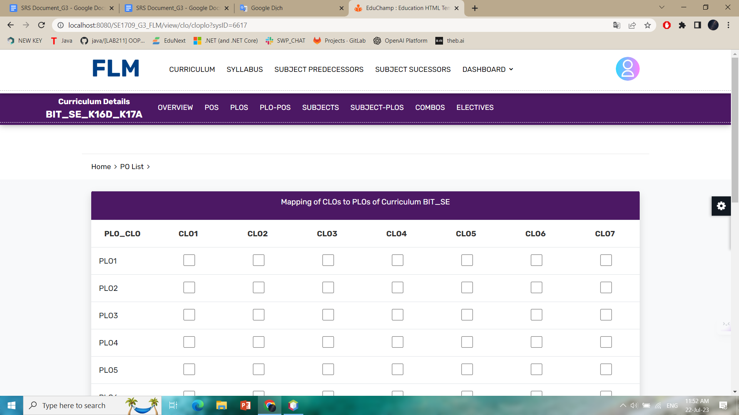

Function details:

* The function "PLO - CLo Mapping" provides the relationship between clo and plo.
* Make it easy for users to understand the relationship of clo and plo

## 15. Assessment Management

### Assessment List

### Assessment Details

## 16. Reference Material

### Material List

### Material Details